

RESQAI: AI-BASED ACCIDENT DETECTION, SEVERITY ASSESSMENT AND INTELLIGENT EMERGENCY RESPONSE SYSTEM
A system that detects a crash from smartphone-style motion readings, grades its severity, asks the occupant to confirm, and drafts a located emergency alert with the nearest hospitals
A project report submitted in partial fulfilment of the requirements for the award of the degree of
BACHELOR OF TECHNOLOGY
in
COMPUTER SCIENCE AND ENGINEERING
Submitted by
Adepu Meenakshi | 23K91A0503
Ayila Shanmukha Sai | 23K91A0521
Chekka Chandrashekhar | 23K91A0552
Avula Sreeya | 23K91A0519
Batch A2 (CSE-A)
Under the esteemed guidance of
Shirisha Reddy
[DESIGNATION]
DEPARTMENT OF COMPUTER SCIENCE AND ENGINEERING
TKR COLLEGE OF ENGINEERING & TECHNOLOGY (AN AUTONOMOUS INSTITUTION)
Medbowli, Meerpet, Balapur, Hyderabad, Telangana - 500 097
Academic year [ACADEMIC YEAR]

CERTIFICATE
This is to certify that the project report entitled "ResQAI: AI-Based Accident Detection, Severity Assessment and Intelligent Emergency Response System" is a bonafide record of the work carried out by Adepu Meenakshi (23K91A0503), Ayila Shanmukha Sai (23K91A0521), Chekka Chandrashekhar (23K91A0552), Avula Sreeya (23K91A0519), in partial fulfilment of the requirements for the award of the degree of Bachelor of Technology in Computer Science and Engineering, during the academic year [ACADEMIC YEAR], under my supervision.

Project Guide | Head of the Department | Principal
Shirisha Reddy | [HOD NAME] | [PRINCIPAL NAME]
[DESIGNATION] | Department of Computer Science and Engineering | TKR College of Engineering & Technology

External Examiner: [NAME AND SIGNATURE]
Place: [PLACE]
Date: [DATE]

DECLARATION
We hereby declare that the project report entitled "ResQAI: AI-Based Accident Detection, Severity Assessment and Intelligent Emergency Response System", submitted to the Department of Computer Science and Engineering, TKR College of Engineering & Technology, in partial fulfilment of the requirements for the award of the degree of Bachelor of Technology in Computer Science and Engineering, is a record of original work carried out by us under the guidance of Shirisha Reddy, [DESIGNATION]. The results embodied in this report have not been submitted to any other university or institution for the award of any degree or diploma.

Adepu Meenakshi 23K91A0503
Ayila Shanmukha Sai 23K91A0521
Chekka Chandrashekhar 23K91A0552
Avula Sreeya 23K91A0519

Place: [PLACE]
Date: [DATE]

ACKNOWLEDGEMENT
We express our sincere gratitude to our project guide, Shirisha Reddy, [DESIGNATION], for valuable guidance, encouragement and constructive suggestions throughout this project.
We thank [HOD NAME], Head of the Department of Computer Science and Engineering, for providing the facilities and support needed to complete this work, and [PRINCIPAL NAME], Principal, TKR College of Engineering & Technology, for the encouragement given to us.
We thank the project coordinators and all faculty and staff members of the department for their help, and our families and friends for their constant support.
We also acknowledge the authors of the base paper, Y. Wang, Z. Liang and Y. He, whose work on accident severity prediction gave this project its starting point, the authors of the GreenBox and CIRS papers, whose systems frame the problem of automatic detection and alerting, and the maintainers of the open-source software the project depends on (Flask, scikit-learn, NumPy, pandas, React, Vite, Leaflet, Recharts and OpenStreetMap).

Adepu Meenakshi
Ayila Shanmukha Sai
Chekka Chandrashekhar
Avula Sreeya
Road accidents cause serious injury and death, and the harm grows when victims cannot call for help. Existing automatic crash detection typically reports only that an impact occurred, with no indication of how serious it was, and dedicated in-vehicle hardware is costly and missing from most two-wheelers and older cars. This project presents ResQAI, a system that detects a crash from the readings a smartphone provides, grades its severity, gives the occupant a short window to cancel a false alarm, and then drafts a located emergency alert that names the nearest hospital. A reading of eleven features (accelerometer, gyroscope, speed change and jerk) is scaled and passed to an accident detector, a random forest of 200 trees, and to a severity model, a random forest of 250 trees, which grades the event as None, Minor, Moderate or Severe; the detector gates the grade. Only a Moderate or Severe result starts a 15-second confirmation. If the occupant does not cancel, the browser location is read, the three nearest hospitals are ranked by great-circle distance, and a dispatch message with a map link is composed. The system is a Flask API with a React console and was built, tested and documented by the team.
No real crash recordings were available, so the models are trained on 12,000 synthetic sensor events and every figure below describes that data, not real roads. On the 2,400 held-out events the detector scores accuracy 1.0000 and the severity model 0.99958 (macro-F1 0.99866; five-seed mean accuracy 0.99875). A threshold on acceleration magnitude detects crashes just as well, so only the severity grade shows an advantage over a simple rule (97.5% accuracy for the rule). Hard braking is never mistaken for a crash in the test set, but two constructed probes of pothole-like and speed-breaker-like events were flagged as accidents 48.9% and 50.5% of the time, although none reached Moderate or Severe. The alert path takes about 56 ms on a local machine, plus the 15-second confirmation window. The interface passes all 33 smoke checks and 47 of 55 checks of a wider suite, whose 8 failures, mostly missing input validation, are reported. Nothing is sent by SMS or call in this build. The base paper predicts severity from recorded Chinese crash reports, so its results cannot be compared with these.
Keywords: accident detection, severity assessment, smartphone sensors, random forest, GPS, hospital recommendation, emergency response, false-alarm confirmation, Flask, React.

TABLE OF CONTENTS
CERTIFICATE i
DECLARATION ii
ACKNOWLEDGEMENT iii
TABLE OF CONTENTS v
LIST OF FIGURES vii
LIST OF TABLES ix
LIST OF ABBREVIATIONS x
CHAPTER 1: INTRODUCTION 1
1.1 Domain and Background 1
1.2 Motivation 2
1.3 Problem Statement 2
1.4 Need of the System 3
1.5 Objectives 3
1.6 Scope of the Project 4
1.7 Contributions 4
1.8 Limitations and Assumptions 5
1.9 Organisation of the Report 6
CHAPTER 2: LITERATURE SURVEY 7
2.1 Overview 7
2.2 Base Paper Analysis 7
2.3 Related Work by Theme 9
2.4 Datasets and Algorithms Used in the Literature 11
2.5 Strengths and Limitations of the Existing Work 12
2.6 Research Gap 12
CHAPTER 3: FEASIBILITY STUDY 13
3.1 Technical Feasibility 13
3.2 Economic Feasibility 14
3.3 Operational Feasibility 14
3.4 Schedule Feasibility 15
3.5 Advantages and Constraints 15
CHAPTER 4: SYSTEM REQUIREMENTS AND ANALYSIS 17
4.1 Existing System and its Limitations 17
4.2 Proposed System and its Advantages 17
4.3 Functional Requirements 18
4.4 Non-Functional Requirements 19
4.5 Hardware Requirements 19
4.6 Software Requirements 20
4.7 User Roles 20
4.8 Constraints and Dependencies 20
CHAPTER 5: SYSTEM DESIGN 22
5.1 Design Goals and Architecture 22
5.2 High-Level Workflow 23
5.3 Data Flow Diagrams 25
5.4 UML Diagrams 28
5.5 Data Design 29
5.6 Module Design 31
5.7 Algorithm Design 32
5.8 User Interface Design 33
5.9 Design Decisions and Trade-offs 35
5.10 Quality Attributes 35
CHAPTER 6: METHODOLOGY AND SOFTWARE IMPLEMENTATION 36
6.1 Overall Methodology 36
6.2 Dataset 37
6.3 Features and Preprocessing 38
6.4 Algorithm Choice and Justification 39
6.5 Mathematical Formulation 41
6.6 Model Architecture and Training Configuration 42
6.7 Application Architecture and Implementation 43
6.8 API Design 44
6.9 Security and Error Handling 45
6.10 Installation and Execution 47
CHAPTER 7: SYSTEM TESTING 48
7.1 Testing Strategy 48
7.2 Unit Testing 49
7.3 Integration Testing 50
7.4 Functional Testing 50
7.5 Security Testing 51
7.6 Validation and Edge Cases 52
7.7 Performance Testing 53
7.8 Robustness Testing 54
7.9 User Acceptance Testing 55
7.10 Limits of the Testing Done 55
CHAPTER 8: RESULTS AND OUTPUT SCREENS 57
8.1 Experimental Set-up 57
8.2 Output Screens 57
8.3 Accident Detector 59
8.4 Severity Predictor 61
8.5 Comparison with Simpler Models 64
8.6 Robustness and Road-Surface Events 65
8.7 Sample Inputs and Outputs 67
8.8 Comparison with the Base Paper and Related Work 68
8.9 Success and Failure Analysis 69
8.10 Limitations 70
8.11 Objectives Against Outcomes 71
CHAPTER 9: CONCLUSION 72
9.1 Summary 72
9.2 Objectives Achieved 72
9.3 Key Findings 72
9.4 Practical Applications 73
9.5 Known Limitations 73
CHAPTER 10: FUTURE SCOPE 73
10.1 Data and models 74
10.2 Alerting and location 74
10.3 Application quality and security 74
10.4 Deployment and scale 75
10.5 Further research 75
REFERENCES 76
APPENDIX A: IMPORTANT CODE 78
A.1 Synthetic data generator (`train_models.py`) 78
A.2 Training the two models (`train_models.py`, from `main`) 78
A.3 Feature vector, prediction and the detector gate (`app.py`) 78
A.4 Hospital ranking and the dispatch message (`app.py`) 79
A.5 Login with lockout (`auth.py`) 79
A.6 Confirmation countdown and dispatch (`frontend/src/state/MonitorContext.jsx`) 80
APPENDIX B: INSTALLATION AND USER GUIDE 80
B.1 Requirements 80
B.2 Installation 81
B.3 Using the console 81
B.4 Interpreting the result 82
B.5 Checks and troubleshooting 82
APPENDIX C: ADDITIONAL SCREENS 83

LIST OF FIGURES
Figure 1: Four-tier architecture of ResQAI: React console, Flask API, machine-learning tier and file-based data tier. 23
Figure 2: High-level workflow of one event, from the sensor reading to the dispatched alert. 24
Figure 3: Sequence of the main flow: scenario, detection, confirmation and dispatch. 25
Figure 4: Context diagram (DFD level 0) of ResQAI with its user and the two outside services. 26
Figure 5: DFD level 1 of ResQAI: six processes and three data stores. 27
Figure 6: DFD level 2 of process 3.0: expansion of build_feature_vector and predict_from_features. 27
Figure 7: Design-level class diagram of ResQAI: data classes, the two scikit-learn model objects, the hospital directory and the React state provider. 28
Figure 8: Use cases of ResQAI for the vehicle occupant, the developer and the external services. 29
Figure 9: Entities of ResQAI: two persisted records, the model files, and three transient run-time entities. 30
Figure 10: Flowchart of predict_from_features and the client-side confirmation rule. 32
Figure 11: Offline pipeline of train_models.py: generate, split, scale, train, evaluate, save. 33
Figure 12: Landing page, light theme. 33
Figure 13: Sign-in form: the console is locked until an account signs in. 33
Figure 14: Live monitor: scenario buttons, live switch, detection result and the sensor trace. 34
Figure 15: Confirmation dialog for a Severe result with 11 seconds left. 34
Figure 16: Manual override: seven inputs and the derived acceleration magnitude. 34
Figure 17: Emergency response after a dispatch: map, dispatch summary and nearest hospital. 34
Figure 18: Distribution of acceleration magnitude by event kind (log scale) and magnitude against jerk: crashes sit well clear of harsh braking. 38
Figure 19: Feature importance of the detector and the severity model: Gini importance (left) and permutation importance (right). 43
Figure 20: Mean and 95th-percentile latency of each endpoint and of the three-call alert path. 54
Figure 21: Detector F1, severity macro-F1 and detector false-alarm rate as sensor noise grows. 55
Figure 22: Landing page, light theme: the pitch 'Detect. Rate. Dispatch.', the live status tiles (API online, model trained ML, countdown 15 s) and the entry buttons. 58
Figure 23: Sign-in form. The monitor, manual override and response screens are reachable only after signing in. 58
Figure 24: Live monitor before any reading: the five scenario buttons, the live-monitoring switch, and empty result and trace panels. 58
Figure 25: Live monitor after normal driving: 'No accident', severity None, accident probability 0 %, with the sensor trace of acceleration and rotation magnitude. 58
Figure 26: Confirmation dialog 'Possible accident detected' after a Severe crash: 100 % probability, 11 seconds left, the buttons 'I'm fine, cancel' and 'Send alert now', and the note that Escape cancels. 58
Figure 27: Dialog 'Emergency alert dispatched': alert id, severity, device location, the drafted message with its map link and nearest hospital, and the statement that the message is not sent to real responders. 58
Figure 28: Emergency response screen after the dispatch: map with the accident and hospital markers, dispatch summary (id, severity, location source, nearest hospital) and the call button. 59
Figure 29: Manual override with acc_x 32, acc_y 18 m/s2, speed change -45 km/h and jerk 40: derived magnitude 38.00 m/s2, result Moderate; the event log below records the earlier alerts. 59
Figure 30: A Minor crash on the live monitor: 'Accident detected', severity Minor, 100 % probability; it is written to the event log and does not open the countdown. 59
Figure 31: A Moderate crash after the occupant pressed 'I'm fine, cancel': the event log reads 'User confirmed they are OK. Alert cancelled.' 59
Figure 32: Why the detector cannot fail on this data: normal driving and harsh braking stay below 13.2 m/s2 of acceleration magnitude, every crash is above 15.3 m/s2. 60
Figure 33: Confusion matrices of the shipped detector (left) and of the severity model after the detector gate (right), 2,400 test events. 60
Figure 34: Precision and recall of the detector against the accident-probability threshold, with the number of errors. 61
Figure 35: Severity accuracy, macro-F1 and alert-trigger recall in the five repeats. 63
Figure 36: Gini and permutation importance of the 11 features for the detector and the severity model. 63
Figure 37: Severity accuracy and macro-F1 for each feature group. 64
Figure 38: Severity accuracy and macro-F1 of the random forest and four simpler models. 65
Figure 39: Detector F1, severity macro-F1 and false-alarm rate as noise grows from 0 to 100 % of each feature's SD. 66
Figure 40: Share of events flagged as accident and share that start the 15-second alert, for trained and unseen kinds of event. 66
Figure 41: Landing page, dark theme (the theme switch at the top right is remembered in the browser). 83
Figure 42: 'How it works' section of the landing page (Detect, Rate, Confirm, Dispatch). The tiles at the bottom (4 severity levels, 11 sensor features, 15 seconds to cancel, 10 hospitals listed) are captured after their count-up animation has finished. 83
Figure 43: Sign-in with a wrong password (dark theme): the form reports 'Incorrect email or password.' without saying which of the two was wrong. 83
Figure 44: Create-account form (name, e-mail, password and confirmation). 83
Figure 45: Live monitor in the dark theme after a normal reading. 84
Figure 46: Response map before any alert (dark theme): the ten-hospital directory around the default location and the emergency numbers 108, 112 and 103. 84
Figure 47: Top of the manual override screen: the input fields for the accelerometer, gyroscope, speed and jerk, with the magnitude derived from them. 84
Figure 48: The 404 page shown for an unknown route. 84

LIST OF TABLES
Table 1: Abbreviations used in this report x
Table 2: Status of the six project objectives at the end of the project 3
Table 3: Organisation of the report 6
Table 4: Results reported by the base paper on its own Dongguan test split 8
Table 5: Datasets and algorithms of the principal works, as read for this report 11
Table 6: Strengths and limitations of the existing approaches 12
Table 7: Technical building blocks and the evidence that each works 13
Table 8: Cost view of the prototype and of a real deployment (qualitative; no price figures were gathered) 14
Table 9: Project schedule as recorded in the repository 15
Table 10: Feasibility risks and how the design treats them 16
Table 11: Limitations of the existing approaches 17
Table 12: Advantages of the proposed system over the existing approaches 17
Table 13: Functional requirements and where they are met 18
Table 14: Non-functional requirements and measured values 19
Table 15: Hardware used and a practical minimum 19
Table 16: Software used 20
Table 17: User roles 20
Table 18: Technology used by tier 23
Table 19: Use cases of the occupant 29
Table 20: Persisted records 30
Table 21: Modules and their responsibilities 31
Table 22: Main design decisions 35
Table 23: Composition of the synthetic dataset 37
Table 24: Generator parameters per event kind (g = 9.81 m/s²; N = normal, U = uniform) 37
Table 25: The eleven features 38
Table 26: Random forest against simpler models on the 2,400 held-out events 40
Table 27: Hyper-parameters and training set-up 42
Table 28: Endpoints 44
Table 29: Validation gaps found by the edge-case tests (not fixed; product code was left untouched) 46
Table 30: Test layers and results 48
Table 31: Unit checks (scripts/run_tests.py, group 'unit') 49
Table 32: Functional cases and observed behaviour 51
Table 33: Security checks (scripts/run_tests.py, group 'security') 52
Table 34: Findings from the edge-case checks 53
Table 35: API latency in milliseconds (loopback) 54
Table 36: Detector behaviour by kind of event (shipped model, held-out events) 60
Table 37: Detector threshold sweep (shipped model) 61
Table 38: Severity per-class results (shipped model, after the gate) 62
Table 39: Five-seed repeat (2,400 test events each) 62
Table 40: Feature-group ablation (models retrained on each subset) 64
Table 41: Models on the same split (2,400 test events) 64
Table 42: Shipped models under added sensor noise 65
Table 43: Sample readings and the response of /api/predict 67
Table 44: ResQAI against the base paper and the two companion papers 68
Table 45: Objectives and outcomes 71
Table 46: Objectives and verdicts 72
Table 47: Settings in .env 81
Table 48: Reading the verdict 82
Table 49: Commands and common problems 82

LIST OF ABBREVIATIONS
Table 1: Abbreviations used in this report
Abbreviation | Expansion
AI | Artificial Intelligence
API | Application Programming Interface
AUC | Area Under the Curve
CPU | Central Processing Unit
CSS | Cascading Style Sheets
DFD | Data Flow Diagram
ER | Entity-Relationship
FN | False Negative
FP | False Positive
FT-Transformer | Feature Tokenizer Transformer
GPS | Global Positioning System
GSM | Global System for Mobile Communications
HTTP | Hypertext Transfer Protocol
IMU | Inertial Measurement Unit
IoT | Internet of Things
JSON | JavaScript Object Notation
ML | Machine Learning
OOD | Out of Distribution
OSM | OpenStreetMap
REST | Representational State Transfer
RF | Random Forest
ROC | Receiver Operating Characteristic
SHAP | SHapley Additive exPlanations
SMOTE | Synthetic Minority Over-sampling Technique
SMS | Short Message Service
SPA | Single-Page Application
TN / TP | True Negative / True Positive
UI | User Interface
UML | Unified Modeling Language
WHO | World Health Organization
WSGI | Web Server Gateway Interface

CHAPTER 1: INTRODUCTION
This chapter introduces the domain of the project, the motivation for building ResQAI, the problem it addresses, the objectives set for it, the scope that was actually delivered, the contributions, and the limitations and assumptions that govern every result reported later. It ends with a map of the rest of the report. Throughout the report, statements about what the system measured are separated from statements about what a real deployment would require.

1.1 Domain and Background
The project belongs to the domain of Artificial Intelligence and Machine Learning applied to road safety and emergency response. Road traffic injuries are a leading public-health problem, and the World Health Organization publishes a global status report on road safety for exactly this reason [26]. Where a serious crash happens matters as much as how serious it is: a collision on a quiet stretch may go unreported for a long time because the victims cannot call for help, and the first hour after a severe injury, often called the golden hour, is the period in which treatment is most effective.
Modern smartphones already carry the sensors that a crash detector needs: a three-axis accelerometer, a three-axis gyroscope, a GPS receiver from which speed is derived, and a mobile data connection. A crash shows up in these sensors as a large, brief spike of acceleration and rotation together with a sudden loss of speed. The difficulty is that other events resemble it in part: hard braking produces a large negative acceleration, and a pothole or a speed breaker produces a sharp vertical shock. A usable detector must therefore be able to tell these apart, and it must also say how serious the impact is, because a minor scrape and a critical collision call for different responses.
Machine learning is a natural tool for this separation. Tree ensembles such as the random forest [21], available in scikit-learn [22], handle a small set of numeric features, train in seconds and return class probabilities. Published work on accident severity has mostly applied such models, and later deep models, to recorded crash reports after the event [15], [16], [17], [18], [13]. The base paper assigned to this batch, Wang, Liang and He [1], is in this line: it predicts injury, fatal and property-loss severity from police-reported crash records with a multi-task FT-Transformer. ResQAI takes the idea of grading severity, but moves it from the archive to the moment of impact: it works on a sensor reading, not on a finished report, and it connects the grade to an alert.
The eleven features that ResQAI uses are the quantities such a phone reports or can derive. They are the three acceleration components and their magnitude, the three rotation-rate components and their magnitude, the speed before the event, the change in speed over the event, and the jerk, which is the rate of change of acceleration. A normal reading sits near one standard gravity (9.81 m/s²) of acceleration magnitude, hard braking adds a sustained deceleration, and a crash adds a large, short burst in acceleration, rotation and jerk. The classifiers learn the boundaries between these patterns from examples.
An automatic alert raises a second question beyond detection: who confirms it. A system that sends an alert on every impact will, sooner or later, send one on a dropped phone or a violent pothole, and every wrong alert costs responders time and costs the system its credibility. The design used here therefore treats confirmation as a first-class step: the system proposes, the occupant disposes, and silence is read as an inability to respond.

1.2 Motivation
• Victims are often unable to call for help, so an accident on a remote road can go unreported until a passer-by arrives.
• Existing automatic crash detection typically reports that an impact occurred, with no indication of how serious it was; without severity, responders cannot prioritise.
• Dedicated in-vehicle crash hardware is costly and absent from most two-wheelers and older cars, whereas a smartphone is already present.
• False alarms waste emergency resources and teach users to ignore the system, so any automatic alert needs a way for the occupant to say "I am fine".
• The published severity models of the literature survey work on recorded datasets; none closes the loop from live sensing through severity grading to a located, prioritised alert.

1.3 Problem Statement
Accidents on remote stretches often go unreported until a passer-by intervenes. Existing crash detection reports only that an impact occurred, with no indication of how serious it is, and without severity information responders cannot prioritise between a minor scrape and a critical collision. Dedicated in-vehicle crash hardware is costly and absent from most two-wheelers and older cars.
Problem statement. Design and build a smartphone-based system that detects a crash from motion-sensor readings, grades its severity, gives the occupant a short window to cancel a false alarm, and then produces a located, prioritised emergency alert that names the nearest hospital. The system must be evaluated for detection accuracy, false-alarm rate and the time the alert path takes.

1.4 Need of the System
The need is for a low-cost, hardware-free chain that runs end to end: sense, detect, grade, confirm, locate, alert. Each link exists separately in the literature. Sensor-based prototypes such as GreenBox [6] detect an impact with push-buttons and an inertial sensor and send an SMS with the location, but use fixed thresholds and give no severity grade. Camera-based work such as CIRS [7] detects accidents in video frames and describes the scene, but needs fixed cameras. Severity-prediction papers grade crashes but only from recorded reports. ResQAI is built to join the links in one pipeline that a phone could feed, and to show clearly how the confirmation step prevents a mistaken alert from being sent.

1.5 Objectives
The six objectives set in the batch project definition are listed below. Their status at the end of the project is measured in Chapter 8 and summarised in the table that follows;the short version is that the pipeline works end to end on synthetic data, and that two objectives are only partly met.
1. Collect and preprocess smartphone accelerometer, gyroscope, speed and GPS data for normal driving and collision events.
2. Train a classifier that distinguishes genuine accidents from potholes, speed breakers and hard braking.
3. Build a severity model that grades an impact as minor, moderate or severe.
4. Use GPS to locate the crash and identify a suitable nearby hospital.
5. Dispatch an automated alert carrying location and severity to emergency contacts and medical services.
6. Evaluate detection accuracy, false alarm rate and end-to-end alert latency.
Table 2: Status of the six project objectives at the end of the project
No. | Objective (short form) | Status | What was done
1 | Collect and preprocess smartphone sensor data | Partly | A generator of 12,000 synthetic events and an 11-feature pipeline; no real smartphone recordings were collected
2 | Separate accidents from potholes, speed breakers, hard braking | Partly | Hard braking handled (0 of 460 test braking events flagged); potholes and speed breakers are not in the training data and a probe flags about half of them
3 | Severity model: minor, moderate, severe | Achieved on synthetic data | Accuracy 0.99958, macro-F1 0.99866 on 2,400 held-out events
4 | Locate the crash and a nearby hospital | Achieved at demo level | Browser geolocation and haversine ranking over a 10-hospital Hyderabad directory
5 | Automated alert to contacts and medical services | Partly | Alert message and id composed and shown, with tap-to-call 108 and 112; nothing is sent by SMS, call or e-mail
6 | Evaluate accuracy, false-alarm rate, latency | Done | Section 8; alert path 56 ms on loopback plus the 15 s confirmation window

1.6 Scope of the Project
Within scope: a Flask API with simulated sensor input; two random-forest models (accident detector and severity predictor) trained on a synthetic dataset; the 15-second confirmation mechanism; GPS location from the browser; nearest-hospital ranking over a small directory; a drafted dispatch message; account registration and login; a React console with a live monitor, a manual override form and an emergency-response map; and the evaluation scripts that produced every number in this report.
Outside scope: a native mobile application, reading real sensors, continuous background sensing, real SMS, call or e-mail delivery, a live hospital or routing service, multi-user alert history stored on a server, and any clinical or regulatory validation. Chapter 10 of the report and the separate scope document set these boundaries out in detail.
The delivered system is a Flask back end on port 8302 and a React console on port 5302. The back end exposes five application endpoints (health, simulate, predict, hospitals and emergency) and four account routes, loads two scikit-learn models and a scaler once at start-up, and stores two JSON files. The console offers five scenario buttons, a live stream that sends a new reading every 1.5 seconds, a form for manual values, a confirmation dialog, a map with the accident and hospital markers, and an event log. Chapter 5 describes the design and Appendix B the installation.

1.7 Contributions
1. An end-to-end, runnable pipeline that connects a sensor-style reading to detection, severity grading, occupant confirmation, location, hospital ranking and a drafted alert.
2. A two-model design in which a detector gates a four-level severity model, and a client-side rule that only Moderate and Severe results start the 15-second confirmation, so that Minor events are logged and not escalated.
3. An evaluation that goes beyond the single shipped test score: a five-seed repeat, baselines, feature ablation, noise sweep, threshold sweep and an out-of-distribution probe, which together show that on this synthetic data detection is trivially separable and that the severity model is the part that adds value over a threshold rule.
4. A documented set of tested behaviours: 33 of 33 smoke checks pass, and a 55-check suite (unit, edge-case and security) passes 47, with the 8 failures reported as findings and not hidden.
5. A full web console (React 19 and Vite 8) with theme switch, accessible dialogs, a live sensor trace and a response map.
The headline results, all on synthetic data, are these. The detector scores accuracy, precision and recall of 1.0000 on 2,400 held-out events. The severity model scores accuracy 0.99958 with one error in 2,400 events, a Minor crash rated Moderate; over five seeds the mean accuracy is 0.99875. Of the events that should not start the countdown, 0.046% did. The alert path from reading to composed message averages 56 ms on a local machine, and the confirmation window adds a fixed 15 seconds. Chapter 8 qualifies each of these with the baselines and probes that put them in context.

1.8 Limitations and Assumptions
Synthetic data. The project ships no real crash recordings. The 12,000 training events are drawn from hand-written distributions in train_models.py, and the simulated readings used by the console come from the same distributions. The detector scores accuracy 1.0000 on the 2,400 held-out events, but a one-line threshold on acceleration magnitude scores the same, because the generator leaves a gap between the largest braking event (13.2 m/s²) and the smallest crash (15.3 m/s²). These figures show that the pipeline is correct and the classes are separable by construction; they do not predict performance on real roads.
Road-surface events. Potholes and speed breakers are not in the training data. A probe of 1,000 constructed pothole-like and 1,000 speed-breaker-like events (our own construction, not recordings) was flagged as an accident 48.9% and 50.5% of the time; none reached Moderate or Severe, so no alert would start, but the detector cannot be said to reject them.
No transmission. The dispatch message is composed and displayed; the application has no SMS, e-mail or telephony gateway. The hospital directory has ten entries for Hyderabad. The base paper's numbers cannot be compared with this project's, because its data, task and labels are different (Chapter 8).
Assumptions. The phone is assumed to be rigidly mounted so that the axes are consistent; the user is assumed to carry a charged phone with location permission granted; the occupant is assumed able to respond to the countdown if conscious; and a data connection is assumed to exist at the moment of dispatch.

1.9 Organisation of the Report
Table 3: Organisation of the report
Chapter | Title | Content
1 | Introduction | Domain, motivation, problem, objectives, scope, contributions, limitations
2 | Literature Survey | Base paper, related work by theme, datasets and algorithms, research gap
3 | Feasibility Study | Technical, economic, operational and schedule feasibility
4 | System Requirements and Analysis | Existing and proposed system, requirements, hardware, software, roles
5 | System Design | Architecture, workflow, DFDs, UML, database, modules, user interface
6 | Methodology and Software Implementation | Data, preprocessing, algorithms, training, API, security, installation
7 | System Testing | Strategy, unit, integration, functional, security, edge cases, performance
8 | Results and Output Screens | Model performance, output screens, comparison, failure analysis, objectives against outcomes
9 | Conclusion | Summary, objectives achieved, findings, applications, limitations
10 | Future Scope | Improvements, features, scalability, further research

The references and three appendices follow: important code (Appendix A), installation and user guide (Appendix B) and additional screens (Appendix C).

CHAPTER 2: LITERATURE SURVEY
This chapter reviews the work on which ResQAI builds and against which it is placed. It begins with an overview of the literature in this area, analyses the base paper in detail, groups the related work by theme, summarises the datasets and algorithms involved, sets out strengths and limitations, and closes with the research gap that the project addresses. Every bibliographic entry quoted here was checked against the PDF of the paper or a publisher page, except four titles taken from the batch survey, which are named as such.

2.1 Overview
Three bodies of work meet in this project. The first is automatic crash detection and notification, which is largely a hardware and Internet-of-Things literature: a sensor, a microcontroller or phone, a positioning module and a messaging channel [6], [8], [9], [10], [11], [12]. The second is vision-based accident detection from camera frames, represented here by CIRS [7]. The third is accident severity prediction, which applies statistical and machine-learning models to recorded crash data [15], [16], [17], [18], [13], [14] and, in the base paper, a multi-task transformer [1].
The batch literature survey lists five papers: the base paper, and four recent papers on machine-learning prediction of road accident severity (two journal papers, one ITSC 2024 and one INDICON 2024 conference paper). Their titles, years and sources are recorded in the batch file; web searches carried out for this report did not locate any of the four, so their authors, data and results could not be verified and none of them is cited here for a claim. They are listed in the reference section with a note to that effect. The survey's own conclusion is that they predict severity from recorded datasets after the event, and none closes the loop from live sensing through severity grading to automated hospital dispatch.

2.2 Base Paper Analysis
The base paper is Y. Wang, Z. Liang and Y. He, "Multi-Task FT-Transformer: A High-Performance and Interpretable Framework for Traffic Accident Severity Prediction," IEEE Access, vol. 14, 2026 [1]. It was received on 6 January 2026 and published on 28 January 2026, and it was read in full for this report.

2.2.1 What the paper does
The authors predict three outcomes of a traffic accident at once: injury severity (five classes), fatal-accident severity (five classes) and property-loss severity (six classes). They argue that the three are interdependent, so a single multi-task model can share information between them. The model is an FT-Transformer, a transformer that turns each tabular feature into a token [19], with a loss in which the weight of each task is set by its learned uncertainty [20]. Class imbalance is handled with SMOTE on the training split only [23], and the predictions are explained with SHAP [24].

2.2.2 Data and set-up
The data are proprietary, police-reported crash records of the city of Dongguan, China, for 2019 to 2023, accessed under a data-use agreement. The three splits hold 19,483 training, 4,871 validation and 6,088 test samples, a total of 30,442 records. The inputs are driver, vehicle, road and environmental attributes. Training used the Adam optimiser at a learning rate of 1e-4, a batch size of 500 and early stopping after 30 epochs without improvement. Eight baselines were trained on each task: XGBoost, LightGBM, CatBoost, a multilayer perceptron, a decision tree, a random forest, a support-vector machine and k-nearest neighbours.

2.2.3 Reported results
Table 4: Results reported by the base paper on its own Dongguan test split
Task | Accuracy | Precision | Recall | F1
Injury severity (5 classes) | 70.31% | 60.16% | 70.31% | 64.48%
Fatal-accident severity (5 classes) | 90.38% | 87.19% | 90.38% | 86.71%
Property-loss severity (6 classes) | 80.79% | 78.98% | 80.79% | 79.18%

The paper reports that the model beat all eight baselines on accuracy for all three tasks, and that it beat a multi-task CNN of an earlier study, which scored 0.58, 0.82 and 0.62 on the same three tasks.

2.2.4 Strengths and limits stated by the authors
The paper's strengths are a large, real, multi-year dataset, a principled treatment of task interdependence, and interpretability through SHAP. The authors themselves state the limits: the data come from a single city, so the numbers should be read as performance on Dongguan data and not as a general level; injury severity is the number of injured people, used as a proxy because clinical scores were not available; the ordinal nature of severity is not modelled; and training and inference cost against tree baselines was not compared.

2.2.5 Relation to ResQAI
The base paper and ResQAI share a theme, the grading of accident severity, and almost nothing else. The base paper is a post-event analytics model on recorded tabular reports; it does not detect a crash, use phone sensors, locate a crash or dispatch anything. ResQAI works on a sensor reading at the moment of impact, uses two random forests on eleven motion features, and connects the result to a confirmation step and a located alert. ResQAI therefore adopts from the base paper only the idea of grading severity and the habit of reporting accuracy, precision, recall and F1 per class. It does not use the FT-Transformer, the dataset, SMOTE or SHAP. Because the data, the task and the label definitions differ completely, the base paper's percentages cannot be compared with ResQAI's, and this report makes no such comparison as a ranking.

2.3 Related Work by Theme

2.3.1 Sensor-based crash detection and notification
GreenBox [6] is the closest in aim. It is an Arduino Uno prototype with a SIM7600 GSM and GPS shield, four push-buttons acting as impact sensors, an MPU-6050 inertial sensor for rollover detection above 70 degrees of inclination, two water-level sensors and a relay that cuts the engine. On detection it sends an SMS with the vehicle location and last known speed to preset contacts, and the owner can cancel a false detection by SMS. Its evaluation is qualitative: the alerts arrived "in a matter of seconds" and the GPS position and speed matched the car's speedometer; no accuracy, precision or latency figures are given, and no machine learning is used.
The works that GreenBox itself cites describe a family of designs of the same kind. Dashora et al. [8] use an accelerometer to monitor speed change in frontal and rear-end collisions and send data over Wi-Fi; GreenBox notes that sudden braking can cause false positives in such a design. Karthik et al. [9] combine an Arduino, a GSM module, a vibration sensor and an accelerometer for automatic messaging. Anil Kumar et al. [10] describe a vehicle black box that records acceleration, detects alcohol and tracks location. Uma and Eswari [11] use IoT and machine learning for driver safety, and Sharma and Sebastian [12] add a seat-belt heart-rate sensor to the accelerometer, GPS and GSM chain. All of these are described here only by approach, because the numbers in them were not read for this report.

2.3.2 Vision-based accident detection
CIRS [7] is a multi-agent framework in which a YOLOv11 detector classifies camera frames as accident or non-accident, a vision-language model (VideoLLaMA3) describes the scene, and further agents handle localisation and dispatch. On a custom dataset of 5,200 accident and 4,800 non-accident frames YOLOv11 reached a top-1 accuracy of 86.5%, with precision 0.866, recall 0.856 and F1 0.861 for the accident class; 128 of 1,044 non-accident test frames were classified as accidents. The paper is candid that a false-positive rate of this size is tolerable only where missing a real accident matters more. Its sensing modality, fixed cameras, is different from a phone in the vehicle, and its numbers describe frames, not motion readings.

2.3.3 Accident severity prediction from recorded data
The severity literature is large. Lin et al. [15] applied random forest and XGBoost to 8,859 crashes involving teen drivers on rural West Texas roads, and Chen and Chen [16] compared logistic regression, a decision tree and a random forest on 9,472 crashes in Taiwan, finding the random forest most effective (both counts as stated in the base paper). Sameen and Pradhan [17] used recurrent neural networks, which the base paper reports reached 73.76% accuracy, ahead of CNN and feed-forward models, and Zheng et al. [18] mapped crash records to grey images for a CNN. Two recent surveys and studies extend the picture: Hamdan and Sipos [13] review machine-learning models for severity, comparing random forest, XGBoost and support-vector machines and covering ensembles and crash-type-specific models, and Pei et al. [14] propose a framework for risk prediction and key-factor identification with explainable deep learning. The review states no numeric result in its abstract and none is quoted here.
All of these models take a recorded record as input and return a severity class. None of them is attached to a sensor, a confirmation step or an alert.

2.3.4 The remaining titles of the batch survey
The batch survey also lists a 2025 journal paper on machine-learning prediction of road accident severity, an ITSC 2024 paper on deep-learning severity prediction, an INDICON 2024 paper on improving severity prediction rates, and a 2026 review of machine learning and explainable AI for severity prediction. Their content could not be checked, so they are treated only as evidence that the topic is active, and not as a source of numbers.

2.3.5 Why a sensor chain and not recorded data
The reviewed severity models are evaluated by splitting a recorded dataset and measuring how well the held-out part is classified. That is the right test for planning and policy, where the question is which factors make a crash severe. It is not the right test for an emergency system, where the question is whether a particular event, seen for the first time, is a crash, how bad it is, and what to do within seconds. The inputs differ too: a police report carries driver, vehicle, road and weather attributes that are known only after the event, whereas a sensor chain has the physical signature of the impact itself. A system built for response must therefore take the sensor signature as its input, which is what ResQAI does, and must be judged also on false alarms and delay, which severity papers do not report.

2.3.6 Evaluation measures used in the literature
The papers read report accuracy, precision, recall and the F1 score, and the base paper defines them from the counts of true and false positives and negatives. ResQAI uses the same four measures for its detector and, for its four-class severity model, reports accuracy, per-class precision, recall and F1, and macro-F1, which averages the per-class F1 values without weighting by class size and so does not hide a weak rare class. Two measures are added because the application needs them: the false-alarm rate (the share of non-accidents flagged) and the alert-trigger rate (the share of events that would start the 15-second confirmation), together with latency of the alert path. The camera-based CIRS paper reports a count of false positives in the same spirit.

2.4 Datasets and Algorithms Used in the Literature
Table 5: Datasets and algorithms of the principal works, as read for this report
Work | Input data | Algorithm | Reported result
Wang et al. [1] | 30,442 police crash records, Dongguan, 2019-2023 | Multi-task FT-Transformer, uncertainty-weighted loss, SMOTE, SHAP | Accuracy 70.31% / 90.38% / 80.79% (injury / fatal / property)
GreenBox [6] | Push-buttons, MPU-6050, water sensors, GPS (live prototype) | Fixed thresholds, SMS over GSM | Qualitative only: SMS in seconds
CIRS [7] | 5,200 accident + 4,800 non-accident camera frames | YOLOv11, VideoLLaMA3, multi-agent dispatch | Top-1 accuracy 86.5%, F1 0.861
Chen and Chen [16] | 9,472 crashes, Taiwan | Logistic regression, decision tree, random forest | Random forest most effective (per base paper)
Sameen and Pradhan [17] | Crash records | RNN against CNN and feed-forward | 73.76% accuracy (per base paper)
ResQAI (this project) | 12,000 synthetic sensor events | Two random forests on 11 motion features | Detector accuracy 1.0000, severity accuracy 0.99958 (synthetic)

Two algorithms are central to ResQAI. The random forest [21] averages many decorrelated decision trees and returns class probabilities, which the project uses as the accident confidence. The haversine formula [25] gives the great-circle distance between two latitude-longitude points and is used to rank hospitals. Both are standard and are not claimed as contributions.
The base paper's own comparison shows the role of the random forest in this literature: it appears as one of eight baselines and, on the Dongguan data, scores below the FT-Transformer on every task. That finding concerns noisy, mixed categorical records of past crashes. ResQAI's input is low-dimensional and numeric, with large physical differences between classes, and on such data the forest is an appropriate, fast and explainable choice; Chapter 8 shows, however, that a gradient-boosted model ties the forest and a depth-10 decision tree comes within a fraction of a point on the synthetic data, so the choice of forest is a matter of convenience and probabilities and not a measured superiority.

2.5 Strengths and Limitations of the Existing Work
Table 6: Strengths and limitations of the existing approaches
Approach | Strengths | Limitations
IoT prototypes (GreenBox and its relatives) | Low cost, direct sensing, SMS alert with location, owner can cancel | Fixed thresholds and dedicated hardware; no severity grade; no quantitative evaluation in the work read
Camera-based detection (CIRS) | Real image data, quantified results, scene description | Needs fixed cameras; moderate false-positive count; not available on every road
Severity models on records (base paper and others) | Large real datasets, careful comparison, interpretability | Post-event; no sensing, confirmation or alert; single-city data; severity proxies
ResQAI | Joins sensing, grading, confirmation, location and alert; runs on a laptop; fully tested interface | Synthetic data; road-surface events not modelled; nothing transmitted; ten-hospital directory

2.6 Research Gap
The survey shows three gaps, and the project addresses the first and, partly, the second and third.
1. Loop closure. Severity prediction papers work on recorded datasets after the event. None of the work reviewed closes the loop from live sensing, through severity grading, to a prioritised, located alert.
2. False-alarm handling. Threshold-based prototypes report impacts but separate crashes from braking and road-surface shocks only by fixed thresholds, with no confirmation window and no learned grade. ResQAI adds a learned detector, a severity grade and a 15-second cancel window; its handling of potholes and speed breakers is not demonstrated.
3. Quantified evaluation of the whole chain. Prototype papers report qualitative success. ResQAI reports detection and severity metrics, false-alarm rates, noise robustness and the latency of the alert path, with the limits of synthetic data stated.
The gap that remains is evidence on real recordings; Chapter 10 returns to it.

CHAPTER 3: FEASIBILITY STUDY
A feasibility study asks whether the system can be built with the available technology, at an acceptable cost, in a form people can operate, and within the time available. This chapter answers the four questions for ResQAI and then lists the advantages the study found and the constraints that remain. Where the answer rests on a measurement, the measurement is quoted from Chapter 8.

3.1 Technical Feasibility
The system needs a way to obtain sensor readings, two classifiers, a small web back end, a browser interface, a map and a hospital lookup. Each of these exists as mature, freely available software, and the project uses only that.
Table 7: Technical building blocks and the evidence that each works
Need | Technology used | Evidence from the project
Motion-feature classifiers | scikit-learn random forests [22], [21] | Detector and severity models trained on 9,600 events; the two pickles total about 2.9 MB; one prediction takes 14.0 ms in process
Back end and API | Flask 3.1 on Python 3.11, joblib model loading | POST /api/predict averages 26.2 ms over HTTP on loopback (95th percentile 37.8 ms)
Accounts and security | werkzeug scrypt hashes [27], itsdangerous signed tokens | 18 of 18 security checks pass
Console | React 19 and Vite 8 [28], Leaflet map, Recharts trace | Production build succeeds in about 3.6 s; the smoke test serves the app shell
Location | Browser Geolocation API and haversine distance [25] | Nearest-k ranking matches brute force on 500 random points (0 mismatches)
Sensor input | Simulated by /api/simulate; a phone would send the same 11 fields | Real phone sensing was not built (Chapter 10)

The one technical element that is not demonstrated is real sensing. A phone browser can read the accelerometer and gyroscope through standard web APIs, and a native application can do it continuously, but neither was built. The classifiers therefore rest on a generator, and the question that is open is whether their features, which are the physical quantities a phone reports, separate crashes from road-surface events on real data. The technology to find out is available; the data are not yet.
The development machine, a Windows 11 PC with an Intel Core i5-12500 processor and 15.7 GB of memory and no graphics card, was enough for training, evaluation and the full console. The complete evaluation script, which retrains the models many times for the five-seed repeat, the baselines and the feature ablation, ran in 78 seconds. Technical feasibility is therefore established for the processing pipeline and not yet for the sensing front end.

3.2 Economic Feasibility
All software used is open source and free of licence charge. Development needed only a personal computer and a web browser. The cost of the delivered prototype to its builders is therefore the time of the team, and its running cost on a laptop is negligible.
Table 8: Cost view of the prototype and of a real deployment (qualitative; no price figures were gathered)
Item | Prototype (this project) | Real deployment would need
Software licences | None (open-source stack) | None for the stack; map-tile terms of use to be checked
Compute | One PC; 14 ms per prediction | A small server or serverless function; the model is small
Alert delivery | Not implemented (message is displayed) | An SMS or voice gateway with a per-message charge, and a contract with it
Hospital data | Ten entries in a JSON file | A maintained directory or a mapping and routing service
Mobile client | Browser console | A mobile application and its store distribution
Validation | Synthetic data | Recording and labelling real driving and crash-like data, and safety review

The economic argument for the idea, as stated in the problem statement, is that a smartphone is already in the vehicle, whereas dedicated crash hardware is costly and is missing from most two-wheelers and older cars. The project did not carry out a cost-benefit calculation, and no cost or lives-saved figure is claimed. The largest real costs would be alert delivery and the work of collecting real validation data.

3.3 Operational Feasibility
The system is operated by a vehicle occupant, and the design keeps the interaction minimal. Detection is automatic. The only action asked of the occupant is to cancel within 15 seconds if the alarm is false, and cancelling needs a single button press or the Escape key. If the occupant cannot respond, the alert proceeds on its own, which is the intended behaviour for an incapacitated user.
• Usability. The console has three working screens (live monitor, manual override, emergency response) and a landing, login and registration flow; the confirmation dialog is a modal with keyboard support.
• Accessibility. Dialogs carry role and name attributes (the test scripts locate them by role), light and dark themes are available, and call buttons are plain tel: links.
• Training need. A user needs no training beyond granting location permission and mounting the phone; the demonstration console is self-explanatory.
• Maintenance. The models are two small files and can be retrained with one script; hospitals and users are plain JSON.
• Reliability. The 33 smoke checks pass and the security suite passes 18 of 18; the edge-case suite found 8 validation gaps (Chapter 7), which are operational risks if the API were exposed to untrusted callers.
The main operational question is the false-alarm burden. On the synthetic test data there were no detector false alarms (0 of 1,923 non-accident events) and one false Moderate or Severe trigger in 2,156 events that should not trigger. With real, noisy readings the rate would be higher: in the noise sweep, a noise level of a quarter of each feature's own spread raised the detector false-alarm rate to 1.2%, and half of it to 24.2%. The confirmation window is the design's answer to this risk, and its value in practice has to be measured with real users.

3.4 Schedule Feasibility
The project's history, recorded in the repository, shows the stages in which it was built. The dates are those of the commits.
Table 9: Project schedule as recorded in the repository
Date (2026) | Stage | Output
21 September | Initial project | Flask API, synthetic data generator, two trained models, original dashboard, hospital directory
17 October | Console and accounts | React/Vite console (live monitor, manual override, response map), simulator aligned with the training generator, login and registration
25 October | Measurement and documentation | Evaluation scripts, latency and test runs, diagrams, figures, screenshots and the submission documents

The pipeline is small enough that each stage fitted in a short period, so the schedule was feasible for the scope delivered. The stages that were not scheduled, real data collection and a phone client, would each take considerably longer, because they depend on recording and labelling real events, and they are the main items of future work.

3.5 Advantages and Constraints
• Advantages. Hardware-free sensing in principle; open-source stack; small, fast models; a confirmation window that handles false alarms; a severity grade that lets alerts be prioritised; a single readable pipeline that a student team can test end to end.
• Constraints. Synthetic training data; no real-sensor input; no message delivery; a ten-hospital directory for one city; unpinned library versions (the shipped pickles were written by scikit-learn 1.9.0 and load with a warning under 1.5.0); input validation gaps in the API; the development server only.
Table 10: Feasibility risks and how the design treats them
Risk | Likelihood and effect | Treatment in the project
Synthetic data does not represent real crashes | Certain; real-world accuracy unknown | Stated in every document; feature definitions kept physical so real data can replace the generator; real-data collection listed as first future work
False alarms from road-surface shocks | Likely on real roads; detector flags about half of probe events | Moderate / Severe gate and the 15 s cancel window; future work: train on labelled pothole and speed-breaker data
Alert never reaches responders | Certain in this build | Message is shown, 108 / 112 tap-to-call provided; messaging gateway listed as future work
Library versions drift | Possible: requirements are unpinned | Retraining script supplied; same-seed retrain agreed with the shipped models on 100% of test events
Invalid input crashes an endpoint | Seen in tests (HTTP 500 on non-numeric fields) | Findings reported; input validation listed as the first code change
Phone cannot sense continuously | Likely in a browser | A native client is listed as future work; the API accepts the same eleven fields

The study's overall finding is that the project is feasible as a research and teaching prototype and that the path to a field system is clear but long, because it needs real data, a phone client and an alert gateway.

CHAPTER 4: SYSTEM REQUIREMENTS AND ANALYSIS
This chapter describes what exists today, what ResQAI proposes in its place, and the requirements the proposed system must meet. It lists the functional and non-functional requirements, the hardware and software used, the user roles and the constraints. Requirements are numbered so that Chapters 5 and 7 can refer to them.

4.1 Existing System and its Limitations
Today an accident reaches the emergency services in one of three ways: the victim or a passer-by calls, an in-vehicle crash notification system sends a signal, or a purpose-built IoT device sends a message. The first depends on someone being present and able to act. The second is dedicated hardware that is costly and absent from most two-wheelers and older cars. The third is represented in the literature by GreenBox [6] and similar Arduino and GSM designs [8], [9], [12].
Table 11: Limitations of the existing approaches
Limitation | Consequence
Reporting depends on a person being present and able to call | Accidents on quiet roads can go unreported for a long time
Detection reports only that an impact occurred | No severity, so responders cannot prioritise a minor scrape against a critical collision
Fixed-threshold sensor prototypes | Hard braking and road shocks can be mistaken for crashes; no learned separation
Dedicated crash hardware | Cost; not fitted to most two-wheelers and older cars
Severity models on recorded datasets | Useful for analysis and planning, but not connected to sensing or dispatch

4.2 Proposed System and its Advantages
ResQAI proposes a software chain that a smartphone could feed. A reading of eleven motion features is scaled and passed to a detector, a random forest that returns accident or not with a probability. A second random forest grades the severity as None, Minor, Moderate or Severe, and the detector gates it so that a non-accident is always graded None. A Moderate or Severe result opens a 15-second confirmation; the occupant may cancel, and if no one does the browser location is read, the nearest hospitals are ranked, and an alert message is composed and shown. The console also offers a manual override form so that any reading can be tried.
Table 12: Advantages of the proposed system over the existing approaches
Advantage | How it is achieved | Evidence
Severity as well as detection | Second random forest on the same scaled features | Severity accuracy 0.99958 on synthetic test data; 97.5% for a threshold rule
Learned rather than fixed separation | Forest on 11 features, with hard braking as a training class | 0 of 460 braking test events flagged as accidents
False-alarm control | 15-second confirmation; only Moderate and Severe start it | Minor events are logged, not escalated
Prioritised, located alert | Severity, confidence, map link and nearest hospital in the message | Alert path 56 ms mean on loopback, excluding the 15 s window
No special hardware | Phone-style sensors and a browser | Console runs on a laptop; real sensing not yet built

Main scenario. The occupant signs in and opens the live monitor. A reading arrives, either from the stream or from a scenario button, and is shown with its probability and severity. If the severity is Moderate or Severe, a dialog titled Possible accident detected opens and counts down from 15; the occupant presses I'm fine, cancel (or Escape), and the event log records that the user confirmed they are OK. If instead the countdown ends, the console sends the alert, the dispatch dialog opens with the alert id, and the Response screen shows the accident marker, the hospital markers, the dispatch summary and the message. Alternative flows. If the location is denied, the server substitutes a point near the default area. If the API is unreachable, the console shows an error banner and live monitoring stops. If the models are missing, the rule-based fallback answers and the result is labelled as such.
The proposed system is deliberately modest in two respects. It does not try to predict crashes before they happen, which is the subject of driver-assistance systems, and it does not replace the emergency services; it only shortens the time between an impact and a located message, and adds the severity that helps the first responder decide how many resources to send.

4.3 Functional Requirements
Table 13: Functional requirements and where they are met
ID | Requirement | Implemented in
FR1 | Accept an 11-feature sensor reading as JSON and fill missing fields with safe defaults | POST /api/predict, build_feature_vector
FR2 | Decide whether the event is an accident and return its probability | Detector forest, predict_proba
FR3 | Grade severity None, Minor, Moderate or Severe; force None when no accident | Severity forest and gate
FR4 | Provide five simulated scenarios (normal, brake, minor, moderate, severe) and a random live stream every 1.5 s | GET /api/simulate, MonitorContext
FR5 | Start a 15-second confirmation on Moderate or Severe; allow cancel by button or Escape; pause live monitoring | MonitorContext, AlertOverlays
FR6 | On confirmation or timeout, obtain the device location (3 s timeout) or fall back to a default area | Browser Geolocation, POST /api/emergency
FR7 | Rank the three nearest hospitals by great-circle distance and list the five nearest on the map screen | haversine_km, nearest_hospitals
FR8 | Compose a dispatch message with severity, confidence, coordinates, map link, nearest hospital and phone, and an alert id | POST /api/emergency
FR9 | Show 108 and 112 (and 103) as tap-to-call numbers | ContactsCard
FR10 | Let the user type manual sensor values and run detection | Manual override page
FR11 | Register, sign in, sign out; lock the console behind a login; lock an account after 5 failed attempts for 5 minutes | auth.py, AuthProvider
FR12 | Keep an event log (last 25 entries) and a sensor trace (last 40 points) | MonitorContext, EventLog, SensorChart
FR13 | Report model status (loaded or fallback) | GET /api/health, model_source

4.4 Non-Functional Requirements
Table 14: Non-functional requirements and measured values
Quality | Requirement | Measured
Performance | A reading should be classified well within the countdown and without perceptible delay | /api/predict mean 26.2 ms; alert path 56 ms mean (loopback, development server)
Accuracy | Detect crashes and grade severity on held-out events | Detector F1 1.0000; severity macro-F1 0.99866 (synthetic)
Robustness | Degrade gracefully with sensor noise | Detector F1 stays 1.000 up to noise of 10% of each feature's spread and falls to 0.976 at 25%
Security | Hashed passwords, signed expiring tokens, lockout, guard on the API when enabled | Scrypt hashes; 12 h tokens; 18 of 18 security checks pass
Reliability | Fall back to a rule-based answer if the model files are missing | Fallback implemented; tested at unit level
Portability | Run on a standard Windows PC with Python 3.10+ and Node.js 18+ | setup.bat and run.bat provided
Maintainability | Small modules, scripted tests | app.py 296 lines, auth.py 181 lines, train_models.py 195 lines
Privacy | No tracking; accounts stored locally | Alerts are not stored on the server; accounts in data/users.json (git-ignored)

4.5 Hardware Requirements
Table 15: Hardware used and a practical minimum
Component | Used in this project | Practical minimum
Processor | Intel Core i5-12500 (CPU only) | Any recent dual-core processor
Memory | 15.7 GB | 4 GB (the API process held about 115 MB when idle)
Storage | Under 1 GB including node_modules | 1 GB
Graphics card | None | None
Sensors | None attached (simulated) | A phone with accelerometer, gyroscope and GPS for real use
Network | Loopback; internet only for map tiles | A data connection at the moment of dispatch

The practical minimum is an estimate and was not tested on other machines. During the measurements the PC was short of memory because of other programs, and one API server was lost to an out-of-memory error and restarted; the timings are therefore conservative.

4.6 Software Requirements
Table 16: Software used
Layer | Software and version
Operating system | Windows 11 Pro
Language and runtime | Python 3.11.9; Node.js 18 or later
Back end | Flask 3.1.0, werkzeug, itsdangerous, joblib
Machine learning | scikit-learn 1.5.0 in this environment (shipped pickles written by 1.9.0), numpy 1.26.4, pandas 2.2.1
Front end | React 19, Vite 8, react-router 7, Leaflet 1.9, Recharts 3, framer-motion, GSAP, lucide-react
Testing and capture | Playwright (Chrome) for screenshots; the scripts smoke_test.py, run_tests.py, measure_metrics.py, measure_api.py
Browser | A current Chrome, Edge or Firefox with location permission

requirements.txt lists Flask, scikit-learn, joblib, numpy and pandas without version numbers. This keeps installation simple but lets a new installation pick a scikit-learn version different from the one that wrote the shipped pickles; Chapter 6 gives the consequence and the advice.

4.7 User Roles
Table 17: User roles
Role | Description | Access
Visitor | Not signed in | Landing page only; the console redirects to the login screen
Occupant (signed-in user) | Driver or rider using the console | Live monitor, manual override, emergency response; confirm or cancel alerts
Developer or administrator | Maintains the system from the command line | Retrains the models, sets REQUIRE_AUTH and SECRET_KEY, edits the hospital directory, runs the test scripts
Responder (external) | Would receive the alert | Not a user of the console; in this build the alert is shown to the occupant, not sent

4.8 Constraints and Dependencies
• Data and sensing. The synthetic generator is the only source of training events, and the console cannot read real sensors; input is simulated or typed by hand.
• Delivery. No messaging gateway exists, so no alert leaves the application.
• Location. The hospital list covers one city; location depends on browser permission and falls back to a default point near Hyderabad when it is denied or times out.
• Server. Flask runs in debug mode on the development server; a production deployment would need a proper WSGI server.
• Dependencies and authentication. The map needs internet for tiles; Python packages are unpinned; REQUIRE_AUTH is off by default, so the API endpoints are open.

CHAPTER 5: SYSTEM DESIGN
This chapter turns the requirements of Chapter 4 into a design. It gives the architecture, the workflow of one event from sensor reading to dispatched alert, the data flow diagrams, the UML models, the data design, the module design, the algorithm design, the interface design and the reasons for the main design decisions. Every diagram was drawn from the code in the repository (app.py, auth.py, train_models.py, data/ and frontend/src) and each is listed again, with a short explanation, in the block-diagram document. Where the design is simpler than a production system would need, the chapter says so; Chapter 10 lists the corresponding future work.

5.1 Design Goals and Architecture
Four goals shaped the design. The first is end-to-end completeness: the base paper and the other surveyed work stop at predicting severity from recorded crash data, whereas the problem statement asks for a loop that runs from sensing to a located, prioritised alert. The second is false-alarm control: an alert that reaches responders for a pothole or a hard stop costs trust, so a human confirmation step sits between the model and the alert. The third is demonstrability without hardware: no phone, vehicle or crash-test data was available, so the sensing stage is simulated by the backend and everything after it is real code. The fourth is simplicity of deployment: the application runs from one batch file on an ordinary Windows machine, with no database server and no cloud account.
The architecture has four tiers (see the figure below). The presentation tier is a React 19 and Vite 8 single-page application on port 5302. Its three console screens (live monitor, manual override, emergency response) share one state provider, MonitorContext, which owns the sensor history, the event log, the 15-second countdown and the dispatch result, and the only network code is the thin fetch wrapper in lib/api.js, which attaches the Bearer token and turns failures into a typed ApiError. The application tier is one Flask 3 process on port 8302: app.py holds the five working endpoints and the helper functions, and auth.py is a blueprint that adds registration, login and an optional guard. The machine-learning tier is a scaler and two random forests loaded once at import time with joblib; if a pickle is missing the application sets MODELS_LOADED = False and answers from a three-threshold rule instead, so it never fails to respond. The data tier is two JSON files and four pickles; there is no database.
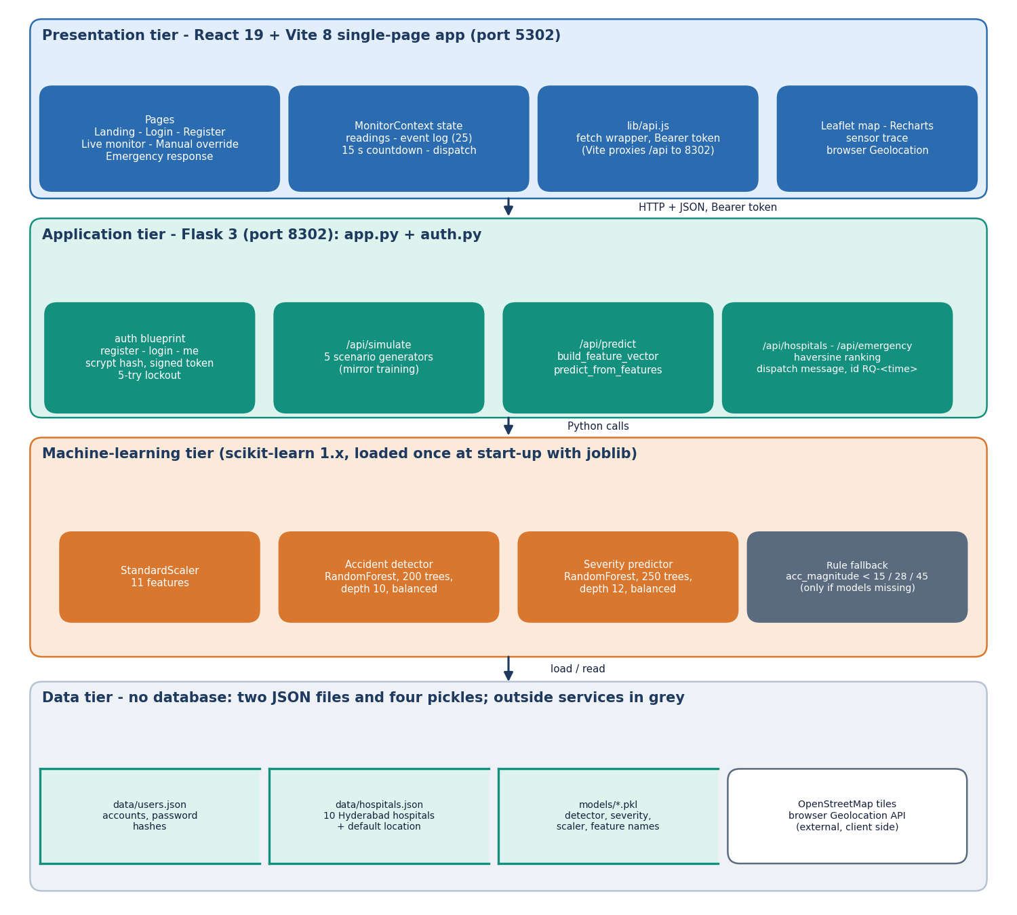
Figure 1: Four-tier architecture of ResQAI: React console, Flask API, machine-learning tier and file-based data tier.
The tiers talk only in one direction through narrow interfaces. The browser sends JSON over HTTP and, when the optional guard is on, a signed Bearer token; the Vite development server proxies every /api request to the Flask port, which removes the need for cross-origin settings. The Flask process calls the models through ordinary Python calls. The only outside services are OpenStreetMap map tiles, which the Leaflet map requests from the browser, and the browser's own Geolocation API; neither is part of the server.
Table 18: Technology used by tier
Tier | Technology | Role
Presentation | React 19, Vite 8, React Router 7, Recharts, Leaflet, framer-motion, GSAP | pages, sensor chart, map, animations, theme
Application | Python 3.11, Flask 3.1, itsdangerous, werkzeug.security | REST endpoints, accounts, signed tokens
Machine learning | scikit-learn (RandomForestClassifier, StandardScaler), NumPy, pandas, joblib | detection, severity grading, persistence
Data | JSON files (users.json, hospitals.json), pickles (models/) | accounts, hospital directory, trained models
Tooling | Playwright, scripts/smoke_test.py, scripts/run_tests.py | screen capture, regression and security checks

5.2 High-Level Workflow
The figure below follows one event through the system. A reading of eleven features is produced; in a deployment the phone would supply it, here the backend's /api/simulate does. The reading is posted to /api/predict, where it is turned into a feature vector, scaled, and passed to the detector and the severity model. The browser then applies the rule that decides whether a person must be asked: only a Moderate or Severe grade opens the confirmation dialog, and a Minor crash or a normal reading is only written to the event log.
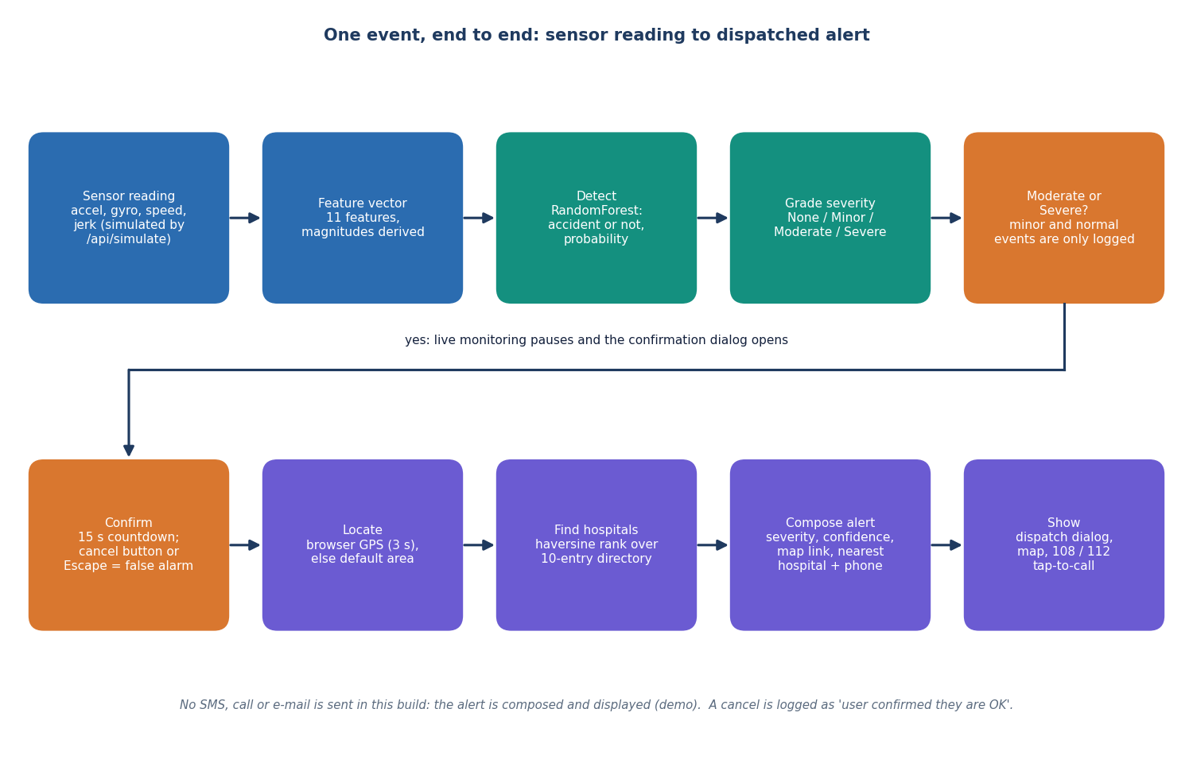
Figure 2: High-level workflow of one event, from the sensor reading to the dispatched alert.
The numbered steps below are the behaviour of the console, taken from MonitorContext.jsx:
1. The occupant presses a scenario button, starts live monitoring (one reading every 1.5 seconds, never two requests in flight) or submits manual values.
2. The reading is sent to POST /api/predict; the response (accident flag, severity label, probability, the features used, the model source) is stored as the current result, a point is added to the sensor trace (the last 40 are kept) and a line is added to the event log (the last 25 are kept).
3. If the label is Moderate or Severe and no alert is already pending, the result becomes the pending alert, live monitoring is stopped, and a dialog with a countdown from 15 seconds opens.
4. The occupant can answer I'm fine, cancel or press Escape; either counts as a response, the pending alert is cleared and the event log records that the user confirmed they are all right.
5. If the counter reaches zero, or the occupant presses Send alert now, the browser asks for its position (three-second timeout) and posts the severity, the confidence and, when known, the latitude and longitude to POST /api/emergency.
6. The server ranks the hospitals, composes the dispatch message and returns it with an alert id; the dispatch dialog opens, the Emergency response screen draws the map, and the event log records the alert.
Nothing leaves the machine in step 6. The dispatch message is drafted and shown, with a copy button and tap-to-call links for 108, 112 and 103, and the interface states that the demo does not contact responders. This is the main gap between the system as built and the sixth objective's wording about dispatching to emergency contacts, and it is repeated in the limitations.
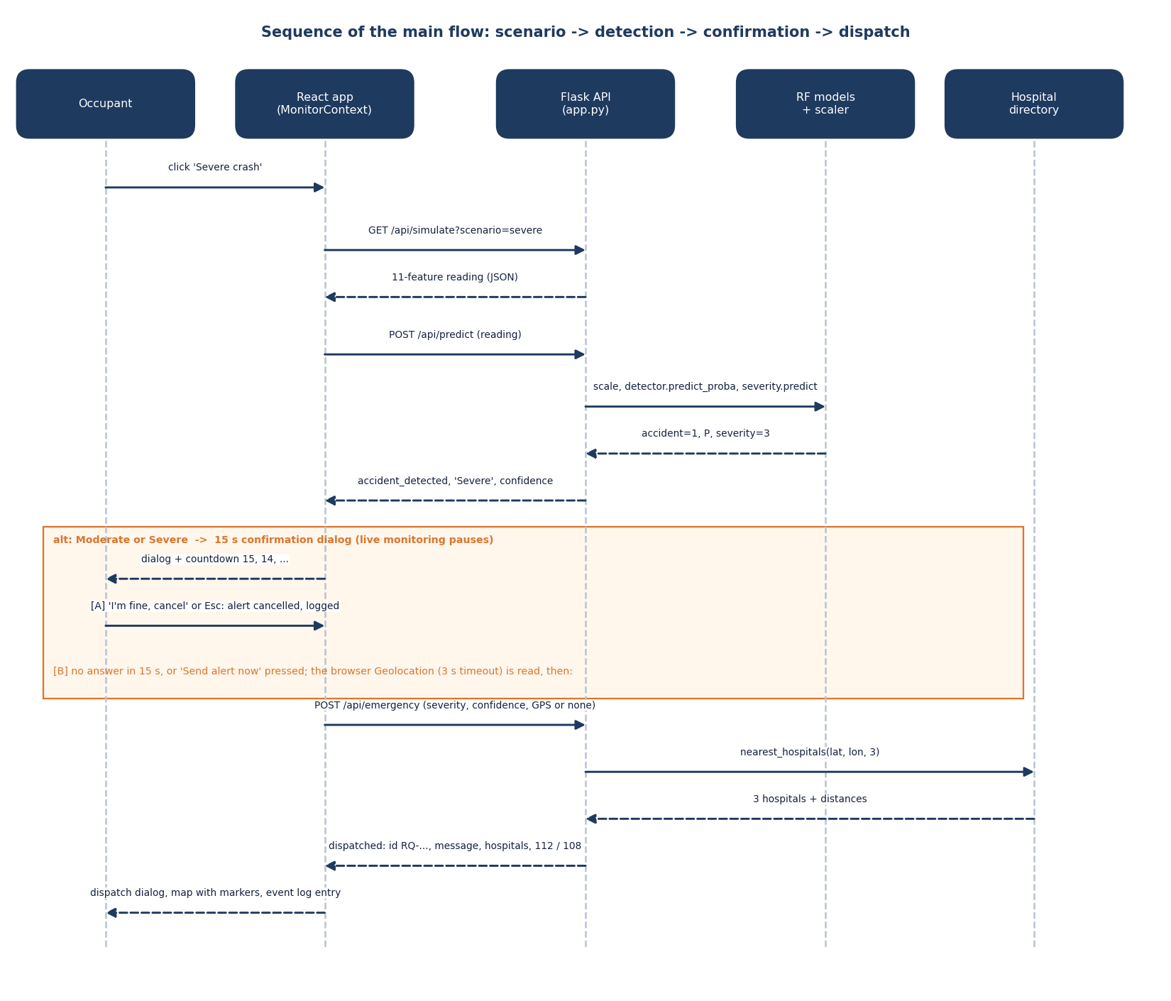
Figure 3: Sequence of the main flow: scenario, detection, confirmation and dispatch.
The sequence diagram shows the same flow as messages between the five parties. Two details are worth noting. First, the detector and the severity model are called inside one request, so the browser sees one consistent answer rather than two. Second, the location is read in the browser, not on the server: the server only receives numbers, and if the position is unavailable it substitutes a random point within about six kilometres of the default Hyderabad location, which keeps the demonstration working on a machine with no location service.

5.3 Data Flow Diagrams

5.3.1 Level 0 (context diagram)
At level 0 ResQAI is a single process with one human entity and two outside services. The occupant supplies credentials, a scenario or manual sensor values, and the cancel-or-send decision, and receives the detection result, the countdown, the dispatch message, the hospitals, the map and the event log. The Geolocation API returns the device coordinates and the tile server returns map images. The diagram also records what is not an entity: there is no phone supplying readings, no responder receiving the message and no hospital system; those three would be added in a deployment.
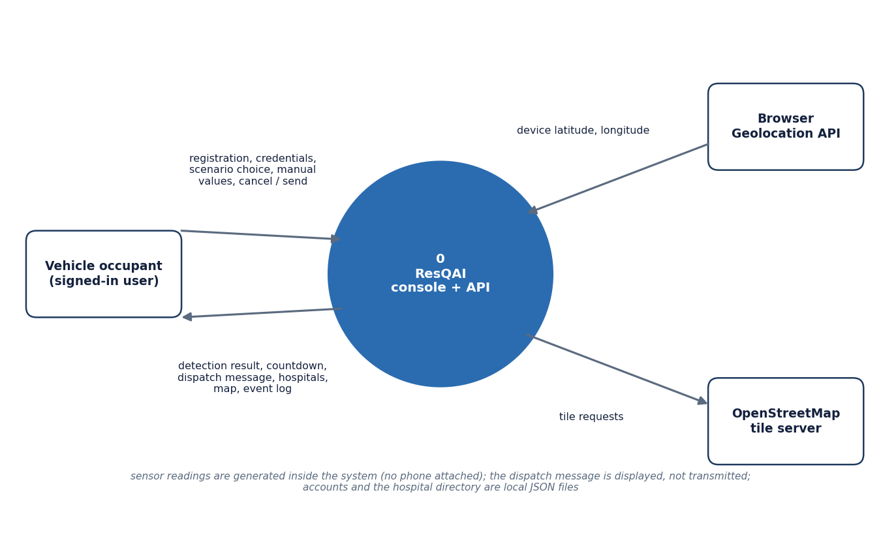
Figure 4: Context diagram (DFD level 0) of ResQAI with its user and the two outside services.

5.3.2 Level 1
Level 1 splits the system into six processes. Authentication (1.0) is the only process that touches the users file; it issues the signed token. Reading acquisition (2.0) produces the eleven-feature record either from the simulator or from the typed values. Detection and grading (3.0) reads the model pickles and returns the accident flag, the probability and the severity. Alert confirmation (4.0) is entirely client-side and is the human-in-the-loop step. Location and hospital ranking (5.0) reads the directory, and dispatch composition (6.0) builds the message. The three data stores are the users file (D1), the hospital directory (D2) and the model pickles (D3).
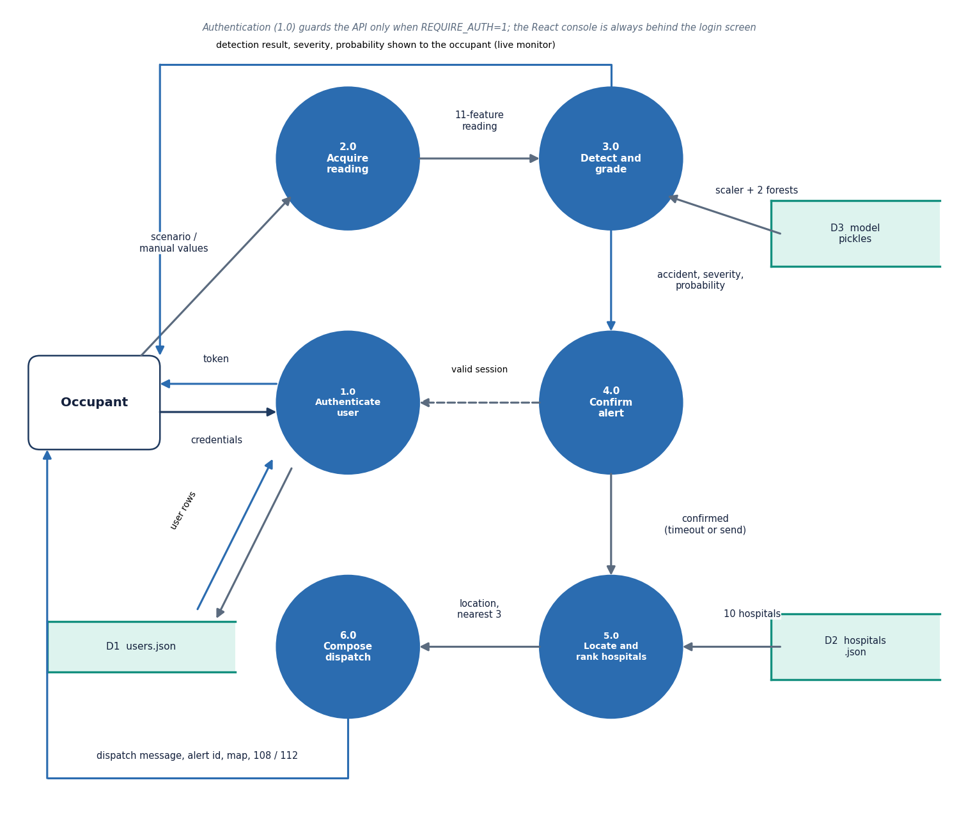
Figure 5: DFD level 1 of ResQAI: six processes and three data stores.

5.3.3 Level 2
Level 2 expands process 3.0, because it is where the machine learning happens and where the design makes its one non-obvious rule. The payload is completed with defaults (a missing acc_z becomes 9.81 m/s², a missing velocity field becomes zero) and the derived magnitudes are computed (3.1). The vector is scaled with the training mean and standard deviation (3.2). The detector (3.3) and the severity model (3.4) both receive the scaled vector; the gate (3.5) then forces the severity to None whenever the detector says no accident. Process 3.6, the rule-based fallback, is drawn dashed because it runs only when the model files cannot be loaded.
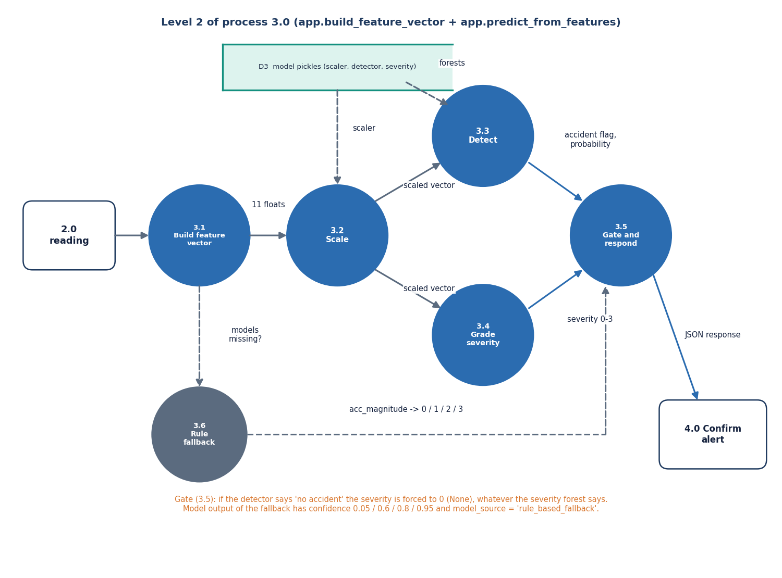
Figure 6: DFD level 2 of process 3.0: expansion of build_feature_vector and predict_from_features.

5.4 UML Diagrams

5.4.1 Class diagram
The backend is written as functions in two modules rather than as application classes, so the class diagram is a design-level view of the objects those functions pass around. SensorReading is the eleven-feature record built by build_feature_vector; Prediction is the response of /api/predict; EmergencyAlert is the response of /api/emergency. All three are transient and exist as JSON. RandomForestClassifier appears once in the diagram but twice at run time: the detector (200 trees, depth 10) and the severity model (250 trees, depth 12). StandardScaler is shared. HospitalDirectory wraps the ten-entry JSON file with the great-circle distance and the nearest-k selection. On the client, MonitorProvider is the state machine; AuthService and User describe auth.py and the accounts file.
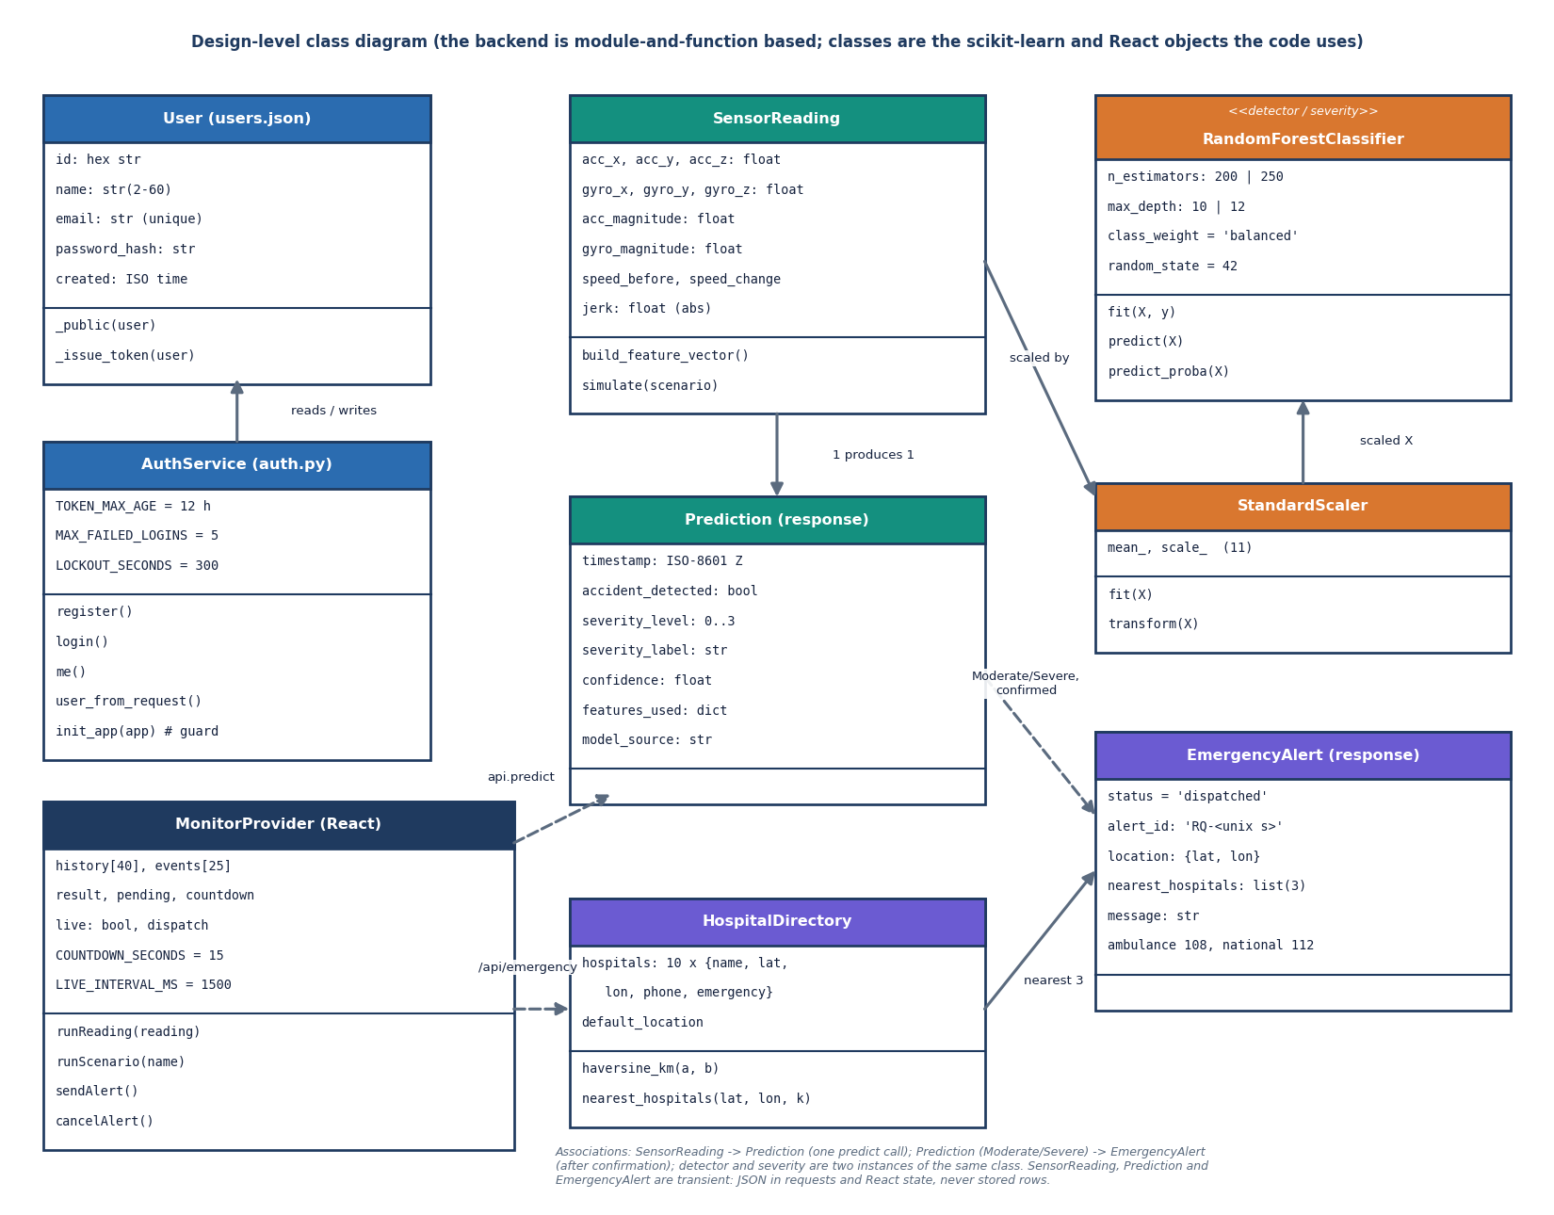
Figure 7: Design-level class diagram of ResQAI: data classes, the two scikit-learn model objects, the hospital directory and the React state provider.

5.4.2 Use-case diagram
The occupant is the only interactive actor. The developer actor covers activities that happen on the command line: retraining the models with train_models.py, switching the API guard on with REQUIRE_AUTH=1, and running the test and measurement scripts. The two external services support the location and map use cases. The table after the diagram expands the eight use cases.
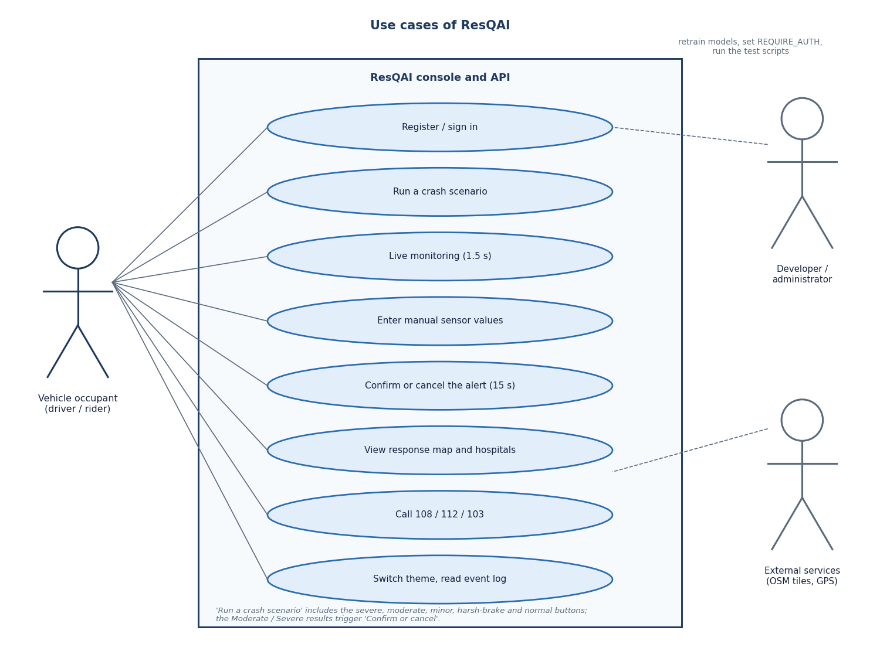
Figure 8: Use cases of ResQAI for the vehicle occupant, the developer and the external services.
Table 19: Use cases of the occupant
ID | Use case | Pre-condition | Main flow | Outcome
UC1 | Register / sign in | none | Enter name, e-mail, password (8 to 128 characters); receive a token | console unlocked; five wrong passwords lock the account for 5 minutes
UC2 | Run a scenario | signed in | Press Normal, Harsh brake, Minor, Moderate or Severe | result panel, trace point and log line; countdown for Moderate / Severe
UC3 | Live monitoring | signed in | Switch on; one random reading every 1.5 s | stops itself when a countdown opens or the API fails
UC4 | Manual override | signed in | Type seven values (client-side range checks), run detection | result for a hand-made reading; derived acc. magnitude shown before the run
UC5 | Confirm or cancel | a Moderate / Severe result | Cancel, press Escape, send now or let 15 s expire | alert cancelled and logged, or dispatched
UC6 | View response map | signed in | Open the Emergency response screen | hospital directory before an alert; accident and 3 nearest hospitals after it
UC7 | Call emergency numbers | none | Tap 108, 112 or 103 | the device dialler opens (tel: link)
UC8 | Theme and log | none | Toggle light / dark; read the last 25 events | preference kept in local storage

5.5 Data Design
ResQAI has no relational database, and the report does not draw one. The data design follows from what must survive a restart. Only three things must: the accounts, the hospital directory and the trained models. Everything produced while the console is in use, namely readings, predictions and alerts, is transient. This is an honest simplification for a demonstration and one of the first things a production version would change.
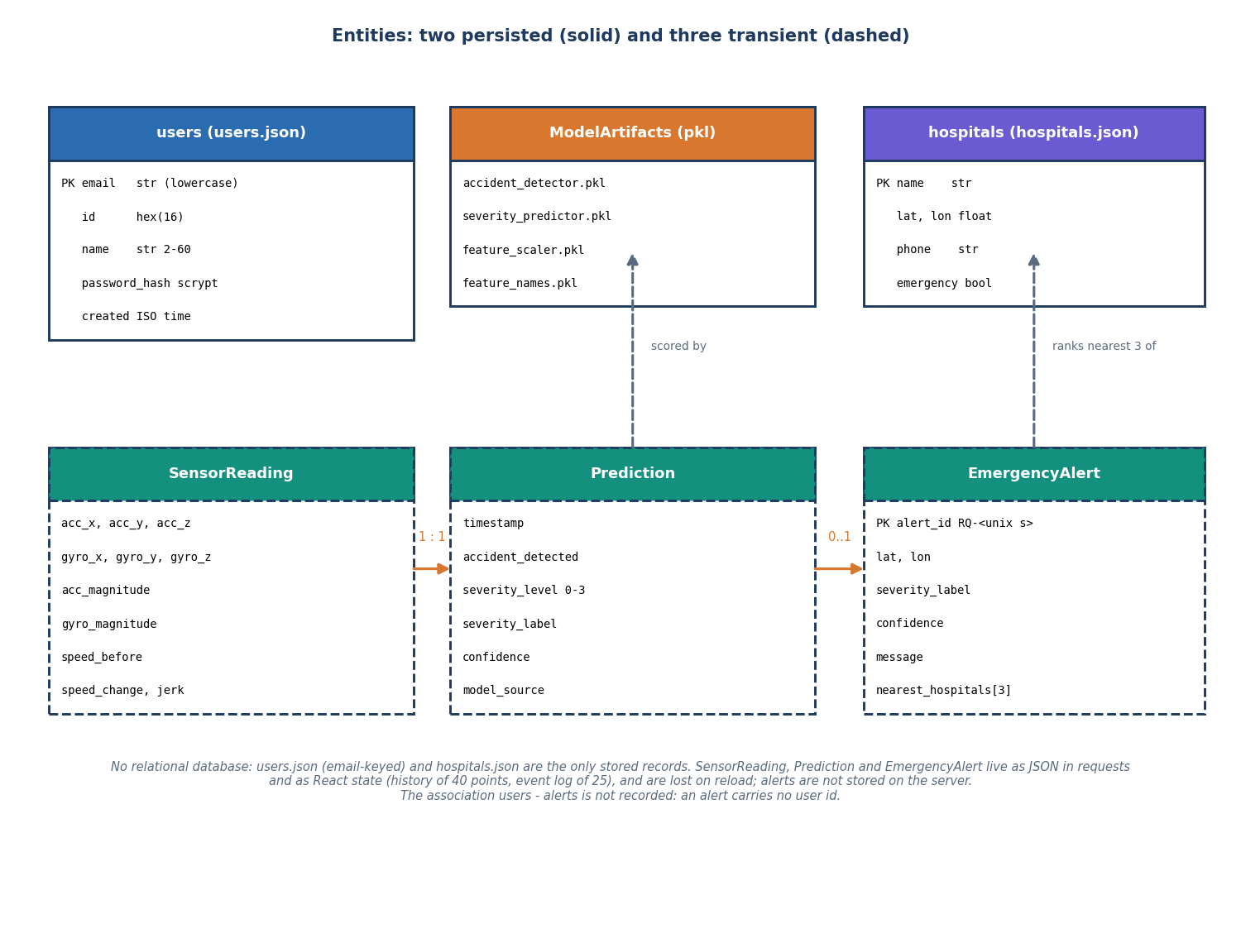
Figure 9: Entities of ResQAI: two persisted records, the model files, and three transient run-time entities.
Table 20: Persisted records
Store | Key | Fields | Size / count
data/users.json | lower-case e-mail | id (16 hex), name (2 to 60), email, password_hash (scrypt:32768:8:1), created (ISO time) | grows with sign-ups; written atomically through a temporary file and os.replace under a lock
data/hospitals.json | name | lat, lon, phone, emergency flag; plus default_location (Hyderabad, 17.3850, 78.4867) | 10 hospitals
models/accident_detector.pkl | - | RandomForest, 200 trees, depth 10 | 385.5 KB
models/severity_predictor.pkl | - | RandomForest, 250 trees, depth 12 | 2,608.2 KB
models/feature_scaler.pkl, feature_names.pkl | - | StandardScaler (11 means and scales); the ordered list of 11 feature names | 0.8 KB and 0.1 KB

The three transient entities are shown dashed in the figure. A reading is the JSON body of one request; a prediction is its response; an alert is the response of /api/emergency. The browser keeps the last 40 trace points and the last 25 log lines in React state, and the current dispatch, so a page reload empties them. Two consequences follow and are recorded as limitations: the server keeps no history of events, and an alert carries no user id, so alerts cannot be tied to an account. The failed-login counters used for the lockout are also only in memory and reset when the server restarts.
The reasons for the design are practical. A JSON file for ten hospitals is easier to read and edit than a table, and swapping it for a call to a hospital-search service changes one function. Accounts in a file are acceptable for a single-machine demonstration, and the write path is safe against a torn file because the new content is written to a temporary file and then renamed. A database such as SQLite or PostgreSQL, with tables for users, alerts and events and a foreign key from each alert to a user, is the obvious next step (Chapter 10).

5.6 Module Design
The delivered code is small and flat. The three Python modules of the product have about 553 non-blank lines, the React source about 3,377 lines of JSX, JavaScript and CSS, and the scripts written for testing and measurement about 922 lines. The table below lists each module with its responsibility and its main entry points.
Table 21: Modules and their responsibilities
Module | Responsibility | Main functions or components
app.py | REST API, helpers, model loading | build_feature_vector, predict_from_features, rule_based_fallback, haversine_km, nearest_hospitals, random_nearby_point; routes /, /api/predict, /api/simulate, /api/hospitals, /api/emergency, /api/health
auth.py | accounts and the optional API guard | register, login, me, status, user_from_request, init_app (the before_request guard); in-memory lockout table
train_models.py | synthetic data and training | make_event, generate_dataset, main (split, scale, fit, report, joblib.dump)
frontend/src/state/MonitorContext.jsx | client state machine | runReading, runScenario, live-monitoring interval, sendAlert, cancelAlert, countdown effects
frontend/src/lib/ | client infrastructure | api.js (fetch wrapper, token), auth.jsx (session, 401 handling), theme.jsx, format.js (scenarios, severity colours, emergency numbers), storage.js
frontend/src/pages/ | screens | Landing, Auth (login and register), Monitor, Manual, Response, NotFound
frontend/src/features/ | reusable parts | ResultPanel, SensorChart, EventLog, AlertOverlays (countdown and dispatch dialogs), MapView (Leaflet), ContactsCard, ApiError
scripts/ | verification | smoke_test.py, run_tests.py, measure_metrics.py, measure_api.py, capture_screens.py, capture_extra_screens.py
templates/, static/ | the original single-page dashboard | served at /; still works beside the React console

`app.py` is organised in three layers: loading (the models and the hospital file are read once, inside a try that falls back to the rule engine), pure helpers that can be tested without a server, and thin route functions that only read the request, call a helper and return JSON. The helper build_feature_vector is the single place where the payload is normalised, so the manual form, the simulator and a future phone client all pass through the same code. `auth.py` keeps the accounts file and the signing serializer private and exposes a blueprint; its init_app registers a before_request hook that, only when REQUIRE_AUTH is set, rejects any /api/ request except health and the auth routes unless a valid token is present. `MonitorContext.jsx` is the largest client module and the only one with logic that matters for safety: it decides when a countdown starts, stops live readings under an open dialog, cancels on Escape and calls the dispatch endpoint exactly once.

5.7 Algorithm Design
The core algorithm is the function predict_from_features and the client-side rule that follows it. The flowchart below shows it. In words: build the feature vector, check that the models are loaded, scale the vector, ask the detector for the class and the probability of an accident, ask the severity model for the grade, and set the grade to None if the detector said no. Only after the response reaches the browser does the confirmation rule apply: open the 15-second countdown when the grade is Moderate or Severe.
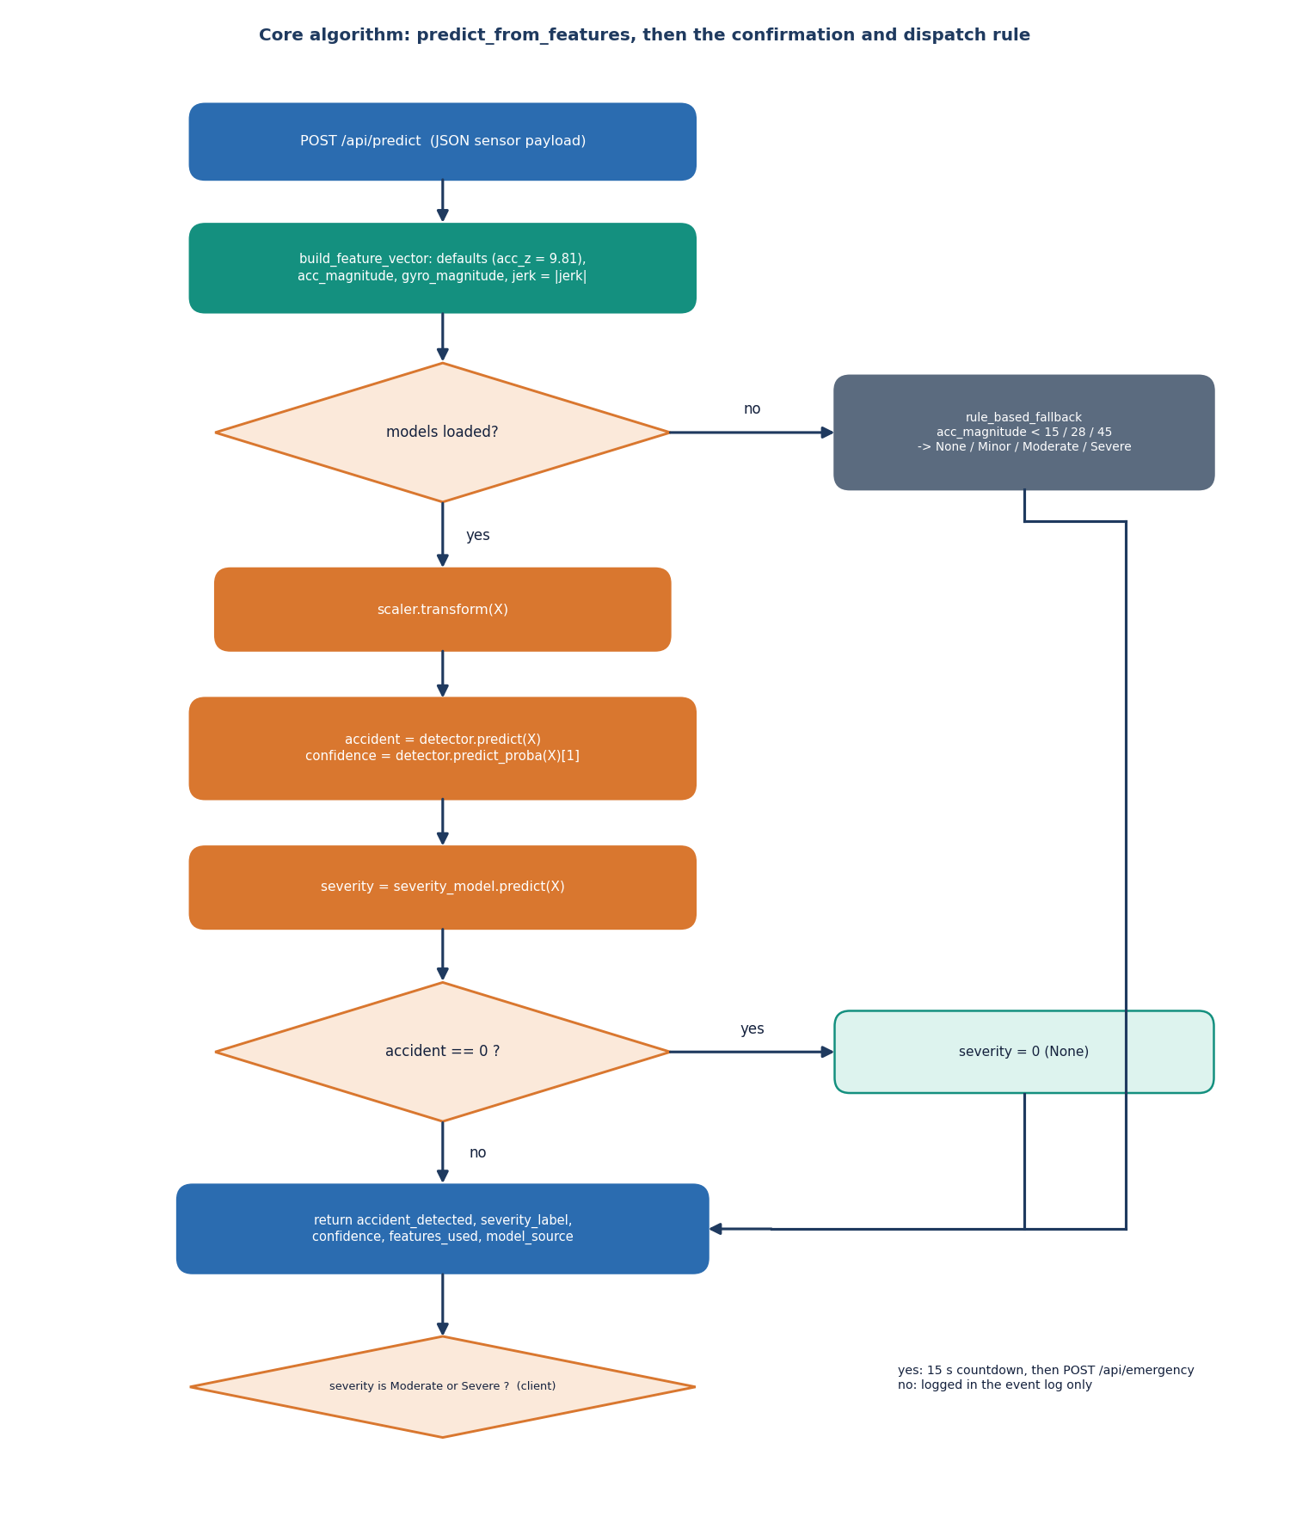
Figure 10: Flowchart of predict_from_features and the client-side confirmation rule.
The gate is deliberate. The severity forest is trained on all events with None as class 0, so it can also say None; the detector is trained on the binary label. Letting the detector override the severity means that the two models can never contradict each other in the response (an event reported as no accident always has severity None), and it gives one place to adjust the system's willingness to alert. On the 2,400 held-out events the gate changes nothing, because the severity model alone gives the same accuracy (99.958%); it matters when the two models would disagree, for example under noise.
The offline training pipeline is a separate algorithm, run once. It generates the data, splits it, fits the scaler on the training part only, trains the two forests with balanced class weights, prints the held-out accuracy and report, and writes the four pickles.
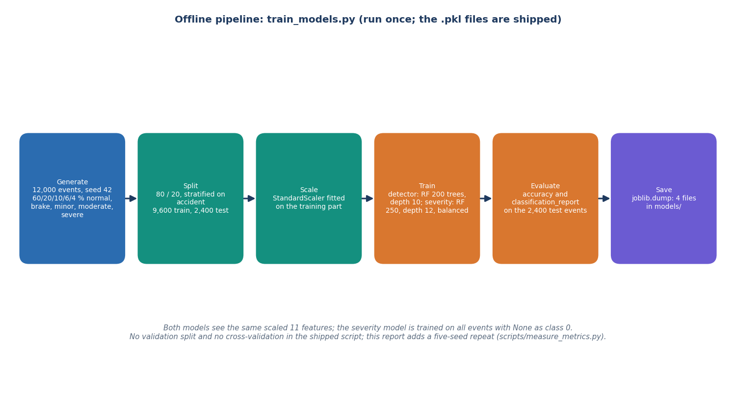
Figure 11: Offline pipeline of train_models.py: generate, split, scale, train, evaluate, save.

5.8 User Interface Design
The interface is a React console in a neo-brutalist visual style: heavy outlines, flat colour blocks, a lime accent and a coral accent reserved for danger, with a light and a dark theme that is remembered between visits. Colour is never the only carrier of meaning: every severity is also a text badge, the result headline says No accident or Accident detected, and the countdown is a large numeral with a progress bar. The countdown dialog is a real dialog with a focus-first I'm fine, cancel button, a polite live-region announcement of the remaining seconds, and an Escape-to-cancel rule, so keyboard and screen-reader users can answer in time.
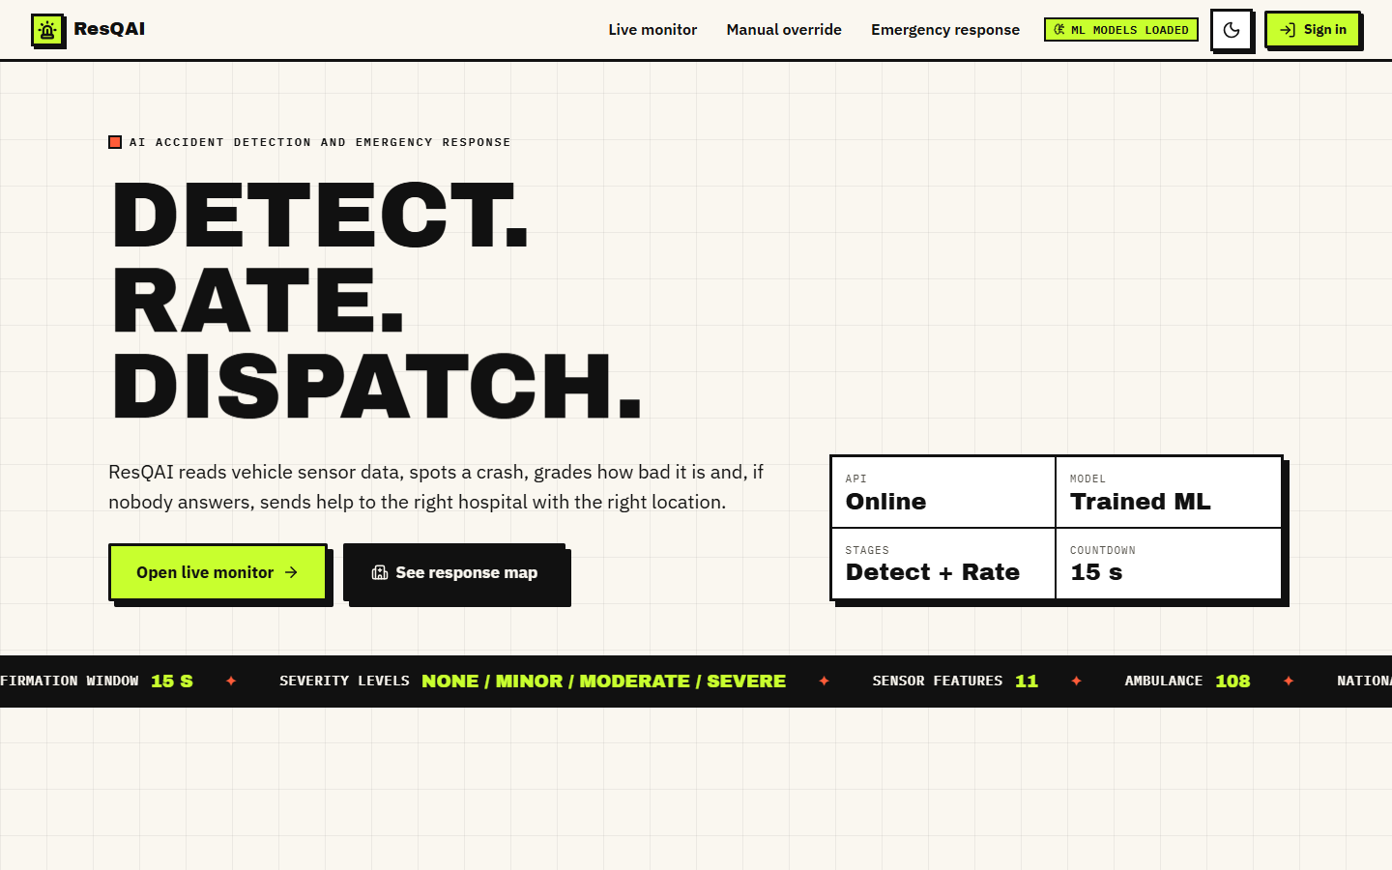  Figure 12: Landing page, light theme. | 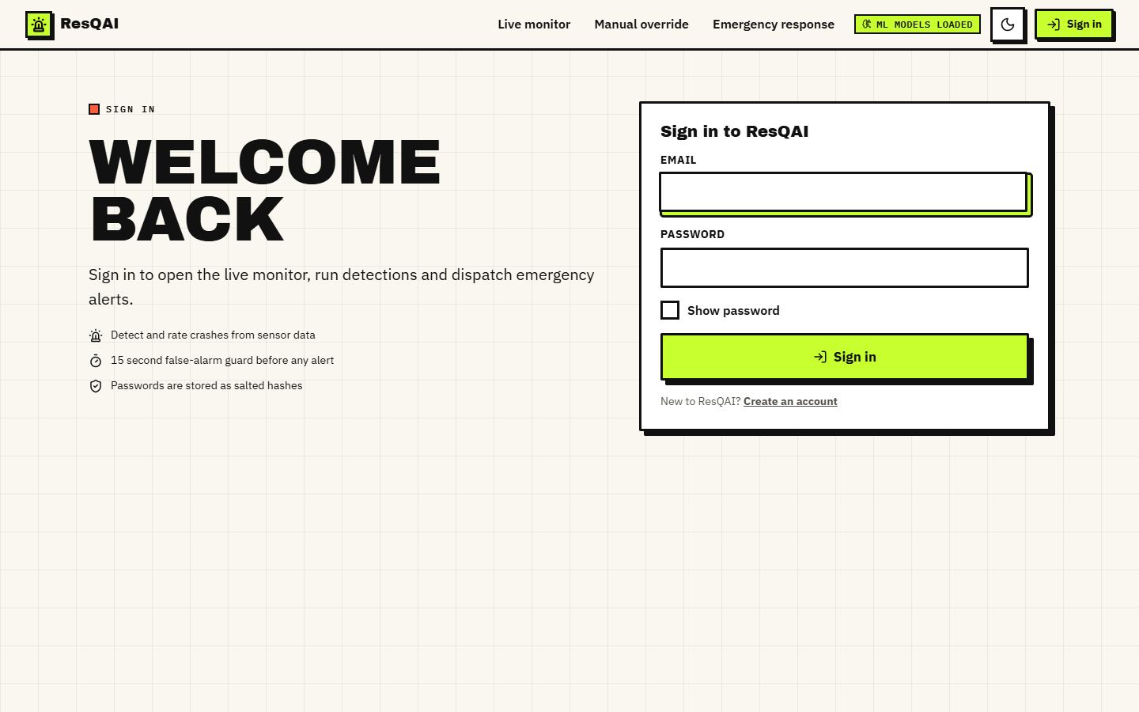  Figure 13: Sign-in form: the console is locked until an account signs in.

The landing page explains the pipeline in five steps (Five steps, no hand-offs) and links to sign-in. The three console screens sit behind the login: a signed-out visitor who opens /monitor is redirected to /login and returned to the page afterwards. Navigation is a left rail on wide screens; below 1,024 pixels the style sheet switches to a bottom bar (not captured as a screenshot in this report).
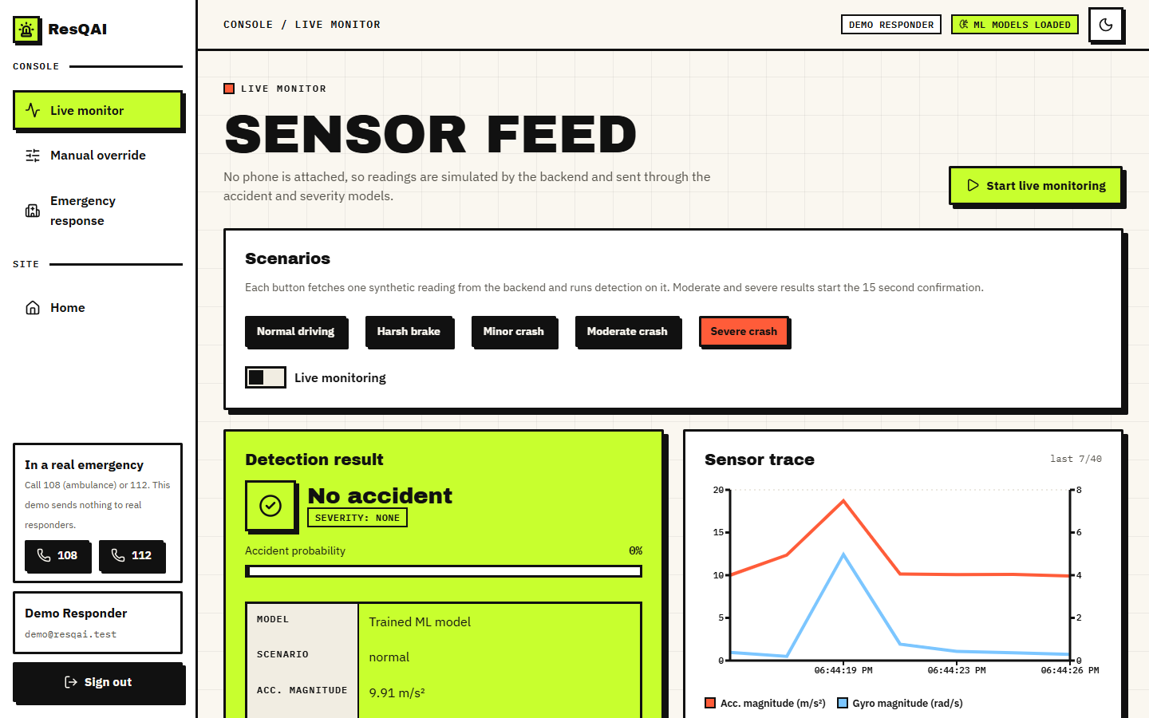  Figure 14: Live monitor: scenario buttons, live switch, detection result and the sensor trace. | 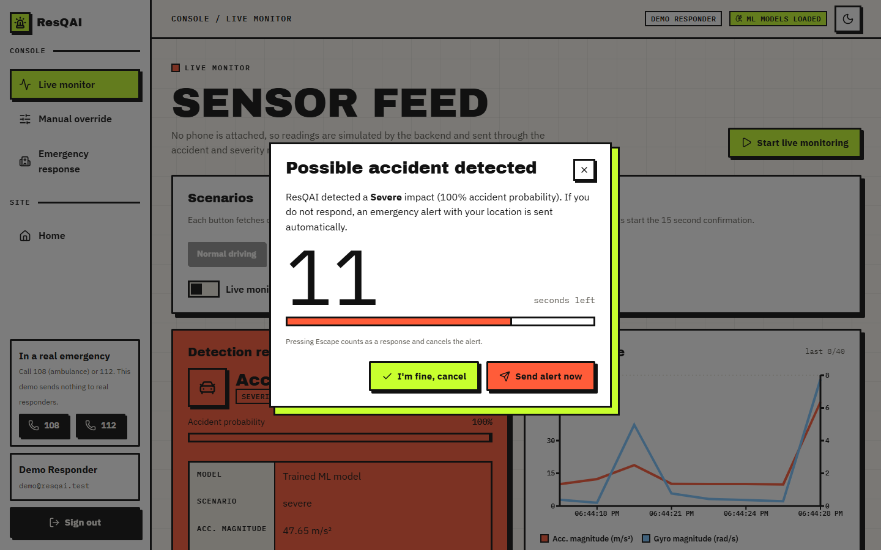  Figure 15: Confirmation dialog for a Severe result with 11 seconds left.

The Live monitor has three zones: the scenario buttons and the live-monitoring switch; the detection result (headline, severity badge, accident probability bar and a key-value table of the features used); and the sensor trace, a two-axis line chart of acceleration magnitude (m/s²) and gyroscope magnitude (rad/s) over the last 40 readings, followed by the event log. The Manual override screen has seven fields (three accelerations, gyroscope magnitude, speed before, speed change, jerk) with range checks in the browser, a live display of the derived acceleration magnitude, a Load simulated sample button and Reset.
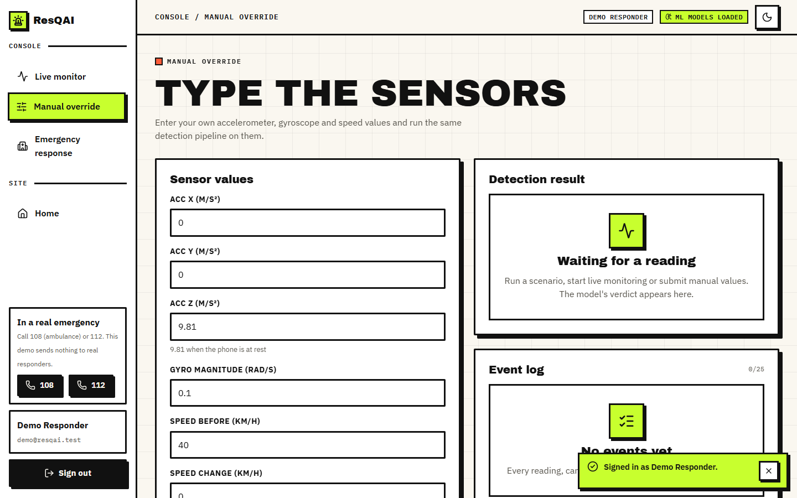  Figure 16: Manual override: seven inputs and the derived acceleration magnitude. | 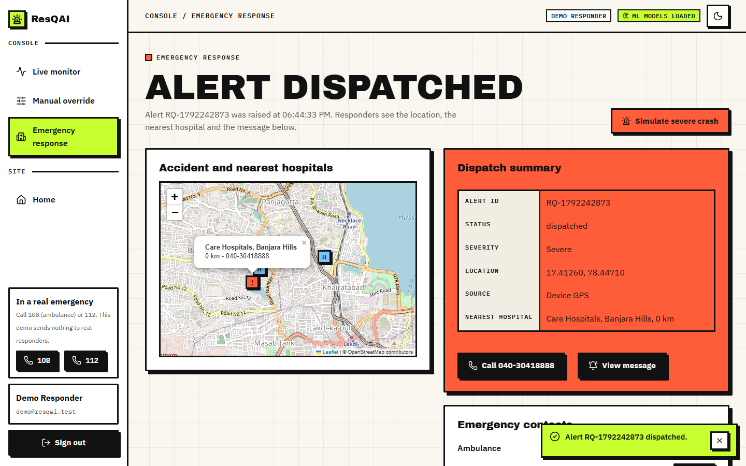  Figure 17: Emergency response after a dispatch: map, dispatch summary and nearest hospital.

The Emergency response screen shows the hospital directory around the default area before any alert, and after a dispatch it plots the accident position and the three nearest hospitals on an OpenStreetMap layer, with a summary table (alert id, status, severity, location, source, nearest hospital), a Call button for the nearest hospital, a View message dialog with a copy button, and the three emergency numbers. A banner inside the dispatch dialog says that the message is drafted but not sent.

5.9 Design Decisions and Trade-offs
Table 22: Main design decisions
Decision | Alternative | Reason for the choice | Cost
Two random forests (detect, grade) | one 4-class model; a neural network | forests need no feature engineering beyond magnitudes, train in seconds on a CPU, give a probability and have importance scores [21] | cannot extrapolate; ~2.6 MB for the severity model
Detector gates the severity | trust the severity model alone | the response can never say no accident with a severity other than None | one more rule to explain
Confirmation window of 15 s, client-side | alert at once; longer window | gives a conscious occupant time to stop a false alarm; short enough for a real emergency | an unconscious occupant delays the alert by 15 s
Only Moderate / Severe start the countdown | also Minor | Minor crashes would interrupt the driver; they are logged | a Minor crash with a hurt occupant is not escalated
Simulated sensors served by the backend | a real phone app | no hardware or recordings were available; the simulator mirrors the training generator so the demo is repeatable | results say nothing about real sensors
JSON files instead of a database | SQLite / PostgreSQL | ten hospitals and a handful of accounts; zero set-up | no event history, no alerts per user, no concurrency control beyond one lock
Haversine ranking of a 10-hospital directory | routing distance; a places API | closed form, no network [25]; adequate for a demo | straight-line distance ignores roads, traffic and capacity
Signed tokens, optional guard | mandatory guard; server sessions | keeps the original dashboard working; tokens are stateless and expire in 12 h | the guard is off by default, so a default install exposes the API to the local network
Flask development server | gunicorn / waitress | single command start-up on Windows | not a production server; debug=True must be off outside a demonstration

5.10 Quality Attributes
Performance. On loopback, /api/predict takes a mean of 26.2 ms (95th percentile 37.8 ms) and the three-call alert path takes a mean of 56.4 ms; the model call alone takes 14.0 ms in process. The 15-second confirmation window therefore dominates the time to an alert by more than two orders of magnitude, which is the intended trade. The numbers were measured with the Flask development server on a machine that was short of memory (Chapter 7).
Reliability. The application starts and answers without the model files, using the rule-based fallback; the front end shows an explicit Cannot reach the ResQAI API banner with a retry button instead of a blank screen, stops live monitoring on the first failure and logs the error. Security. Passwords are stored as scrypt hashes, tokens are signed and expire after 12 hours, repeated failures lock an account, and the guard can be switched on for the whole API; Chapter 6 lists the validation gaps that the tests found. Usability. One-click scenarios, an Escape key that answers the countdown, tap-to-call links and light and dark themes keep the console usable under stress. Maintainability. The helpers in app.py are pure functions, the front end is split into pages, features and a small UI kit, and every number in this report can be regenerated with three scripts.

CHAPTER 6: METHODOLOGY AND SOFTWARE IMPLEMENTATION

6.1 Overall Methodology
The method has two halves. The first half is what the product does: a reading of eleven features is classified as crash or not, graded, confirmed by the occupant and turned into a located alert. The second half is how the claims about it were checked, because the project shipped without any evaluation: no metrics file existed, so every number in this report was measured afresh by three scripts written for the purpose. The method, in order, is:
1. Define the event and the features. A crash is a short, large acceleration and rotation spike with a speed drop; harsh braking and normal driving are the look-alikes. Eleven features describe an event (Table below).
2. Generate the data. train_models.py draws 12,000 synthetic events of five kinds with a fixed seed (42); there are no real recordings.
3. Split and scale. An 80/20 split stratified on the accident label gives 9,600 training and 2,400 test events; a StandardScaler is fitted on the training part only.
4. Train two random forests. One predicts accident / no accident, the other predicts the four-level severity; both use balanced class weights.
5. Serve them. app.py loads the pickles once, builds the feature vector of each request, applies the detector-gates-severity rule and returns the label, the probability and the features used.
6. Confirm and dispatch. The browser opens a 15-second countdown for Moderate and Severe results; on expiry it reads the position, ranks the hospitals by great-circle distance and composes the dispatch message.
7. Measure. The shipped pickles are scored on the held-out 2,400 events and compared with a fresh retrain; a five-seed repeat, four baselines, feature ablations, a noise sweep, a threshold sweep and two out-of-distribution probes follow; the API is timed and 55 unit, edge-case and security checks are run.
The base paper follows a different method for a different problem: it trains a multi-task FT-Transformer with an uncertainty-weighted loss on 30,442 police-reported crash records to predict injury, fatality and property-loss severity after the event [1]. ResQAI shares only the idea of grading severity; its input is a motion-sensor reading, its output is an alert decision, and its models are far smaller (Section 6.4).

6.2 Dataset
Source and licence. The dataset is generated by make_event and generate_dataset in train_models.py; it is self-made, has no external source and no licence restriction. Re-running the generator with numpy.random.seed(42) reproduces the same 12,000 rows, which the measurement script verified. The README describes the data as "crafted to resemble the documented sensor characteristics of real crashes"; this report treats it as exactly what it is, synthetic data whose classes were defined by the author of the generator. No smartphone recording, vehicle log or public crash-sensor corpus was used, so the first objective (collect smartphone data) is met only in the sense of a generator for the features.
Composition. Events are drawn from five kinds with probabilities 0.60, 0.20, 0.10, 0.06 and 0.04. Of the 12,000 rows, 19.89% are crashes. The accident label is 1 for the three crash kinds; the severity label is 0 for normal driving and harsh braking and 1, 2 and 3 for the three crash kinds.
Table 23: Composition of the synthetic dataset
Event kind | Events | Share | In the test split | Severity label
normal driving | 7,289 | 60.7% | 1,463 | 0 (None)
harsh braking | 2,324 | 19.4% | 460 | 0 (None)
minor crash | 1,215 | 10.1% | 233 | 1 (Minor)
moderate crash | 725 | 6.0% | 156 | 2 (Moderate)
severe crash | 447 | 3.7% | 88 | 3 (Severe)

Generator parameters. Every channel of every kind is drawn from a normal or uniform distribution (Table below). A crash spike has a magnitude drawn uniformly from a band that depends on the grade (15 to 28, 28 to 45, 45 to 80 m/s²) and a random direction in the horizontal plane, so that acc_x = m cos θ + noise and acc_y = m sin θ + noise; the vertical axis stays near gravity (9.81 m/s²) with a larger spread for harder crashes. Deceleration, rotation noise and jerk all grow with severity.
Table 24: Generator parameters per event kind (g = 9.81 m/s²; N = normal, U = uniform)
Channel | Normal driving | Harsh braking | Minor crash | Moderate crash | Severe crash
acc x, y (m/s²) | N(0, 0.4) | x N(-4.5, 1.2); y N(0, 0.6) | m cos θ, m sin θ, m ~ U(15, 28), noise 1.5 | m ~ U(28, 45), noise 2 | m ~ U(45, 80), noise 3
acc z (m/s²) | N(g, 0.3) | N(g, 0.5) | N(g, 2.0) | N(g, 3.0) | N(g, 5.0)
gyro x, y, z (rad/s) | N(0, 0.15) | N(0, 0.3) / 0.3 / 0.4 | N(0, 1.5) | N(0, 2.5) | N(0, 4.0)
speed before (km/h) | U(0, 80) | U(20, 100) | U(10, 60) | U(30, 90) | U(40, 140)
speed change (km/h) | N(0, 2) | -U(10, 35) | -U(10, 40) | -U(25, 55) | -U(45, 100)
jerk (absolute) | N(0, 0.5) | N(6, 2) | N(20, 5) | N(35, 8) | N(60, 12)

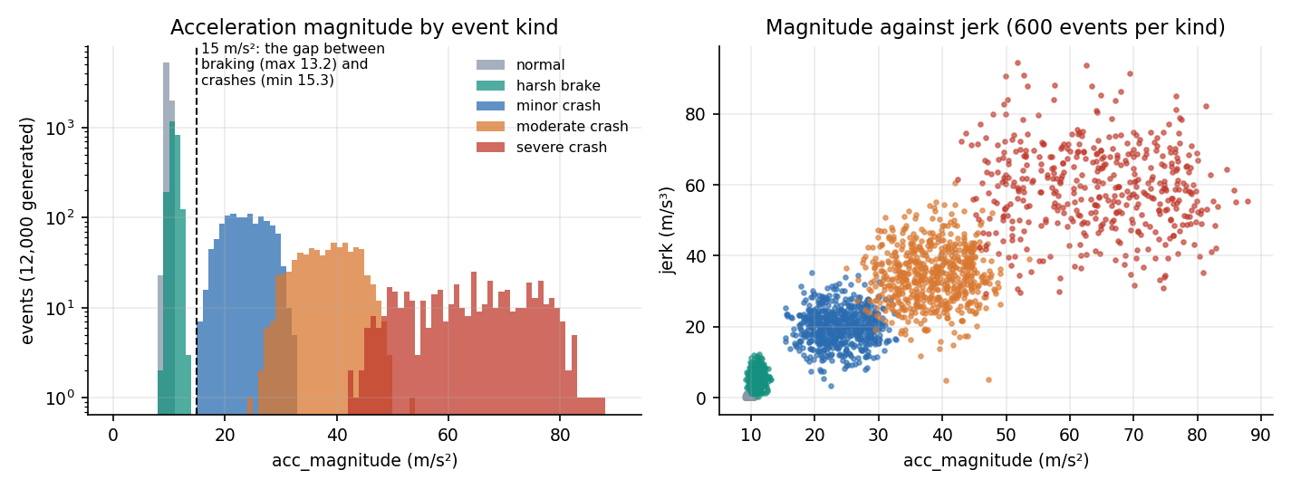
Figure 18: Distribution of acceleration magnitude by event kind (log scale) and magnitude against jerk: crashes sit well clear of harsh braking.
What the figure shows. Normal driving and harsh braking never exceed 13.2 m/s² in acceleration magnitude, whereas the weakest crash starts at 15.3 m/s²: a single threshold near 15 m/s² separates crash from non-crash with no error. The severity bands overlap only at their edges (minor and moderate between 24.9 and 32.8 m/s², moderate and severe between 42.4 and 53.6). This construction explains the near-perfect scores reported in Chapter 8 and is the most important thing to remember when reading them.
Split. train_test_split(test_size=0.2, random_state=42, stratify=accident) gives 9,600 training and 2,400 test events, of which 477 are crashes in the test part (233 minor, 156 moderate, 88 severe). There is no separate validation set and no cross-validation in the shipped script; the five-seed repeat of Chapter 8 compensates by regenerating the data and the split five times.
Contrast with the base paper. The base paper's data are proprietary police-reported records from one Chinese city (Dongguan, 2019 to 2023): 30,442 crashes split 19,483 / 4,871 / 6,088, with driver, vehicle, road and environment attributes and three severity targets [1]. The two datasets differ in origin (real versus generated), unit (a recorded crash versus a sensor event), features and labels, so no score on one can be compared with a score on the other.

6.3 Features and Preprocessing
A reading carries nine raw channels; two magnitudes are derived and the jerk is made non-negative, giving eleven features in a fixed order that is stored in feature_names.pkl so that training and serving can never disagree on column order.
Table 25: The eleven features
No. | Feature | Unit | Meaning | Raw or derived
1-3 | acc_x, acc_y, acc_z | m/s² | accelerometer axes; acc_z is about 9.81 at rest | raw
4 | acc_magnitude | m/s² | length of the acceleration vector | derived (or supplied by the client)
5-7 | gyro_x, gyro_y, gyro_z | rad/s | gyroscope axes (angular velocity) | raw
8 | gyro_magnitude | rad/s | length of the angular-velocity vector | derived (or supplied)
9 | speed_before | km/h | speed before the event (GPS) | raw
10 | speed_change | km/h | change in speed over the event; negative = slowing | raw
11 | jerk | not stated in code | rate of change of acceleration | raw, absolute value taken

Steps applied to every request (build_feature_vector): each field is read as a float; a missing acc_z defaults to 9.81 and every other missing field to 0, so an empty payload becomes a calm, stationary reading; acc_magnitude and gyro_magnitude are computed when the client does not supply them; jerk is replaced by its absolute value; and the values are arranged in the stored order. The React manual form sends the three accelerations, the gyroscope magnitude (carried on gyro_z, with gyro_x and gyro_y set to zero) and the three motion fields, and computes acc_magnitude itself.
Scaling. A StandardScaler is fitted on the 9,600 training rows and applied unchanged to the test rows and to every request, so that the test and serving data cannot influence the statistics. Random forests do not need scaling, and the scaler does not change their splits; it is kept because the pickled models were trained on scaled inputs and because it lets the logistic-regression baseline run on the same matrix.
Class imbalance. About one event in five is a crash and one in twenty is Severe or Moderate. Instead of resampling, both forests use class_weight='balanced', which weights each class by the inverse of its frequency. The base paper instead applies SMOTE with one neighbour to the training part [1, 23]; the two approaches have the same aim, and on this separable data the difference would not be measurable.
What is not done. There is no outlier clipping, no missing-value imputation beyond the defaults, no filtering of a raw accelerometer trace and no windowing: a reading is already a summary of an event. Turning a stream of raw 50 Hz samples into these summaries, and deciding when an event begins, is a necessary stage of a real smartphone application that this project did not build (Chapter 10).

6.4 Algorithm Choice and Justification
What was chosen. Two random forests [21] trained with scikit-learn [22]: a detector with 200 trees of depth at most 10 and a severity model with 250 trees of depth at most 12. A random forest averages many decision trees, each grown on a bootstrap sample with a random subset of features at every split; it handles features on different scales, captures interactions such as large acceleration and large speed drop, gives a probability that is used as the confidence, and exposes feature importances.
Why not a deep model. The base paper's FT-Transformer turns every feature into a token and applies self-attention [19], and weights its three tasks with learned uncertainties [20]. That machinery pays off on tens of thousands of heterogeneous, categorical-rich crash records. Here the input is eleven numeric channels with a clear physical meaning, the dataset is generated, and the deployment target is a phone or a small server; a transformer would add training cost, a larger artefact and a dependency on a deep-learning runtime without a measurable gain. The multi-task idea is kept in a simpler form: two models that share one scaler and one feature vector, joined by the gate.
What the comparison shows. To test whether the choice is justified, four alternatives were trained on the same split with the same scaled features. For the severity rows the detector gate is applied to every model, as in the application.
Table 26: Random forest against simpler models on the 2,400 held-out events
Model | Detector accuracy | Detector F1 | False alarms | Severity accuracy | Severity macro-F1
Rule thresholds on acc_magnitude | 1.0000 | 1.0000 | 0.00% | 0.9750 | 0.9122
Logistic regression | 1.0000 | 1.0000 | 0.00% | 0.9983 | 0.9946
Decision tree, depth 10 | 1.0000 | 1.0000 | 0.00% | 0.9988 | 0.9960
Histogram gradient boosting | 1.0000 | 1.0000 | 0.00% | 0.9996 | 0.9987
Random forest (ResQAI) | 1.0000 | 1.0000 | 0.00% | 0.9996 | 0.9987

Every model detects crashes perfectly, including the three-line threshold rule, which confirms that detection is not a hard problem on this data. The learned models earn their place on severity: the threshold rule loses about two and a half points of accuracy and almost nine points of macro-F1, while the forest, the tree and the boosted model are within a fraction of a point of each other and the histogram gradient-boosting model ties the forest. The forest is therefore a reasonable choice, not a uniquely best one; its advantages are the calibrated-looking probability, the absence of tuning and the interpretability, and a fair summary is that a boosted model or a decision tree would have served as well.

6.5 Mathematical Formulation
The quantities that the code computes are listed here in the order of the pipeline. With accelerations (aₓ, a_y, a_z) in m/s² and angular velocities (ωₓ, ω_y, ω_z) in rad/s, the derived features are
a = √(aₓ² + a_y² + a_z²) ω = √(ωₓ² + ω_y² + ω_z²) j = |j_raw| (1)
At rest only gravity acts, so a is about 9.81 m/s² and ω is about zero; the generator's normal-driving events have a between 8.7 and 10.9 m/s². Every feature xᵢ is then standardised with the training mean and standard deviation,
zᵢ = (xᵢ − μᵢ) / σᵢ, i = 1 … 11 (2)
A decision tree chooses, at each node, the feature and threshold that most reduce the Gini impurity of the class proportions pₖ in the node,
G(t) = 1 − Σₖ pₖ², ΔG = G(parent) − (n_L/n) G(L) − (n_R/n) G(R) (3)
With balanced class weights each training row of class c carries the weight w_c = n / (K · n_c), where n is the number of rows, K the number of classes and n_c the size of class c. A forest of T trees averages the class probabilities of its trees, so the detector's confidence is
P(accident | z) = (1/T) Σₜ pₜ(1 | z), T = 200, â = 1 if P(accident | z) ≥ 0.5 (4)
and the severity model returns the grade with the largest averaged probability over its T′ = 250 trees,
ŝ = argmaxₖ (1/T′) Σₜ p′ₜ(k | z), k ∈ {0 None, 1 Minor, 2 Moderate, 3 Severe} (5)
The detector gate, which is the only rule linking the two models, and the alert rule applied by the browser are
s* = 0 if â = 0, otherwise ŝ; alert ⇔ s* ≥ 2 (6)
When the model files are missing the fallback assigns s* from fixed bands of the acceleration magnitude, 0 below 15, 1 below 28, 2 below 45 and 3 otherwise, with confidences 0.05, 0.6, 0.8 and 0.95. To rank hospitals the server uses the haversine great-circle distance [25] between the crash position (φ₁, λ₁) and each hospital (φ₂, λ₂), with the Earth radius R = 6,371 km,
h = sin²(Δφ/2) + cos φ₁ cos φ₂ sin²(Δλ/2), d = 2R · arcsin(√h) (7)
and returns the k smallest distances, rounded to two decimals (three are returned in an alert). Finally, the quantities reported in Chapter 8 are defined in the usual way from the counts of true and false positives and negatives,
precision = TP/(TP+FP), recall = TP/(TP+FN), F1 = 2·precision·recall/(precision+recall), false-alarm rate = FP/(FP+TN) (8)
The macro-F1 of the severity model is the unweighted mean of the four per-class F1 scores, so that the small Severe class counts as much as the large None class.

6.6 Model Architecture and Training Configuration
Table 27: Hyper-parameters and training set-up
Item | Accident detector | Severity predictor
Algorithm | RandomForestClassifier | RandomForestClassifier
Trees / maximum depth | 200 / 10 | 250 / 12
Target | accident (0 / 1) | severity (0 None, 1 Minor, 2 Moderate, 3 Severe)
Class weights | balanced | balanced
Other settings | scikit-learn defaults (Gini, bootstrap, sqrt features per split) | scikit-learn defaults
Random seed | 42 | 42
Input | 11 standardised features | the same 11 features
Training rows | 9,600 | 9,600 (all events, None as class 0)
Stored size | 385.5 KB | 2,608.2 KB
Training accuracy / held-out accuracy | 1.000 / 1.000 | 1.000 / 0.99958

No hyper-parameter search was run; the values are those written in train_models.py. The training script is deterministic and takes seconds on a CPU; its training time was not measured separately. Training accuracy is 1.000 for both models and the held-out accuracy is the same for the detector and 0.99958 for the severity model, so there is no generalisation gap on this data, which again reflects the separability of the generated classes.
Environment caveat. The shipped pickles were written by scikit-learn 1.9.0, while the measurements in this report were run under 1.5.0, which prints an InconsistentVersionWarning on loading and states that the result may be invalid. The requirements.txt file lists scikit-learn without a version. To rule out a silent difference, the models were retrained with the same seed under 1.5.0; they agree with the shipped models on 100.00 percent of the 2,400 test events for the detector and for the severity grade, and they score identically. A pinned requirements file, or retraining at set-up time, would remove the risk.
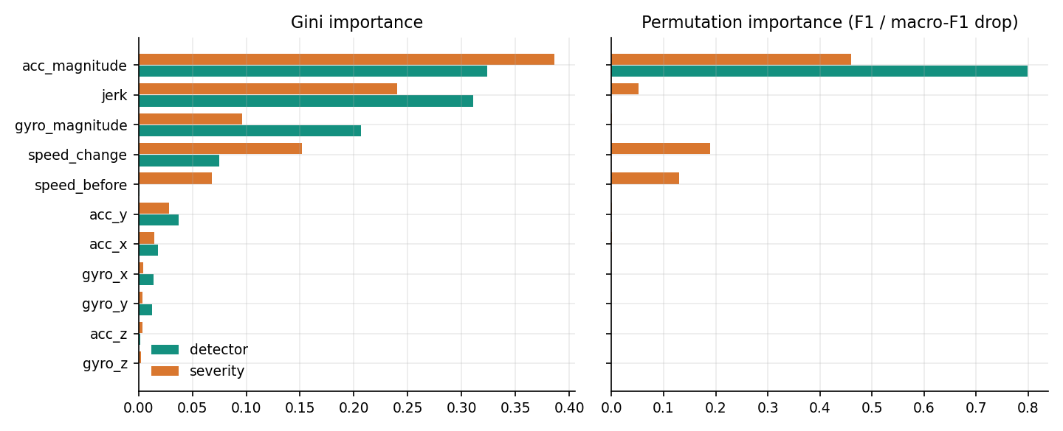
Figure 19: Feature importance of the detector and the severity model: Gini importance (left) and permutation importance (right).
What the models rely on. The Gini importance of the detector is spread over acc_magnitude (0.324), jerk (0.311) and gyro_magnitude (0.206), but permuting any feature other than acc_magnitude leaves the F1 score unchanged (0.798 drop for acc_magnitude, zero for the rest): the other features carry the same information, so the forest can lose them without harm. The severity model uses acc_magnitude (0.459 macro-F1 drop), speed_change (0.189), speed_before (0.130) and jerk (0.051). The gyroscope contributes nothing measurable here, because in the generator the rotation noise does not distinguish the classes beyond what acceleration already does; whether it would on real data is unknown.

6.7 Application Architecture and Implementation
Back end. app.py creates the Flask application, registers the auth blueprint, loads the four pickles and hospitals.json once at import time inside a try block, and defines the routes. The server is started with python app.py, which runs the Werkzeug development server with debug=True on the port in the PORT variable (8302 under run.bat); debug=True also starts a reloader process. Because the models are module-level objects, every request in the process shares them, and scikit-learn's predict calls are read-only, so no lock is needed around inference. The only shared mutable state is the accounts file, guarded by a threading.Lock, and the in-memory failed-login table.
Front end. The React source (about 3,377 lines) is a single-page application built with Vite. Pages are loaded lazily, so the map library, which is the heaviest dependency, is fetched only when the Emergency response screen is opened. The production build succeeds in about 3.6 seconds; its largest chunks are the line-trace chart (353 kB, 103 kB gzipped), the UI kit (346 kB, 121 kB gzipped), the entry chunk (219 kB, 70 kB gzipped) and the map view (150 kB, 44 kB gzipped). State lives in MonitorContext, which is mounted above the routes, so a countdown survives navigation between screens, and is remounted with a new key when the user signs in or out, so one user's readings and alerts never show for the next. Authentication state lives in lib/auth.jsx; a 401 response on any protected call signs the user out through a callback registered with api.js.
Key implementation techniques. (1) One request in flight: live monitoring uses a setInterval plus an in-flight flag, so a slow response never causes two overlapping predictions. (2) Single pending alert: a ref, pendingRef, is set when a Moderate or Severe result arrives and cleared on cancel or send, so a second severe result cannot open a second countdown and the alert is sent exactly once. (3) Countdown: an effect decrements a counter every second while an alert is pending, and a second effect calls sendAlert when the counter reaches zero. (4) Location: navigator.geolocation.getCurrentPosition with a three-second timeout, falling back to no coordinates, in which case the server chooses a point. (5) Graceful failure: a failed request sets an error state with a retry button and logs a Severe-toned line, instead of leaving the interface blank.

6.8 API Design
The API is JSON over HTTP with no versioning prefix. Responses use ordinary status codes; the auth routes return {error, field} for validation failures so that the form can mark the offending field.
Table 28: Endpoints
Method and path | Request | Response | Notes
GET /api/health | - | {status, models_loaded} | public, also when the guard is on
GET /api/simulate?scenario= | normal, brake, minor, moderate, severe or random | 11 features + scenario | unknown name falls back to a random scenario (weights 65 / 18 / 9 / 5 / 3 %)
POST /api/predict | JSON of the nine raw channels (magnitudes optional) | accident_detected, severity_level, severity_label, confidence, features_used, model_source, timestamp | empty body is a calm reading
GET /api/hospitals?lat&lon&k= | position, count | origin, hospitals[] with distance_km | default k = 3; the UI asks for 5
POST /api/emergency | severity_label, confidence, optional lat, lon | status, alert_id, location, nearest_hospitals[3], message, national_emergency_number 112, ambulance_number 108 | random point near the default area when no position is sent
POST /api/auth/register | name, email, password | token, user (201) | 400 with field, 409 for a duplicate
POST /api/auth/login | email, password | token, user | 401 wrong, 429 after 5 failures
GET /api/auth/me, /status | Bearer token / none | user / {auth_required} | 401 for an invalid or expired token

A real exchange, produced by calling the application with a hand-made moderate-crash reading, shows the shapes:
POST /api/predict
{"acc_x": 30.0, "acc_y": 22.0, "acc_z": 9.81, "gyro_x": 2.1, "gyro_y": -1.4, "gyro_z": 3.0,
"speed_before": 62, "speed_change": -48, "jerk": 36}

200 {"accident_detected": true, "severity_level": 2, "severity_label": "Moderate", "confidence": 1.0,
"model_source": "trained_ml_model", "timestamp": "2026-10-25T02:54:27Z",
"features_used": {"acc_magnitude": 38.47, "gyro_magnitude": 3.92, "jerk": 36.0, ...}}

POST /api/emergency {"severity_label": "Moderate", "confidence": 1.0, "lat": 17.4126, "lon": 78.4471}

200 {"status": "dispatched", "alert_id": "RQ-1792896867", "location": {"lat": 17.4126, "lon": 78.4471},
"nearest_hospitals": [{"name": "Care Hospitals, Banjara Hills", "distance_km": 0.0, ...},
{"name": "Rainbow Children's Hospital, Banjara Hills", "distance_km": 0.27, ...},
{"name": "Yashoda Hospitals, Somajiguda", "distance_km": 1.34, ...}],
"message": "ResQAI EMERGENCY ALERT / Severity: Moderate (confidence 100%) / Location: 17.41260, 78.44710 /
Google Maps: https://www.google.com/maps?q=17.41260,78.44710 /
Nearest hospital: Care Hospitals, Banjara Hills (0.0 km away, 040-30418888) /
No response received from occupant. Please dispatch assistance.",
"national_emergency_number": "112", "ambulance_number": "108"}

The example also shows a limitation of the directory: it has an emergency flag for every entry and no information on specialty, so a children's hospital is ranked as the second-nearest destination for an adult crash. The confidence field is the probability of the accident class, not of the severity grade, and the dispatch message presents it as the confidence of the grade; that wording would need to change in a deployment.

6.9 Security and Error Handling
Accounts. Registration accepts a name of 2 to 60 characters, an e-mail address matching a simple pattern (at most 120 characters) and a password of 8 to 128 characters. E-mail addresses are lower-cased, so duplicates are detected case-insensitively (HTTP 409). Passwords are hashed with werkzeug's generate_password_hash, whose current default is scrypt with parameters 32768, 8, 1 (the stored prefix is scrypt:32768:8:1) [27]; the plain password is never stored or returned. The accounts file is written to a temporary file and renamed, under a lock, so a crash cannot leave half a file.
Tokens and lockout. A successful login returns a token produced by itsdangerous.URLSafeTimedSerializer with the salt resqai-auth; it holds only the user id, is signed with a secret from the SECRET_KEY variable or a random 32-byte key generated once into data/.secret, and expires after 12 hours. Five failed logins for an e-mail address within five minutes make further attempts return HTTP 429 for the remainder of the window, even with the correct password; the counters are in memory, so a restart clears them and they are keyed by e-mail only, not by client address.
The API guard. REQUIRE_AUTH=1 makes a before_request hook reject every /api/ request, except /api/health and /api/auth/*, that has no valid Bearer token, and lets OPTIONS requests through. The default is 0 so the original dashboard keeps working. This means a default installation exposes the prediction and emergency endpoints to anyone who can reach the port, and app.run(host='0.0.0.0') makes that the whole local network; for any shared use the guard should be on and the server bound to the loopback address.
What the tests found. The 55 checks of scripts/run_tests.py (47 pass) include 18 security checks, all of which pass: unauthenticated calls refused, altered and non-Bearer tokens refused, no hash in any response, short and long inputs rejected, duplicate e-mail, lockout, stored hash format, ignored files and OPTIONS. The eight failures are all input-validation gaps in app.py and are listed below. None gives access to data, but several return HTTP 500 where a 4xx is correct, and two (the free-text severity label and the unchecked coordinates) let a client shape the dispatch message.
Table 29: Validation gaps found by the edge-case tests (not fixed; product code was left untouched)
Input | Observed | Expected | Effect
non-numeric field in /api/predict, e.g. acc_x: "abc" | HTTP 500 | 400 | float() raises; unhandled
JSON array as the body of /api/predict | HTTP 500 | 400 | payload.get on a list
non-numeric lat in /api/hospitals | HTTP 500 | 400 | unhandled ValueError
k=-1 in /api/hospitals | 200 with 9 of 10 hospitals | empty or 400 | Python slice [:-1]
lat=999, lon=999 | 200, distances computed | 400 | no range check
non-numeric confidence in /api/emergency | HTTP 500 | 400 | unhandled float()
free-text severity_label (e.g. with a line break) | copied into the dispatch message | one of the four labels | message can be shaped by the client
two alerts in the same second | same alert_id (RQ-<unix seconds>) | unique ids | ids are not unique

The remaining twelve edge-case checks pass: malformed JSON gives 400; an empty object, NaN, absurdly large values and a negative speed are answered without a crash; GET on a POST route gives 405; an unknown scenario falls back; k=0 returns an empty list and k=1000 is capped at the ten entries. Error handling in the browser: a network failure or a 5xx without a body becomes the banner Cannot reach the ResQAI API with a retry button, a 401 on a protected call signs the user out, and the dispatch step shows a toast with the reason if /api/emergency fails, leaving the alert unsent but visible in the log. A weakness is that a failed dispatch is not retried automatically.

6.10 Installation and Execution
The application targets Windows with Python 3.10 or later and Node.js 18 or later. First time: run setup.bat, which creates venv, installs requirements.txt (Flask, scikit-learn, joblib, NumPy, pandas), runs npm install in frontend/ and copies .env.example to .env. Every time: run run.bat, which checks that ports 8302 and 5302 are free, starts the API and the Vite server in two windows and opens http://localhost:5302; stop.bat ends both. The ports and REQUIRE_AUTH can be changed in .env. To retrain the models, run python train_models.py once; it overwrites the four files in models/.
Checks. With the application running, python scripts/smoke_test.py runs 33 checks through the Vite proxy (33 pass); python scripts/run_tests.py runs the unit, edge-case and security checks (it needs a second backend started with REQUIRE_AUTH=1 on port 8399); python scripts/measure_metrics.py and python scripts/measure_api.py regenerate the metrics and the latency files in experiments/resqai_eval/; python scripts/capture_screens.py and python scripts/capture_extra_screens.py capture the screens with Playwright. On the first run an account must be created on the Create an account screen; the documentation scripts use the demo account demo@resqai.test.
Practical notes found while running the project. The venv folder is not shipped, so setup.bat installs the newest scikit-learn, which may differ from the 1.9.0 that wrote the pickles; the Flask reloader starts a second Python process, which doubles memory use on a small machine; and localhost can resolve to the IPv6 address, so API timing scripts should use 127.0.0.1. Appendix B repeats the installation steps as a user guide.

CHAPTER 7: SYSTEM TESTING

7.1 Testing Strategy
ResQAI was tested in five layers. Single functions of the backend (distance calculation, feature-vector construction, the rule-based fallback, the simulator) are tested in isolation; the API is exercised over HTTP against a running server; the whole stack, including the React web server and its proxy, is driven by the smoke test that ships with the application; security and input validation were probed with a second script written for this report; and the two classifiers were measured on held-out events, which Chapter 8 reports. Every screen was also walked in a real browser while the screenshots of Chapter 8 were captured; that script stops with an error if the browser console shows an error or a failed request.
The automated checks are 33 in scripts/smoke_test.py (shipped with the application) and 55 in scripts/run_tests.py (unit, edge-case and security checks). 47 of the 55 pass. The 8 that fail are not hidden or fixed away: they are recorded in Section 7.6 as findings, because a test script that was edited until it passed would say nothing about the application.
What the tests establish is that the code behaves as designed on the cases tried. They do not establish that the system would detect real crashes on real roads: the models were trained and tested on synthetic events, no phone was attached, and no user study was run. Section 7.10 states the limits plainly.
Table 30: Test layers and results
Layer | What it covers | How | Result
Unit | haversine distance, nearest-hospital ranking, feature-vector derivation, rule-based fallback, health route, simulator-to-model consistency | scripts/run_tests.py, in-process (Flask test client) | 17 of 17 pass
Integration | accounts and login, every simulated scenario through /api/predict, hospitals, emergency, front-end shell served through the Vite proxy | scripts/smoke_test.py over HTTP on port 5302 | 33 of 33 pass
Functional | five scenarios, manual override, 15-second countdown, cancel, dispatch, map, theme, sign-out | scripts/capture_screens.py and capture_extra_screens.py (Playwright, real Chrome) | All screens reached; no console errors in the main run
Security | token guard with REQUIRE_AUTH=1, tampered token, lock-out after five failures, hash storage, ignored secret files | scripts/run_tests.py against a second server on port 8399 | 18 of 18 pass
Validation and edge cases | empty, malformed, non-numeric, NaN, huge and out-of-range input; id uniqueness | scripts/run_tests.py against port 8302 | 12 of 20 pass; 8 findings
Performance | latency per endpoint, alert path, new connections, single-client throughput, in-process model call | scripts/measure_api.py, scripts/measure_metrics.py | Measured (Section 7.7)

7.2 Unit Testing
The unit group has 17 checks and all pass. They import app.py directly and call its helper functions or its routes through Flask's test client, so no server is needed. The distance function is checked for the zero case, for symmetry and against a known pair of cities: London to Paris comes out at 343.6 km, which agrees with the published great-circle distance of about 343 km. The nearest-hospital ranking is compared with a brute-force sort on 500 random points around the default location; the top three distances match every time (the comparison is at the two-decimal precision at which the application sorts, because rounding can swap two hospitals that are a few metres apart).
The feature-vector builder is checked on three inputs: a payload of (3, 4, 0) must give an acceleration magnitude of exactly 5; a negative jerk must be stored as its absolute value; and an empty payload must default to a stationary reading of 1 g (9.81 m/s2) with a vector of 11 values in the order the models were trained on. The rule-based fallback is checked at four magnitudes (10, 20, 30 and 60 m/s2), which must give None, Minor, Moderate and Severe.
The last five checks tie the simulator to the models. For each of the five scenarios, 60 readings are drawn from /api/simulate and sent to /api/predict; all 60 are rated as the scenario they were generated as. This is a consistency check between the generator in app.py and the one in train_models.py, not an accuracy measurement on independent data; it passes because the two generators use the same parameters.
Table 31: Unit checks (scripts/run_tests.py, group 'unit')
No. | Check | Result
1 | haversine of identical points is 0 | Pass
2 | haversine is symmetric | Pass
3 | haversine London-Paris is about 343 km | Pass
4 | nearest_hospitals top-3 distances match brute force on 500 random points | Pass
5 | nearest_hospitals returns distances in ascending order | Pass
6 | build_feature_vector derives acc_magnitude = 5 from (3, 4, 0) | Pass
7 | build_feature_vector stores jerk as absolute value | Pass
8 | empty payload defaults to a 1 g, stationary reading | Pass
9 | feature vector follows the trained feature order | Pass
10 | rule-based fallback bands 10/20/30/60 m/s2 -> None/Minor/Moderate/Severe | Pass
11 | trained models are loaded | Pass
12 | /api/health reports models_loaded | Pass
13 | 60 simulated 'normal' readings are all rated None | Pass
14 | 60 simulated 'brake' readings are all rated None | Pass
15 | 60 simulated 'minor' readings are all rated Minor | Pass
16 | 60 simulated 'moderate' readings are all rated Moderate | Pass
17 | 60 simulated 'severe' readings are all rated Severe | Pass

7.3 Integration Testing
The smoke test (scripts/smoke_test.py) is the integration test of the application. It runs against the Vite server on port 5302, which proxies /api to the Flask server on 8302, so a pass proves the front-end wiring as well as the API. It makes 33 checks and all 33 pass (output saved in experiments/resqai_eval/smoke_test.txt).
• Health (1 check). /api/health reports status ok and models_loaded.
• Accounts (8 checks). A short password and a malformed e-mail are rejected with HTTP 400 and the offending field name; a valid registration returns 201 and a token; a duplicate e-mail is refused with 409; a wrong password gives 401; login returns a token; /me returns the signed-in user; a garbage token is refused.
• Detection (15 checks). For each of the five scenarios the reading carries all four derived keys, and the prediction has the full response shape. Normal driving is not an accident and a severe crash is detected as Moderate or Severe. Then 40 more readings of each crash scenario are generated and each scenario must be rated as its own severity in at least 36 of 40 cases; the observed result was 40 of 40 for Minor, Moderate and Severe.
• Manual input (1 check). The payload that the Manual override screen builds, with a calm reading, predicts no accident.
• Response (6 checks). The hospital list returns five entries sorted by distance; the emergency route dispatches with an id that starts with RQ-, lists three hospitals, names the severity in the message and carries 112 and 108; a call without coordinates falls back to a server-side location.
• Front end (1 check). The Vite server serves the application shell (the page that holds the React root).
The smoke test also passes when the server is started with REQUIRE_AUTH=1, because it sends its token on every call; it detects that mode from /api/auth/status and adds one extra check that an unauthenticated call is refused.

7.4 Functional Testing
Functional testing followed the use cases of Chapter 5. The Playwright script signs in through the real login form (creating the demo account on the first run), then presses every scenario button, starts and stops live monitoring, lets the 15-second dialog run for three seconds and presses Send alert now, opens the response map, types values on the manual override screen, switches the theme, reloads the response page and finally signs out, after which it checks that /response redirects back to the login form. It fails if the browser console shows an error, a page error or a failed request (HTTP 401 and 409 from the auth form and map tiles are excluded, because they are the designed error path or a third-party service).
Table 32: Functional cases and observed behaviour
Case | Action | Observed
Calm drive | Press Normal driving | Result 'No accident', severity None, probability 0 %; no dialog
Hard braking | Press Harsh brake | 'No accident' (0 of 460 held-out braking events were flagged in the batch test)
Minor crash | Press Minor crash | 'Accident detected', severity Minor; logged in the event log; no countdown (screen 16)
Moderate crash | Press Moderate crash | Dialog 'Possible accident detected'; live monitoring pauses; cancelling logs 'User confirmed they are OK. Alert cancelled.' (screen 17)
Severe crash, send now | Press Severe crash, then Send alert now | Alert id RQ-..., dispatch dialog, map with accident and hospital markers (screens 09-11)
Countdown expiry | Leave the dialog alone for 15 s | The alert is sent automatically at 0 s (code path in MonitorContext; the screenshot run presses the button instead of waiting)
Cancel by keyboard | Press Escape during the countdown | Counted as a response and cancels the alert (the dialog states this)
Manual values | acc_x 32, acc_y 18, speed change -45, jerk 40 | Derived magnitude 38.00 m/s2, result Moderate (screen 12)
Live monitoring | Start live monitoring for 7 s | One reading every 1.5 s, sensor trace fills; a Moderate or Severe draw pauses monitoring and opens the dialog
Sign-out and guard | Sign out, then open /response | Redirected to /login; the console is locked again
Unknown route | Open /no-such-page | The 404 page (screen 18)

One behaviour is worth noting because it is easy to misread in a demonstration: closing the dialog with the cross, or pressing Escape, cancels the alert in the same way as the cancel button, while a click outside the dialog does not close it; and only Moderate and Severe events open it. A Minor crash is flagged as an accident but, by design, never contacts anyone.

7.5 Security Testing
Security checks ran against a second backend started with REQUIRE_AUTH=1 on port 8399. All 18 checks pass. With the guard on, /api/predict, /api/simulate, /api/hospitals and /api/emergency each answer 401 without a token while /api/health stays public; a valid token opens them; a token whose signature has been altered and an Authorization header that is not a Bearer token are both refused.
Account handling behaves as designed. A registration never echoes the password or its hash; /me never exposes the hash; a one-character name and a 200-character password are rejected; the same e-mail in capitals is treated as a duplicate (409). Five wrong passwords in a row each return 401, and the sixth attempt with the correct password is refused with 429 for five minutes, so a guessing attack is slowed. Stored passwords begin with scrypt:32768:8:1, the scrypt key-derivation function [27], with a per-user salt. The signing key comes from SECRET_KEY or from data/.secret, and .env, data/users.json and data/.secret are in .gitignore.
Table 33: Security checks (scripts/run_tests.py, group 'security')
No. | Check | Result
1 | REQUIRE_AUTH=1: /api/predict without a token is refused (401) | Pass
2 | REQUIRE_AUTH=1: /api/simulate without a token is refused (401) | Pass
3 | REQUIRE_AUTH=1: /api/hospitals without a token is refused (401) | Pass
4 | REQUIRE_AUTH=1: /api/emergency without a token is refused (401) | Pass
5 | REQUIRE_AUTH=1: /api/health stays public | Pass
6 | register returns 201 and a token, never the password or its hash | Pass
7 | a valid token opens the protected API | Pass
8 | a token with an altered signature is refused | Pass
9 | a non-Bearer Authorization header is refused | Pass
10 | /me never exposes password_hash | Pass
11 | register rejects a 1-character name | Pass
12 | register rejects a 200-character password | Pass
13 | register treats e-mail case-insensitively (duplicate -> 409) | Pass
14 | login with a malformed body is a client error, not a 500 | Pass
15 | five wrong passwords lock the account: the correct password is then refused with 429 | Pass
16 | stored passwords are salted hashes (scrypt/pbkdf2), never plain text | Pass
17 | .env and data/users.json are git-ignored | Pass
18 | an OPTIONS pre-flight is not blocked by the auth guard | Pass

These results show that the access-control logic works as coded. They are not a penetration test: transport encryption is out of scope for a loopback demonstration, the lock-out counter is kept in the memory of one process, tokens are valid for 12 hours with no revocation list, and the default setting (REQUIRE_AUTH=0) leaves the API open so that the original Flask page keeps working. Anyone deploying the system would have to turn the guard on and put it behind HTTPS.

7.6 Validation and Edge Cases
The edge-case group sends 20 unusual requests to the open API. 12 are handled acceptably and 8 are not. Handled acceptably: an empty object defaults to a calm reading and predicts no accident; malformed JSON gives HTTP 400; NaN is answered without a crash (no accident, probability 0); absurdly large values (1e9 on three axes) and a negative speed are still answered; a GET on a POST-only route gives 405; an unknown scenario falls back to a random one; k = 0 returns an empty list and k = 1000 is capped at the ten hospitals in the directory; an emergency call with no body falls back to the default area and dispatches; the dispatch message carries a map link and lists the nearest hospital first; and alert ids raised a second apart differ.
The eight failures are all input-validation gaps in app.py. They were found by the test script, not fixed, because this stage of the work documents the system as built. None of them can be triggered from the React screens, which send well-formed numbers and one of four fixed labels, but each is reachable by anyone who calls the API directly.
Table 34: Findings from the edge-case checks
Request | Observed | Consequence | Suggested fix
POST /api/predict with {"acc_x": "abc"} | HTTP 500 (an unhandled ValueError in float()) | A malformed field from a faulty client crashes the request instead of returning 400; the React app never sends one, so the screens are not affected. | Wrap the conversion and answer 400 with the field name.
POST /api/predict with [1, 2, 3] | HTTP 500 (the array has no .get) | Same class of fault: the body is assumed to be an object. | Reject non-object bodies with 400.
GET /api/hospitals?lat=abc | HTTP 500 | A hand-typed URL can crash the request. | Parse with error handling; answer 400.
GET /api/hospitals?k=-1 | HTTP 200 with 9 of 10 hospitals (the Python slice [:-1]) | Wrong, not harmful: a negative count is accepted and silently means 'all but the last'. | Clamp k to 1..10.
GET /api/hospitals?lat=999&lon=999 | HTTP 200, hospitals ranked from an impossible point | No range check, so nonsense input gives nonsense output without a warning. | Check |lat| <= 90 and |lon| <= 180.
POST /api/emergency with {"confidence": "abc"} | HTTP 500 | The dispatch route crashes on a bad number; the React app always sends a float. | Validate and answer 400.
POST /api/emergency with a free-text severity_label containing a line break | HTTP 200, the text is copied into the dispatch message | The message could carry arbitrary text supplied by the caller. The React app sends only the four labels, and the message is shown as plain text, so the effect on the screens is nil, but a future SMS gateway would forward it. | Accept only None / Minor / Moderate / Severe.
Two POST /api/emergency calls within one second | Both return the same alert id (RQ-<unix seconds>) | Two genuine alerts in one second would be indistinguishable and could overwrite each other once alerts are stored. | Use a UUID or a counter.

The large-value case deserves a remark of its own. With acceleration of 1e9 m/s2 the classifier answers 'Minor', not 'Severe', because the values lie far outside the range the forests have seen and tree models extrapolate flat; the answer is not an error, but it shows that an absurd reading is not recognised as absurd. A plausibility check on the physical range of a phone accelerometer (a few tens of m/s2) would catch it before the model.

7.7 Performance Testing
Latency was measured on 127.0.0.1 (using 'localhost' adds about two seconds per call on this Windows machine because of an IPv6 fall-back) against the Flask development server, one process, debug mode on, from a single Python client with a persistent connection. The machine was an Intel Core i5-12500 with no GPU and 15.7 GB of RAM, and during the measurements other programs held most of the memory, so the figures are conservative rather than best-case. Each endpoint was called 300 times after a 20-call warm-up.
Table 35: API latency in milliseconds (loopback)
Endpoint | Mean | Median | 95th pct | 99th pct | Max
GET /api/simulate | 12.70 | 15.09 | 24.82 | 25.38 | 25.65
POST /api/predict | 26.17 | 26.21 | 37.84 | 44.84 | 124.70
GET /api/hospitals (k = 3) | 13.48 | 15.31 | 24.75 | 26.72 | 79.44
POST /api/emergency | 13.80 | 15.69 | 24.65 | 26.75 | 97.59
Alert path: simulate + predict + emergency (n = 150) | 56.43 | 56.54 | 82.72 | 100.49 | 132.29
POST /api/predict on a new connection (n = 100) | 28.02 | 27.30 | 38.20 | 50.82 | 134.43

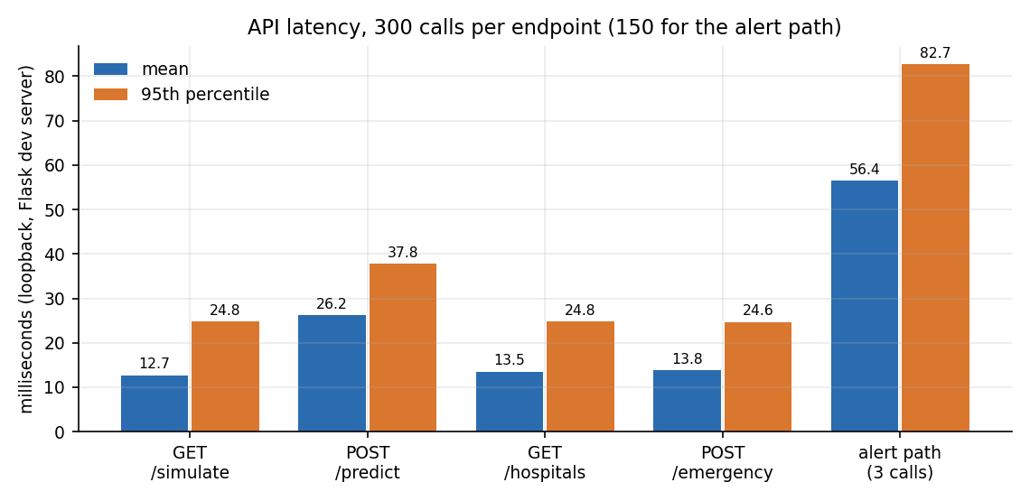
Figure 20: Mean and 95th-percentile latency of each endpoint and of the three-call alert path.
Calling the two forests directly in the same process takes 14.01 ms on average (median 13.95, 95th percentile 19.67, 99th 27.37 ms; 1000 calls), so about half of the 26.2 ms that /api/predict takes over HTTP is model evaluation and the rest is the web server and JSON handling. The three calls of one alert (reading, prediction, dispatch) take 56.4 ms on average. A single client sustains 34.1 prediction requests per second. The pickled models are small (the detector 385.5 KB, the severity model 2,608.2 KB), so start-up is quick and memory use is low.
Three cautions apply. The latency of the alert path excludes the deliberate 15-second confirmation window, which dominates the time to an alert by three orders of magnitude, and it excludes the time to deliver a real message, which is not measured because nothing is sent. The timings show steps of about 15 ms because of the operating-system timer, so differences of a few milliseconds are not meaningful. And no load or concurrency test was run: the development server is single-process and was not designed for many simultaneous users.

7.8 Robustness Testing
Two further tests probe behaviour outside the clean test split; Chapter 8 analyses them in detail. In the noise test the nine raw sensor channels of the 2,400 test events are perturbed with zero-mean Gaussian noise whose standard deviation is a fraction of each feature's own standard deviation. Up to 10 % the detector is unaffected (false-alarm rate 0.0%); at 25 % it begins to fail (1.2% false alarms); at 50 % it raises 24.2%; at 100 % it is wrong more often than right (detector accuracy 41.7%). The models were never trained with noise, so this is a measure of how far the synthetic separation can be trusted, not of a tuned system.
In the road-surface probe, 1,000 pothole-like and 1,000 speed-breaker-like events that the training generator never produces were sent through the models. The detector flags 48.9% of the pothole-like and 50.5% of the speed-breaker-like events as accidents, but none (0.0% and 0.0%) is graded Moderate or Severe, so none would start the countdown. The events were constructed for this report from our own parameter choices; they are not real recordings.
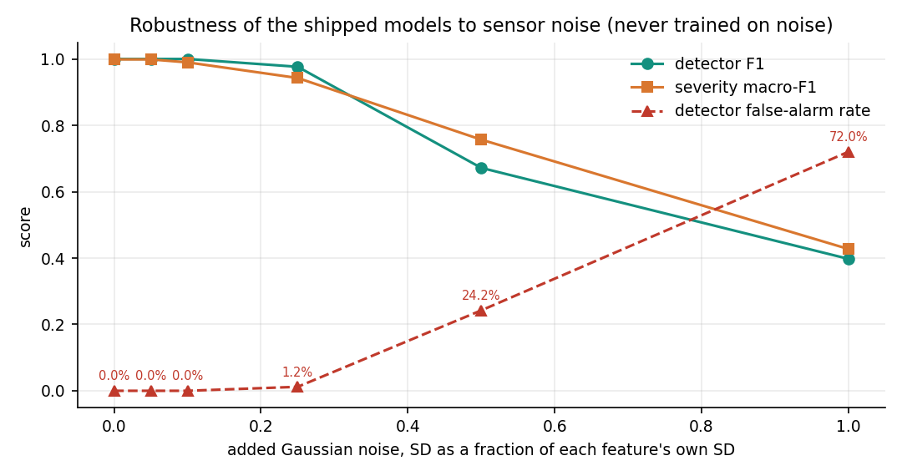
Figure 21: Detector F1, severity macro-F1 and detector false-alarm rate as sensor noise grows.

7.9 User Acceptance Testing
No user acceptance test was carried out. No driver, rider, paramedic or hospital staff member used the system, no questionnaire was issued and no usability metric (task time, error rate, satisfaction) was collected. The only people who operated the application were the project team, and they wrote it; their walk-through is useful for finding defects, as Section 7.4 shows, but it is not acceptance testing.
What a real acceptance test would need is described in Chapter 10: a phone application that records genuine motion data, a protocol for staged low-speed impacts and for ordinary rough roads, agreement with a responsible emergency service about receiving automated alerts, and a trial in which volunteers press (or fail to press) the cancel button under realistic stress. Until that is done the confirmation window of 15 seconds is a design choice taken from the project brief, not a value validated with users.

7.10 Limits of the Testing Done
• Synthetic data throughout. The classifiers were tested on events drawn from the same generator that trained them, so the scores in Chapter 8 measure separability by construction. There are no real phone recordings, and no crash, pothole or speed-breaker data from a vehicle.
• Simulated sensors and location. The readings come from /api/simulate, and the position comes from the browser or, if it is refused, from a random point near the default location. No GPS accuracy was tested.
• No delivery. Nothing is sent to a phone, a hospital or an ambulance service, so alert delivery and end-to-end time to help were not and could not be measured.
• No concurrency, endurance or battery tests. One client was used; the server was the development server; no long-running monitoring, mobile CPU or battery measurement was made.
• Input validation gaps remain. Eight edge cases fail (Section 7.6); the checks were not extended to every parameter of every route.
• Small, self-written suites. The 55 checks of run_tests.py and the 33 of the smoke test were written by the project team for this application; they are not an independent audit, and there is no coverage measurement.
• Single environment. All runs were on one Windows 11 machine with scikit-learn 1.5.0 loading pickles that were written by version 1.9.0. A fresh retraining with the same seed agrees with the shipped models on every one of the 2,400 test events, which removes the main worry, but other platforms were not tried.

CHAPTER 8: RESULTS AND OUTPUT SCREENS

8.1 Experimental Set-up
All model results in this chapter are measured on 2,400 held-out events: the 20 % split of 12,000 synthetic sensor events that train_models.py generates with seed 42 and splits with a stratified random split. The test part holds 1,463 normal-driving, 460 harsh-braking, 233 minor-crash, 156 moderate-crash and 88 severe-crash events, that is 477 accidents (19.9%) and 1,923 non-accidents. The shipped models in models/*.pkl are evaluated, and a fresh retraining with the same seed is compared with them. The measurements ran with Python 3.11.9, scikit-learn 1.5.0, numpy 1.26.4 and pandas 2.2.1, on one Intel Core i5-12500 with 15.7 GB of RAM and no GPU. The pickles were written by scikit-learn 1.9.0 and loaded by 1.5.0; the retrained models agree with them on 100.00% of the detector decisions and 100.00% of the severity decisions, so the version difference does not change a single answer.
The word 'real' in this chapter means that the number was measured by running the code; it does not mean that the data are real. There is no dataset of smartphone recordings of crashes in this project. The events are drawn from hand-written distributions that imitate normal driving, harsh braking and three grades of impact (Chapter 6), and the test events come from the same distributions as the training events. The scores that follow therefore measure how well the forests learn the generator, and they are an upper bound on what any real recording could achieve.

8.2 Output Screens
The screens below were captured from the running application with a Playwright script (Chrome, 1440 by 900 pixels, Flask backend on port 8302, React front end on port 5302, demo account). Every result on them was produced by the real models: the readings come from the built-in simulator, which stands in for the phone, and the position is supplied by the browser (set to a point in Banjara Hills, Hyderabad, for the capture). Nothing was edited after capture. The principal screens are shown here; the other captures (dark-theme landing and monitor, the landing page's how-it-works section, the wrong-password message, registration, the manual form, the response map before an alert, and the 404 page) are in Appendix C.
Figure 22: Landing page, light theme: the pitch 'Detect. Rate. Dispatch.', the live status tiles (API online, model trained ML, countdown 15 s) and the entry buttons. | Figure 23: Sign-in form. The monitor, manual override and response screens are reachable only after signing in.

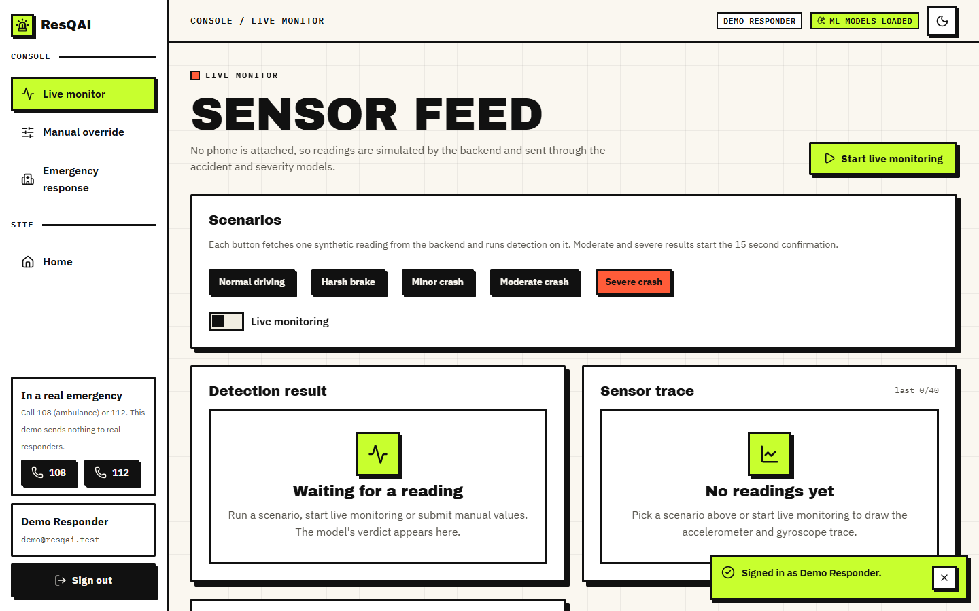  Figure 24: Live monitor before any reading: the five scenario buttons, the live-monitoring switch, and empty result and trace panels. | Figure 25: Live monitor after normal driving: 'No accident', severity None, accident probability 0 %, with the sensor trace of acceleration and rotation magnitude.

Figure 26: Confirmation dialog 'Possible accident detected' after a Severe crash: 100 % probability, 11 seconds left, the buttons 'I'm fine, cancel' and 'Send alert now', and the note that Escape cancels. | 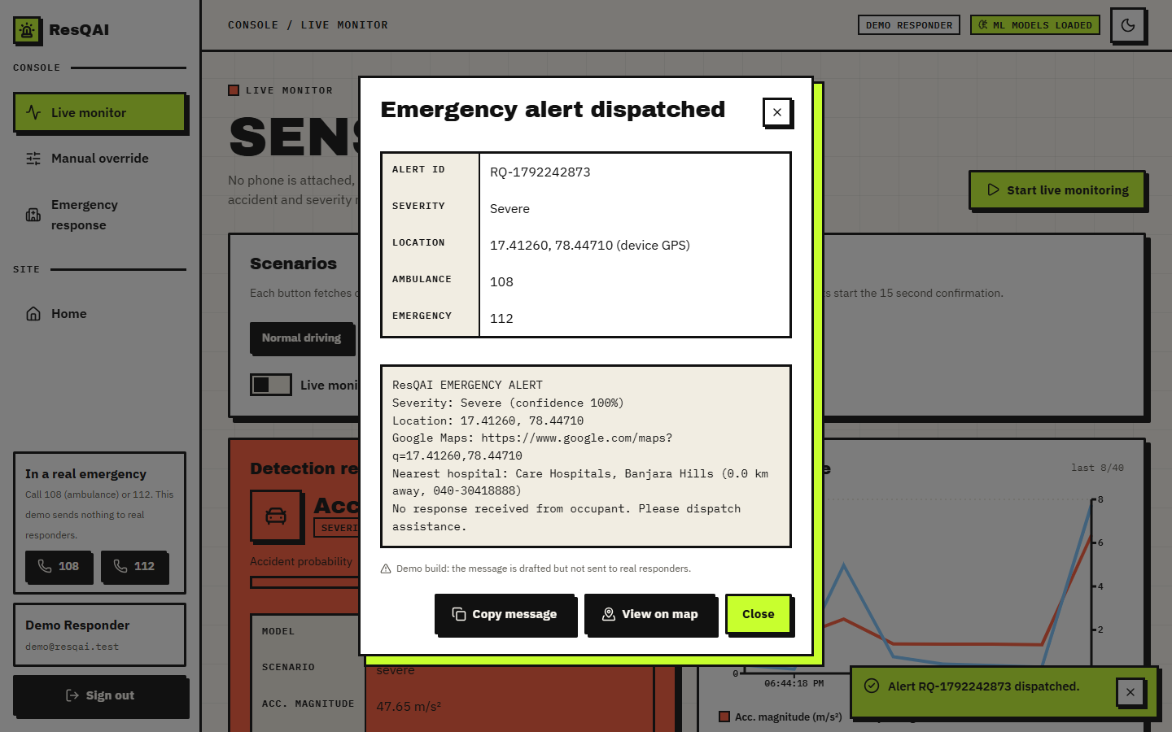  Figure 27: Dialog 'Emergency alert dispatched': alert id, severity, device location, the drafted message with its map link and nearest hospital, and the statement that the message is not sent to real responders.

Figure 28: Emergency response screen after the dispatch: map with the accident and hospital markers, dispatch summary (id, severity, location source, nearest hospital) and the call button. | 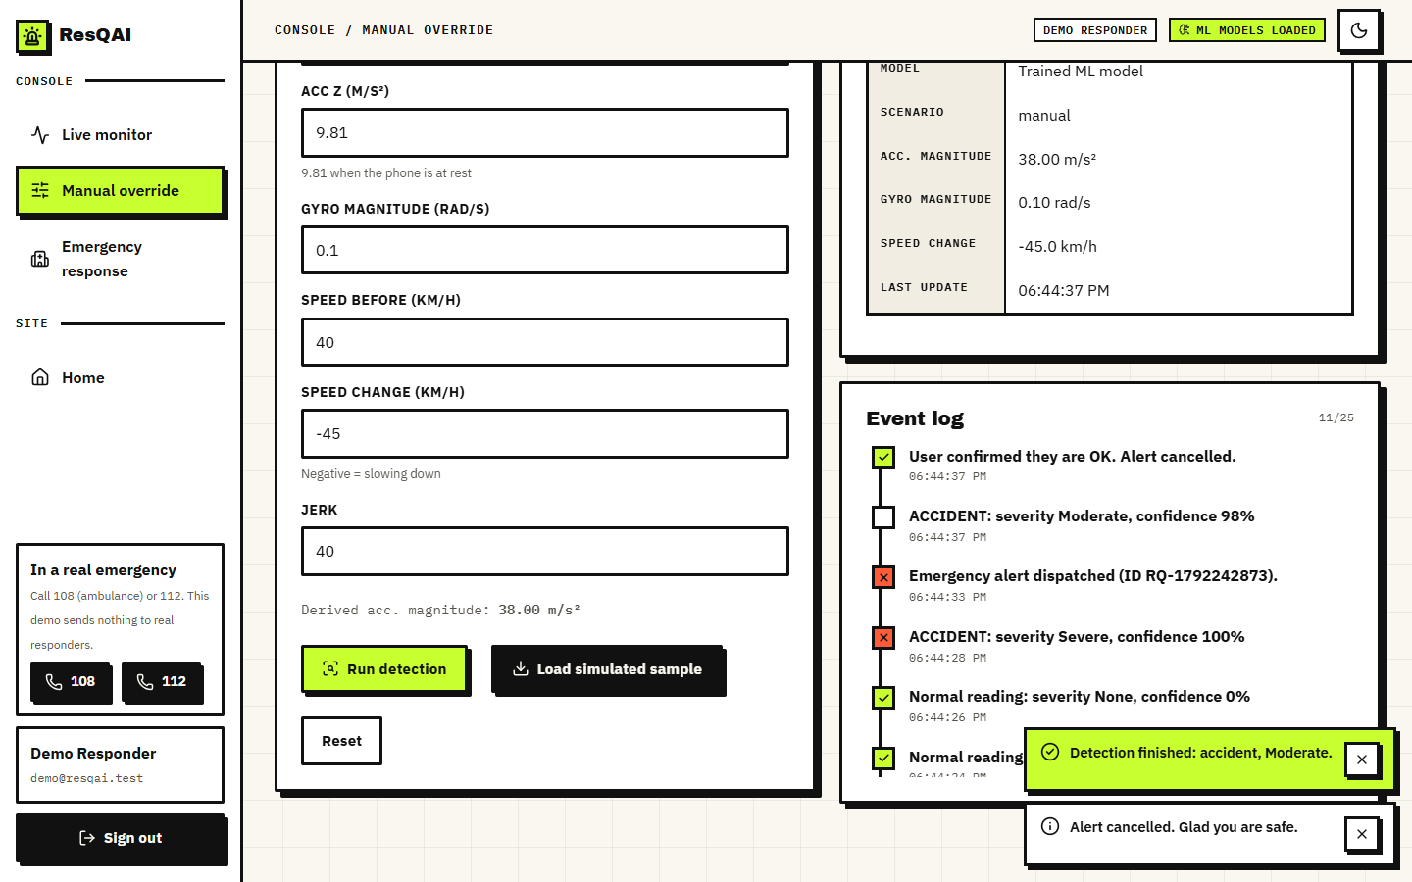  Figure 29: Manual override with acc_x 32, acc_y 18 m/s2, speed change -45 km/h and jerk 40: derived magnitude 38.00 m/s2, result Moderate; the event log below records the earlier alerts.

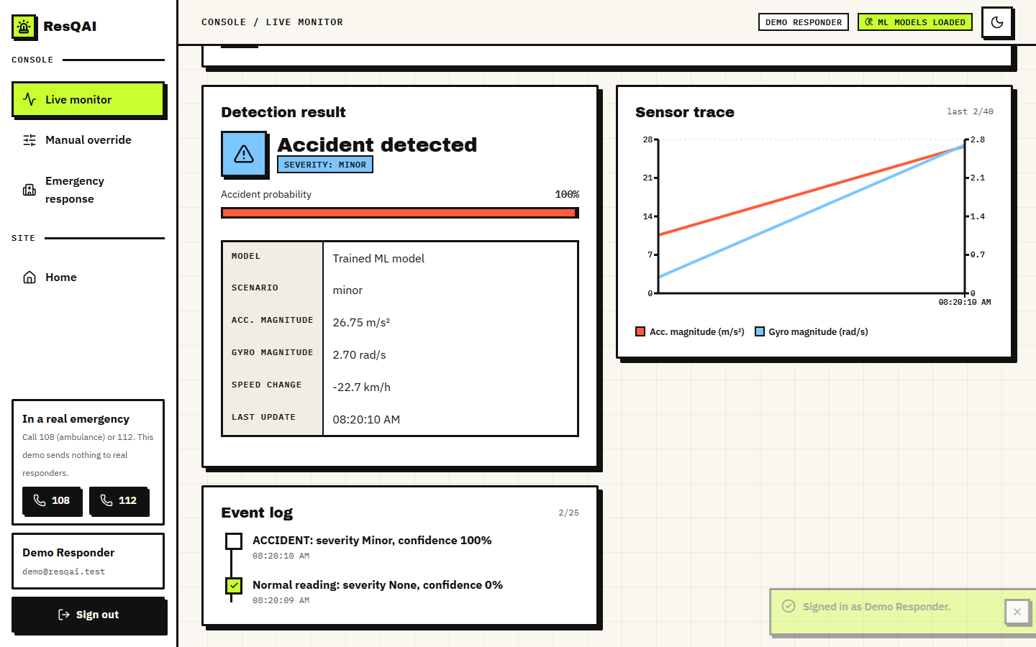  Figure 30: A Minor crash on the live monitor: 'Accident detected', severity Minor, 100 % probability; it is written to the event log and does not open the countdown. | 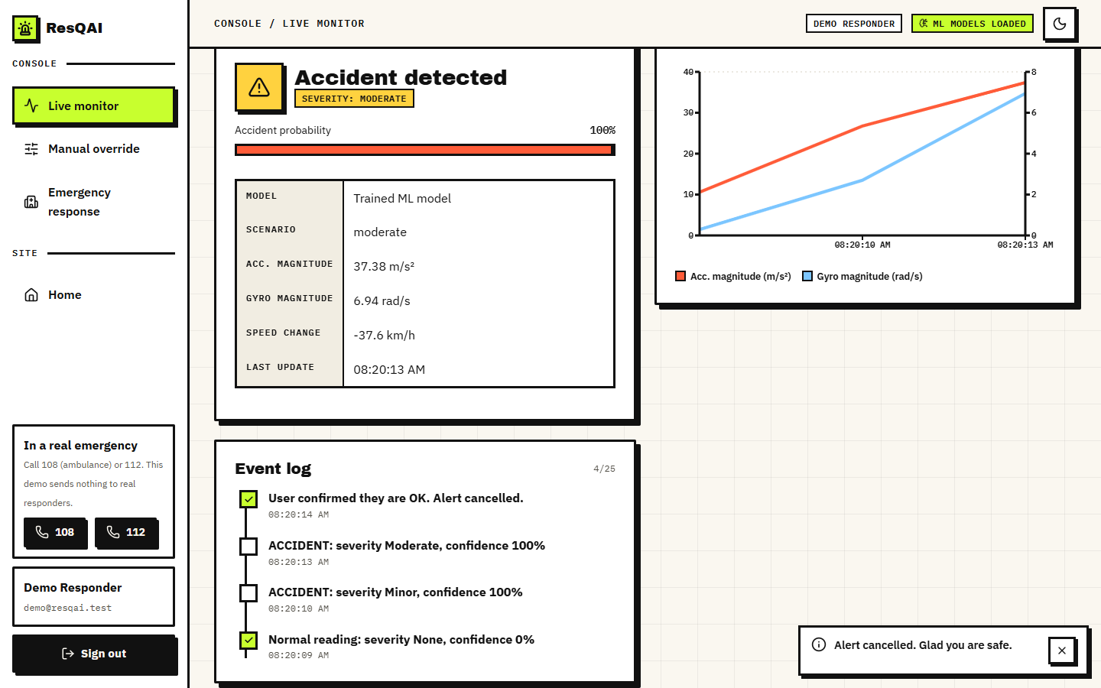  Figure 31: A Moderate crash after the occupant pressed 'I'm fine, cancel': the event log reads 'User confirmed they are OK. Alert cancelled.'

The sequence 08, 09, 10, 11 is the main flow of the system: a normal reading raises nothing; a Severe crash opens the countdown; pressing Send alert now (or letting the 15 seconds run out) composes the message; and the response screen shows where the accident is and which hospitals are nearest. Screens 16 and 17 show the two outcomes that do not dispatch anything: a Minor crash, which is only logged, and a Moderate crash that the occupant cancels.

8.3 Accident Detector
On the 2,400 held-out events the detector makes no error: accuracy, precision, recall, F1 and ROC-AUC are all 1.0000, the confusion matrix is [[1923, 0], [0, 477]], and both the false-alarm rate and the miss rate are 0.0%. Its accuracy on the 9,600 training events is also 1.0000, so there is no gap between training and test. A perfect score on a test set is normally a warning sign, and here it is one: it comes from the way the data are built, not from a skilful model.
Figure 32: Why the detector cannot fail on this data: normal driving and harsh braking stay below 13.2 m/s2 of acceleration magnitude, every crash is above 15.3 m/s2.
The left panel of the figure above shows the reason. The largest acceleration magnitude of any harsh-braking event in the 12,000 generated is 13.18 m/s2, the smallest of any crash is 15.3 m/s2, and a gap lies between them. A single threshold at 15 m/s2 separates the two classes without an error, and Section 8.5 confirms that a rule with that threshold scores exactly as well as the random forest. The detector in this project is therefore easy by construction; its value in this chapter is that the full pipeline from reading to alert is exercised, not that 100 % tells us something about roads.
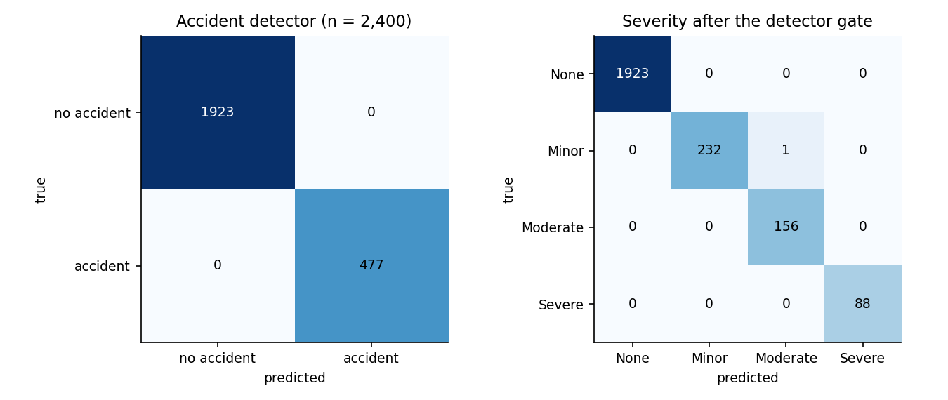
Figure 33: Confusion matrices of the shipped detector (left) and of the severity model after the detector gate (right), 2,400 test events.
Table 36: Detector behaviour by kind of event (shipped model, held-out events)
Event kind | Events | Flagged as accident | Mean accident probability
normal | 1463 | 0.0% | 0.0000
harsh brake | 460 | 0.0% | 0.0024
minor crash | 233 | 100.0% | 0.9984
moderate crash | 156 | 100.0% | 0.9998
severe crash | 88 | 100.0% | 1.0000

The row that matters for the first objective is harsh braking: none of the 460 held-out braking events is flagged, and their mean accident probability is 0.0024. The weakest accident in the test set still receives an accident probability of 0.90, and the strongest non-accident receives 0.17, so the probabilities are well separated.

8.3.1 Decision threshold
The application uses the forest's own decision (equivalent to a probability threshold of 0.5). The table and figure below vary that threshold. Between 0.20 and 0.90 there is no error at all; at 0.10 and 0.05 a few false alarms appear (2 and 5), and at 0.95 two true accidents are missed. The operating point is not sensitive to the threshold on this data, which is again a sign of well-separated classes. On real recordings the choice would trade missed crashes against false alarms and would have to be set with a cost in mind: a missed crash can cost a life, a false alarm costs the occupant a few seconds, which is what the confirmation window is for.
Table 37: Detector threshold sweep (shipped model)
Threshold | Precision | Recall | F1 | False positives | False negatives
0.05 | 0.9896 | 1.0000 | 0.9948 | 5 | 0
0.10 | 0.9958 | 1.0000 | 0.9979 | 2 | 0
0.20 | 1.0000 | 1.0000 | 1.0000 | 0 | 0
0.30 | 1.0000 | 1.0000 | 1.0000 | 0 | 0
0.40 | 1.0000 | 1.0000 | 1.0000 | 0 | 0
0.50 | 1.0000 | 1.0000 | 1.0000 | 0 | 0
0.60 | 1.0000 | 1.0000 | 1.0000 | 0 | 0
0.70 | 1.0000 | 1.0000 | 1.0000 | 0 | 0
0.80 | 1.0000 | 1.0000 | 1.0000 | 0 | 0
0.90 | 1.0000 | 1.0000 | 1.0000 | 0 | 0
0.95 | 1.0000 | 0.9958 | 0.9979 | 0 | 2

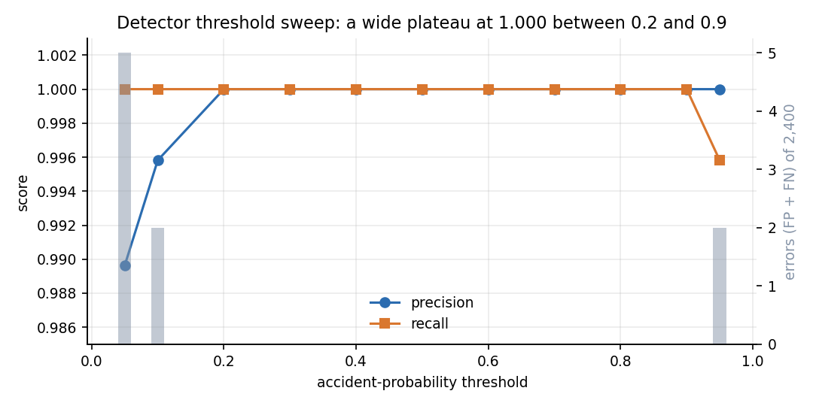
Figure 34: Precision and recall of the detector against the accident-probability threshold, with the number of errors.

8.4 Severity Predictor
After the detector gate, as the application runs it, the severity model reaches accuracy 0.99958 and macro-F1 0.99866 on the 2,400 test events. There is exactly one error (1 of 2,400): a Minor crash graded Moderate. It is a neighbouring class (Minor and Moderate are adjacent grades). Per class, precision and recall are at least 0.9936.
Table 38: Severity per-class results (shipped model, after the gate)
Class | Precision | Recall | F1 | Support
None | 1.0000 | 1.0000 | 1.0000 | 1923
Minor | 1.0000 | 0.9957 | 0.9978 | 233
Moderate | 0.9936 | 1.0000 | 0.9968 | 156
Severe | 1.0000 | 1.0000 | 1.0000 | 88

The decision that actually starts a countdown is whether the grade is Moderate or Severe. Treated as a two-class problem this decision has precision 0.9959, recall 1.0000 and a false-alarm rate of 0.046% (1 false trigger in 2,156 events that should not trigger one). No Moderate or Severe event was missed. The one false trigger is the Minor crash that was graded Moderate: in the application it would have opened the countdown, and the occupant could have cancelled it.

8.4.1 Repeatability over five seeds
A single split can flatter a model, so the whole experiment was repeated five times, each time with a new dataset, a new split and newly trained forests (seeds 11, 22, 33, 44 and 55). The detector scored accuracy 1.0000 in all five runs. The severity results varied only in the third decimal: accuracy 0.99875 on average (SD 0.00066, worst run 0.99792) and macro-F1 0.99501 (SD 0.00293, worst 0.99158). The shipped model's single-split figures therefore sit within the spread of the five repeats, slightly above their mean.
Table 39: Five-seed repeat (2,400 test events each)
Seed | Severity accuracy | Severity macro-F1 | Alert precision | Alert recall | Alert false-alarm
11 | 0.99917 | 0.99727 | 0.9958 | 0.9958 | 0.046%
22 | 0.99875 | 0.99503 | 1.0000 | 0.9917 | 0.000%
33 | 0.99958 | 0.99847 | 1.0000 | 0.9956 | 0.000%
44 | 0.99833 | 0.99269 | 1.0000 | 0.9914 | 0.000%
55 | 0.99792 | 0.99158 | 0.9959 | 0.9918 | 0.046%
mean | 0.99875 | 0.99501 | 0.9983 | 0.9933 | 0.018%
SD | 0.00066 | 0.00293 | 0.0023 | 0.0022 | 0.025%

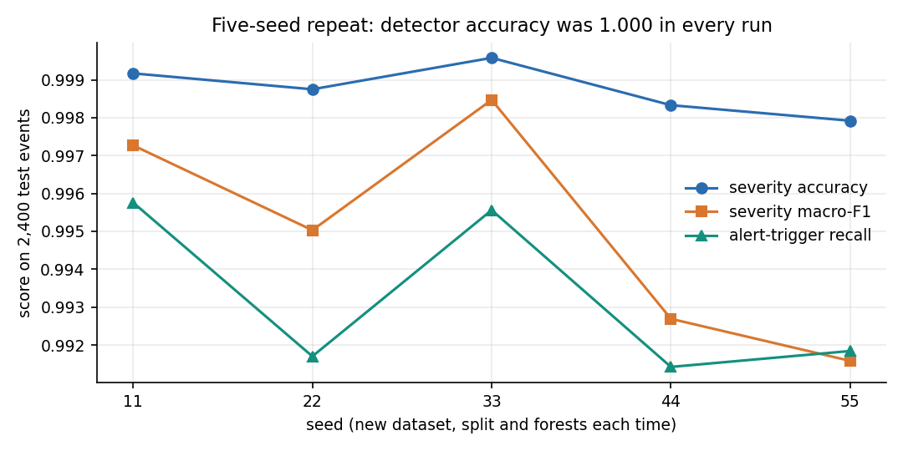
Figure 35: Severity accuracy, macro-F1 and alert-trigger recall in the five repeats.

8.4.2 Which features matter
The detector relies on few features: by Gini importance the leaders are acc_magnitude (0.324), jerk (0.311), gyro_magnitude (0.206); by permutation, shuffling acc_magnitude alone lowers the detector's F1 by 0.798 while shuffling any other single feature changes nothing, because the others carry the same information (jerk, gyroscope magnitude and speed change all rise with the impact). The severity model uses more of the inputs: acc_magnitude (0.386), jerk (0.240), speed_change (0.152), gyro_magnitude (0.096); its permutation drops are largest for acc_magnitude (0.459), speed_change (0.189) and speed_before (0.130).
Figure 36: Gini and permutation importance of the 11 features for the detector and the severity model.
Retraining on feature subsets (table below) shows what can be removed. The gyroscope can be dropped without any change on this data, and speed and jerk each add a little to severity; acceleration alone detects every crash but grades severity less well (accuracy 0.9904, macro-F1 0.9622), and the single feature acc_magnitude gives severity accuracy 0.9858. That the gyroscope adds nothing is a property of the generator, in which rotation grows with impact exactly as acceleration does; on a real phone, rotation would help to separate a roll-over from a frontal impact.
Table 40: Feature-group ablation (models retrained on each subset)
Features used | N | Detector accuracy | Severity accuracy | Severity macro-F1
all 11 features | 11 | 1.0000 | 0.9996 | 0.9987
accelerometer only (x, y, z, magnitude) | 4 | 1.0000 | 0.9904 | 0.9622
acc_magnitude only | 1 | 1.0000 | 0.9858 | 0.9459
without gyroscope | 7 | 1.0000 | 0.9996 | 0.9987
without speed (speed_before, speed_change) | 9 | 1.0000 | 0.9983 | 0.9929
without jerk | 10 | 1.0000 | 0.9983 | 0.9938
without acc_magnitude and jerk | 9 | 0.9996 | 0.9917 | 0.9677

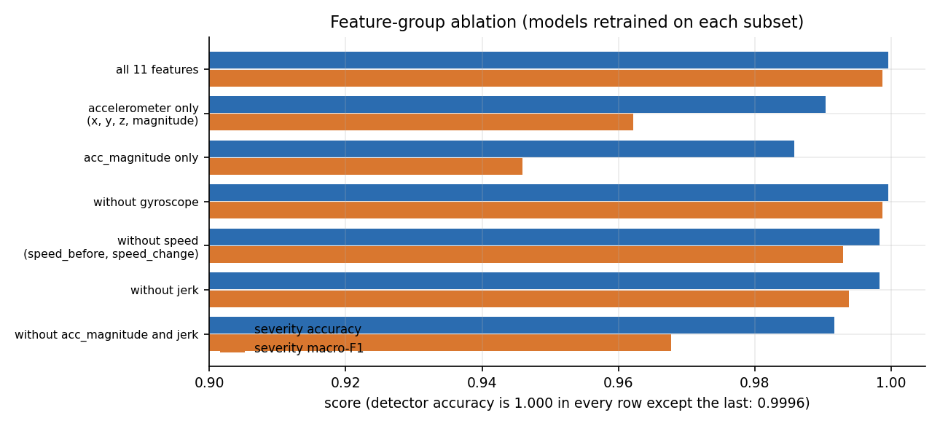
Figure 37: Severity accuracy and macro-F1 for each feature group.

8.5 Comparison with Simpler Models
To see what the random forests add, four other models were trained on the same split, with the same scaling and the same detector gate for severity. All five detect crashes perfectly. The random forest and gradient boosting are the best on severity (accuracy 0.9996 and 0.9996); the decision tree and logistic regression are close (0.9988 and 0.9983); and the three-threshold rule on acceleration magnitude, which the application itself uses as a fallback, is clearly worse (0.9750 accuracy, 0.9122 macro-F1).
Table 41: Models on the same split (2,400 test events)
Model | Detector accuracy | Detector F1 | False-alarm | Severity accuracy | Severity macro-F1
Rule-based fallback (acc_magnitude < 15 / 28 / 45) | 1.0000 | 1.0000 | 0.0% | 0.9750 | 0.9122
Logistic regression | 1.0000 | 1.0000 | 0.0% | 0.9983 | 0.9946
Decision tree (depth 10) | 1.0000 | 1.0000 | 0.0% | 0.9988 | 0.9960
HistGradientBoosting | 1.0000 | 1.0000 | 0.0% | 0.9996 | 0.9987
Random forest (ResQAI, retrained) | 1.0000 | 1.0000 | 0.0% | 0.9996 | 0.9987

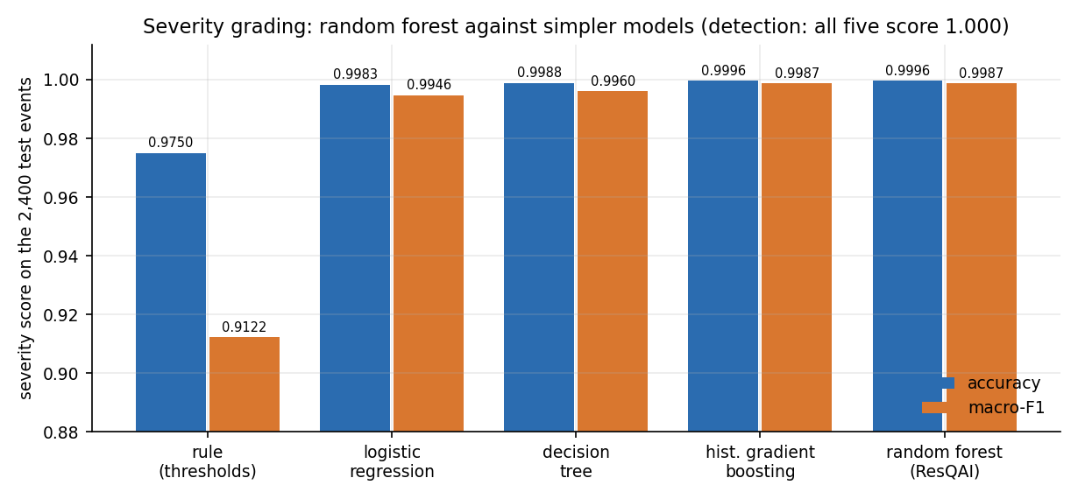
Figure 38: Severity accuracy and macro-F1 of the random forest and four simpler models.
The honest reading is twofold. For detection, the machine-learning model is not needed on this data: a single threshold does as well. For severity, the forest gains 2.5% points of accuracy and 8.6% points of macro-F1 over the rule, because the three severity bands overlap at their edges and the extra inputs (jerk, speed change, speed) resolve many of those cases. Gradient boosting would have been an equally good choice. The random forest [21] was kept because it is robust, needs no tuning, runs both models in about 14 ms and was already in the shipped application.

8.6 Robustness and Road-Surface Events
Two tests go beyond the clean test split. The first adds Gaussian noise to the nine raw sensor channels of the test events; the standard deviation of the noise is a fraction of each feature's own standard deviation across the test set, and the magnitudes are recomputed afterwards. The shipped models were never trained on noisy readings.
Table 42: Shipped models under added sensor noise
Noise (fraction of SD) | Detector accuracy | Detector F1 | False-alarm rate | Detector recall | Severity accuracy | Severity macro-F1
0.00 | 1.0000 | 1.0000 | 0.0% | 100.0% | 0.9996 | 0.9987
0.05 | 1.0000 | 1.0000 | 0.0% | 100.0% | 0.9996 | 0.9987
0.10 | 1.0000 | 1.0000 | 0.0% | 100.0% | 0.9971 | 0.9898
0.25 | 0.9904 | 0.9765 | 1.2% | 100.0% | 0.9804 | 0.9427
0.50 | 0.8058 | 0.6718 | 24.2% | 100.0% | 0.8029 | 0.7569
1.00 | 0.4167 | 0.3976 | 72.0% | 96.9% | 0.3721 | 0.4274

Figure 39: Detector F1, severity macro-F1 and false-alarm rate as noise grows from 0 to 100 % of each feature's SD.
The models tolerate noise up to about one tenth of the natural spread: at 0.10 the detector is still perfect and severity macro-F1 is 0.9898. At 0.25 false alarms reach 1.2% and at 0.50 they reach 24.2%, so a quarter of non-accident events would be flagged. At 1.00 the detector's accuracy (41.7%) is below 50 %. Detector recall stays above 0.969 throughout: noise makes the system cry wolf, it does not make it miss crashes. A real phone is noisy (vibration, orientation, a loose mount), so a noise-aware retraining and a filter before the model would be necessary.
The second test asks the question that the second objective raises: what does the detector do with events that are neither crashes nor the harsh braking it was trained on? Two sets of 1,000 events each were constructed for this report, a pothole-like set (a vertical spike of 6 to 18 m/s2, almost no change of speed) and a speed-breaker-like set (a vertical rise of 3 to 9 m/s2 and a small slowing). They are our own construction and not recordings, and the parameters are in scripts/measure_metrics.py.
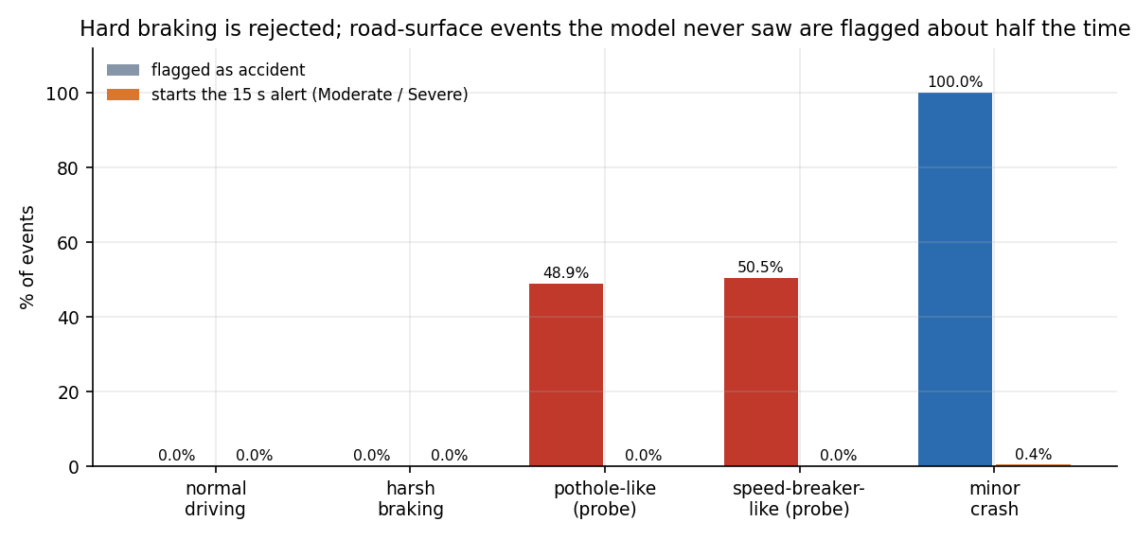
Figure 40: Share of events flagged as accident and share that start the 15-second alert, for trained and unseen kinds of event.
The detector flags 48.9% of the pothole-like events (mean accident probability 0.49) and 50.5% of the speed-breaker-like events (mean probability 0.45): it behaves like a coin toss, because it has never seen a vertical-only spike. None of them is graded Moderate or Severe (0.0% and 0.0% reach the countdown), so no alert would be raised, but the logged 'Accident detected' entries would be false. The objective of telling accidents from potholes and speed breakers is therefore met for hard braking and not demonstrated for the road-surface events. The fix is data, not tuning: such events must be recorded on real roads and added to training as their own class.

8.7 Sample Inputs and Outputs
The table below lists seven readings typed into /api/predict (the same payload the Manual override screen builds) and the answers returned by the shipped models on 2026-10-25. They are hand-picked to show each outcome, not a random sample, and the pothole-like reading is one of our constructed probes.
Table 43: Sample readings and the response of /api/predict
Reading | Input (m/s2, rad/s, km/h) | Acc. magnitude | Gyro magnitude | Accident | Severity | Probability
Calm driving | acc (0.1, -0.2, 9.8), speed 40, change +0.5, jerk 0.3 | 9.80 | 0.11 | No | None | 0.00
Hard braking | acc_x -4.5, speed 60, change -25, jerk 6 | 10.79 | 0.37 | No | None | 0.00
Minor-like impact | acc (17, 8, 9.8), gyro about 1.1 each, change -22, jerk 20 | 21.19 | 1.91 | Yes | Minor | 1.00
Moderate impact (screen 12) | acc (32, 18, 9.81), change -45, jerk 40 | 38.00 | 0.10 | Yes | Moderate | 0.975
Severe impact | acc (55, 25, 10.5), gyro about 3 each, speed 90, change -70, jerk 62 | 61.32 | 5.24 | Yes | Severe | 1.00
Boundary case | acc (22, 14, 9.8), gyro 2 each, change -30, jerk 28 | 27.86 | 3.46 | Yes | Minor | 1.00
Pothole-like (our probe) | acc_z 21.8 (a 12 m/s2 vertical spike), change +1, jerk 12 | 21.82 | 0.67 | Yes | Minor | 0.80

For a Moderate or Severe answer the browser then calls /api/emergency. For the Banjara Hills position used in the screenshots (latitude 17.4126, longitude 78.4471) the server returned alert id RQ-1792896858 and this message:
ResQAI EMERGENCY ALERT
Severity: Severe (confidence 100%)
Location: 17.41260, 78.44710
Google Maps: https://www.google.com/maps?q=17.41260,78.44710
Nearest hospital: Care Hospitals, Banjara Hills (0.0 km away, 040-30418888)
No response received from occupant. Please dispatch assistance.

The three nearest hospitals returned with it were Care Hospitals (0.00 km), Rainbow Children's Hospital (0.27 km) and Yashoda Hospitals, Somajiguda (1.34 km). The second is a paediatric hospital: the directory holds no information about specialty or capacity, so the nearest hospital is not always the most suitable one (Section 8.10).
The single severity error of the test split is a minor crash (true severity Minor) with acceleration magnitude 31.93 m/s2, gyroscope magnitude 2.79, speed change -24.33 km/h and jerk 27.04, which the model graded Moderate with accident probability 1.0. Its magnitude lies in the stretch where the minor and moderate generators overlap (24.9 to 32.8 m/s2), so the error is a boundary case and not a surprise.

8.8 Comparison with the Base Paper and Related Work
The base paper [1] predicts the severity of a crash from the police record written after it happened: 30,442 crash records from Dongguan, China, 2019 to 2023, split 19,483 / 4,871 / 6,088, with driver, vehicle, road and weather attributes, and three tasks (injury severity with five classes, fatal severity with five classes and property loss with six classes). Its multi-task FT-Transformer reports accuracy 70.31 % for injury severity (F1 64.48 %), 90.38 % for fatal severity (F1 86.71 %) and 80.79 % for property loss (F1 79.18 %), and beats eight baseline models and an earlier multi-task CNN.
The two works cannot be compared by their numbers, and the table below is a comparison of what each does, not of scores.
Table 44: ResQAI against the base paper and the two companion papers
Aspect | Base paper [1] | GreenBox [6] | CIRS [7] | ResQAI
Input | Police crash records (tabular, after the event) | Push-button impact sensors, MPU-6050, water sensors, GPS (Arduino) | Camera frames | 11 motion features of a (simulated) phone reading
Data | 30,442 real records, one Chinese city | None reported | 5,200 accident and 4,800 non-accident frames | 12,000 synthetic events; none real
Task | Severity of injury, fatality and property loss | Impact and roll-over detection, alert by SMS | Accident detection, scene description, dispatch | Crash detection, 4-level severity, confirmation, hospital and message
Reported result | Accuracy 70.31 / 90.38 / 80.79 % | Qualitative: SMS 'in a matter of seconds' | Accuracy 86.5 %, precision 0.866, recall 0.856, F1 0.861 | Detector 1.0000, severity 0.99958 on synthetic data (Section 8.3-8.4)
Alert path | None | SMS with GPS position to preset contacts; cancel by SMS | Multi-agent dispatch (reported) | Message drafted and displayed; not sent
False-alarm handling | Not applicable | Owner can cancel by SMS | 128 of 1,044 non-accident frames falsely flagged | 15-second cancel window; measured 0 % on held-out braking

ResQAI's scores are higher than the base paper's, but that is not a finding. The base paper works on real, noisy, human-recorded data with overlapping classes and an inherently uncertain target (how many people were injured); ResQAI works on synthetic classes that are separable by construction. A fair comparison would need ResQAI evaluated on real sensor recordings of crashes, which do not exist in this project. What ResQAI does take from the base paper is the framing: severity is worth predicting, not only occurrence, and per-class accuracy, precision, recall and F1 are the right way to report it. It does not use the FT-Transformer, the multi-task loss, SMOTE or SHAP.
Against GreenBox [6], ResQAI replaces fixed hardware thresholds with a learned severity grade and adds the hospital ranking, but GreenBox sends a real SMS and has been tested on a vehicle on the road, which ResQAI has not. Against CIRS [7], ResQAI uses motion sensors that every phone carries instead of fixed cameras, so it can follow a vehicle anywhere, but CIRS was evaluated on real images and reports a false-alarm count, while ResQAI's figures describe generated data. Neither companion paper reports an end-to-end alert time, so ResQAI's alert-path compute time (56 ms) has nothing to be compared with.

8.9 Success and Failure Analysis

8.9.1 What worked
• The pipeline runs end to end. A reading becomes a detection, a grade, an optional countdown, a location, three ranked hospitals and a dispatch message; 33 of 33 smoke checks and 17 of 17 unit checks pass.
• Hard braking is not mistaken for a crash. None of 460 held-out braking events is flagged, and the 15-second window gives the occupant a way to correct any other false alarm.
• Severity grading is accurate on its own distribution. Accuracy 0.99958 (five-seed mean 0.99875); every error is to a neighbouring class.
• It is quick. 56.4 ms of compute for the three calls of an alert, 14.0 ms for the two models.
• Access control behaves as coded. All 18 security checks pass, including the lock-out after five wrong passwords.

8.9.2 What failed or is unproven
• One severity error. A Minor crash at 31.9 m/s2 was graded Moderate (Section 8.7); the application would have opened a countdown for it.
• Road-surface events. About half of pothole-like (48.9%) and speed-breaker-like (50.5%) events are flagged as accidents because the models have never seen them.
• Noise. Above a quarter of the natural spread the detector's false-alarm rate climbs (1.2% at 0.25, 24.2% at 0.50).
• Input validation. Eight edge cases are mishandled: four return HTTP 500, three accept nonsense input and one reuses an alert id (Chapter 7).
• Alert delivery. No message is sent, so the time to reach a human, which is what the system is for, is unmeasured.

8.9.3 Why the near-perfect scores should not be trusted as a forecast
Three features of the experiment make the scores optimistic. The training and test events come from one generator, so there is no distribution shift; the crash classes are far from the non-crash classes, so detection is trivial; and the sensors are noiseless apart from the Gaussian spread written into the generator. The repeat over five seeds and the fact that a retrained model agrees with the shipped one show that the numbers are stable and reproducible; they do not show that they transfer. The right claim is that the software and the models are consistent with each other and with the design, and that the next step is real data.

8.10 Limitations
• No real data. All 12,000 events are generated; no smartphone recording, crash test or road trial was used.
• Single sensor location and orientation. The generator has no notion of how the phone is mounted, which axis points forward, or whether the phone is in a pocket; a real deployment needs orientation normalisation.
• Pothole, speed-breaker, drop and bump events are not modelled (Section 8.6).
• Hospital directory. Ten hospitals in Hyderabad, ranked by straight-line distance; no road network, traffic, specialty (the second-nearest hospital in the sample is a children's hospital), bed capacity or opening hours. Outside Hyderabad the 'nearest' hospital would be hundreds of kilometres away.
• No transmission. The dispatch message is displayed; there is no SMS, voice call or e-mail gateway, no contact list and no acknowledgement from a responder.
• Confirmation window. 15 seconds is taken from the project brief; an incapacitated occupant cannot cancel, which is intended, but a conscious occupant who is slow also triggers an alert.
• Server. Flask development server, in-process lock-out counter, JSON-file accounts, 12-hour tokens without revocation, no HTTPS, no rate limiting beyond the login lock-out.
• Alerts are not stored and carry no user id, so there is no audit trail and no history of alerts.
• No user study and no usability or accessibility evaluation beyond the keyboard (Escape) and screen-reader labels visible in the code.

8.11 Objectives Against Outcomes
The project brief lists six objectives (6.OBJECTIVES&PROBLEM STATEMENT.docx). The table states, for each, what was built and what was measured, in plain terms.
Table 45: Objectives and outcomes
No. | Objective | Outcome | Evidence
1 | Collect and preprocess smartphone accelerometer, gyroscope, speed and GPS data for normal driving and collision events | Partly. An 11-feature pipeline and a generator of 12,000 synthetic events; no real smartphone recordings were collected. | train_models.py; Sections 8.1, 8.3
2 | Train a classifier that separates genuine accidents from potholes, speed breakers and hard braking | Partly. Hard braking: 0 of 460 held-out events flagged. Potholes and speed breakers are not in the training data; a constructed probe flags 49% and 50% of them, never as Moderate or Severe. | Sections 8.3, 8.6
3 | Build a severity model that grades an impact as minor, moderate or severe | Achieved on synthetic data. Accuracy 0.99958, macro-F1 0.99866; five-seed mean 0.99875 / 0.99501. | Section 8.4
4 | Use GPS to locate the crash and identify a suitable nearby hospital | Achieved at demo level. Browser geolocation (fallback: default area), haversine ranking over a ten-hospital Hyderabad directory; no live hospital service, no specialty or capacity. | Sections 8.2, 8.7
5 | Dispatch an automated alert carrying location and severity to emergency contacts and medical services | Partly. The alert id, message, map link and hospital are generated and displayed, with tap-to-call for 108, 112 and 103; nothing is transmitted. | Screens 10, 11
6 | Evaluate detection accuracy, false-alarm rate and end-to-end alert latency | Done. Accuracy and false-alarm rate reported with five-seed repeat, baselines, noise and threshold analyses; alert path 56.4 ms mean on loopback plus the 15 s confirmation window; real delivery latency not measurable. | Sections 8.3-8.6; Chapter 7

Two items of the project definition beyond the six objectives were also met: a confirmation mechanism that reduces false alerts (the 15-second countdown, cancellable by button or Escape) and an emergency dashboard showing the accident and the hospitals on a map. The evaluation metrics named in the brief (accuracy, precision, recall and F1) are all reported, per class for severity.

CHAPTER 9: CONCLUSION

9.1 Summary
ResQAI set out to shorten the time between a road accident and the arrival of help by detecting the accident automatically from the sensors that a smartphone already carries, judging how serious it is, asking the occupant to confirm, and then composing a located alert that names the nearest hospital. The base paper and the surveyed work [1] predict severity from records after the event, and none of it connects sensing to dispatch; this project built that connection as a working prototype and measured it.
The prototype is a Flask service with two random forests behind one scaler and a React console. A reading of eleven features is classified as accident or not, graded None, Minor, Moderate or Severe, and, for Moderate and Severe grades, held for a 15-second confirmation before the location, the three nearest hospitals and the dispatch message are produced. On 2,400 held-out events the detector scored accuracy 1.0000 and the severity model accuracy 0.99958 with macro-F1 0.99866; over five repeats severity accuracy averaged 0.99875. The whole alert path took 56 ms of computing on loopback, before the deliberate 15-second window.

9.2 Objectives Achieved
The brief set six objectives. They are repeated here with the verdict that Chapter 8 supports; the evidence for each is in Section 8.11.
Table 46: Objectives and verdicts
No. | Objective (short) | Verdict
1 | Collect and preprocess smartphone sensor data | Partly: 11-feature pipeline and 12,000 synthetic events; no real recordings
2 | Separate accidents from potholes, speed breakers and hard braking | Partly: hard braking yes (0 of 460 flagged); potholes and speed breakers not demonstrated
3 | Severity model (minor, moderate, severe) | Achieved on synthetic data: accuracy 0.99958, macro-F1 0.99866
4 | Locate the crash and suggest a nearby hospital | Achieved at demonstration level (ten hospitals, straight-line distance)
5 | Dispatch an automated alert with location and severity | Partly: message composed and displayed, not transmitted
6 | Evaluate accuracy, false-alarm rate and alert latency | Done: see Chapter 8; alert path 56 ms plus the 15 s window

9.3 Key Findings
1. The complete chain from reading to dispatch message works, and its tests pass (33 of 33 smoke checks; 47 of 55 further checks, the eight failures being input-validation gaps).
2. On the synthetic data a single acceleration threshold detects crashes as well as the forest; the forest's contribution is the severity grade, where it raises accuracy from 0.9750 to 0.99958.
3. Detector accuracy was 1.0000 in every one of five repeats; severity accuracy was 0.99875 on average (SD 0.00066). These figures are upper bounds because the data are generated.
4. Hard braking is not mistaken for a crash, but about half of constructed pothole-like (49%) and speed-breaker-like (50%) events are flagged; none starts the countdown.
5. Light noise is tolerated; beyond a quarter of the natural spread the false-alarm rate climbs quickly (Section 8.6).
6. The 15-second confirmation, limited to Moderate and Severe results, is the design element that keeps false alarms cheap; its length was not validated with users.

9.4 Practical Applications
• A demonstration and teaching platform for automatic crash response.
• A test bench into which other detectors can be plugged with the same features, scripts and screens.
• A basis for a phone-based crash-notification service once real data, a messaging channel and a real hospital directory are added.

9.5 Known Limitations
The data are synthetic; the scores measure separability by construction and cannot be taken as real-world accuracy. Potholes, speed breakers and sensor noise degrade the detector. Nothing is transmitted, so the time to reach a human is unmeasured. The hospital directory has ten entries and no specialty information. The API has eight known input-validation gaps, the server is a development server, and no user study was carried out. The conclusion is therefore that the architecture is sound and demonstrable, that the severity model beats a threshold rule, and that the project's claims about real roads remain to be earned by data and field trials.

CHAPTER 10: FUTURE SCOPE
The limits found in Chapters 7 and 8 define the future work. It is grouped by what it would change: the data and models, the alert and its location, the quality of the application, the deployment, and open research questions.

10.1 Data and models
• Collect real data. Record accelerometer, gyroscope, speed and GPS from phones in ordinary driving, on rough roads, over speed breakers and kerbs, in low-speed bumps and, under a safe protocol (instrumented crash tests, staged low-speed impacts, public crash-reconstruction data), in impacts; retrain and re-measure.
• Make potholes, speed breakers and drops their own classes and add the cases of phone drops, door slams and rough parking.
• Use a window of readings. Replace the single-reading classifier with a model over 1 to 3 seconds of samples (1-D CNN, gradient boosting on window features) and compare it with the forests of this work.
• Train for noise and orientation. Add noise and random phone orientation during training, normalise the axes with the gravity vector, and calibrate the probabilities.
• Consider multi-task learning of the kind in the base paper (one network for detection and severity) and explain predictions with SHAP, once real data make the extra capacity worthwhile.

10.2 Alerting and location
• Send the alert. Add an SMS, voice-call or push gateway, a list of emergency contacts per user and an acknowledgement from the receiver; measure the delivery time.
• Use a real hospital source and road routing. Replace the ten-entry file with a maps or health-registry service giving road distance, traffic, specialty (trauma centre, paediatric) and capacity, and let the recommendation depend on the grade.
• Store alerts with a unique id, user, time and outcome, so that an audit trail and statistics are possible.
• Send location updates after the first alert (the vehicle may be moving or the first fix poor).

10.3 Application quality and security
• Fix the eight validation gaps: reject non-numeric and out-of-range input with 400, bound k, accept only the four severity labels, reject physically impossible readings, and generate unique alert ids.
• Move to a production WSGI server behind HTTPS, store accounts in a database, share the lock-out counter between processes, revoke tokens, and require authentication by default.
• Add automated tests to the repository (pytest, front-end tests), a continuous-integration run, and a pinned requirements file so that the models always load under the version that wrote them.
• Improve accessibility: sound and vibration for the countdown, larger controls, screen-reader announcements already in place to be tested with users.

10.4 Deployment and scale
• A phone client (Android first) that samples the sensors in the background within the operating system's limits, computes the features on the device or streams compressed windows, and keeps the confirmation state machine alive when the app is not in the foreground.
• Edge inference. Export the forests (or a smaller model) to run on the phone so that detection works without coverage and only the alert needs the network.
• Scale the back end with several workers, a queue for alerts and monitoring of latency and error rates.

10.5 Further research
• How early, within a crash, can severity be estimated from phone sensors, and how well does it correlate with injury? This needs linkage with medical outcomes, as the base paper itself notes for its own data.
• What confirmation window and what interface minimise both missed alerts and nuisance alerts under real stress? This needs a user study and, for a regulated service, agreement with emergency authorities.
• Can the false-alarm behaviour on road-surface events be learned from crowd-sourced, privacy-preserving phone data?
• Can a post-event severity model such as the base paper's be fed with the facts available at the scene (vehicle type, road class from the map, time of day) to refine the first grade measured from motion alone?

REFERENCES
[1] Y. Wang, Z. Liang and Y. He, "Multi-Task FT-Transformer: A high-performance and interpretable framework for traffic accident severity prediction," IEEE Access, vol. 14, pp. 21585-21606, 2026, doi: 10.1109/ACCESS.2026.3658687.
[2] "Machine learning-based prediction of road accident severity," Int. J. Res. Publication and Reviews, 2025. [Listed in the batch literature survey; authors, volume and pages could not be verified.]
[3] "Advancing road safety: Road accident severity prediction using deep learning models," in Proc. IEEE 27th Int. Conf. Intelligent Transportation Systems (ITSC), 2024. [Listed in the batch literature survey; authors and pages could not be verified.]
[4] "Avoiding road accidents by improving accident severity prediction rates," in Proc. IEEE 21st India Council Int. Conf. (INDICON), 2024. [Listed in the batch literature survey; authors and pages could not be verified.]
[5] "A comprehensive review of machine learning and explainable AI approaches for road accident severity prediction," Iconic Research and Engineering Journals, 2026. [Listed in the batch literature survey; authors, volume and pages could not be verified.]
[6] J. Rocha, S. Soares, A. Valente and F. C. Pinto, "GreenBox: Prototyping of an automatic road accident detection system with real-time notification SMS," arXiv:2606.16468 [eess.SY], Jun. 2026.
[7] S. Ayesha, A. Aslam, M. H. Zaheer and M. B. Khan, "CIRS: A multi-agent machine learning framework for real-time accident detection and emergency response," Sensors, vol. 25, no. 18, Art. no. 5845, Sep. 2025, doi: 10.3390/s25185845.
[8] C. Dashora, P. E. Sudhagar and J. Marietta, "IoT based framework for the detection of vehicle accident," Cluster Comput., vol. 23, no. 2, pp. 1235-1250, 2020.
[9] M. Karthik, L. Sreevidya, K. Vinodha, M. Thangaraj, G. Hemalatha and T. Viswak Sena, "Automatic messaging system by detecting the road accidents for vehicle applications," Mater. Today: Proc., vol. 80, pp. 3124-3128, 2023.
[10] M. Anil Kumar, M. Venkata Suman, Y. Misra and M. Geetha Pratyusha, "Intelligent vehicle black box using IoT," Int. J. Eng. Technol., vol. 7, no. 2.7, pp. 215-218, Mar. 2018.
[11] S. Uma and R. Eswari, "Accident prevention and safety assistance using IoT and machine learning," J. Reliable Intell. Environ., vol. 8, no. 2, pp. 79-103, Jun. 2022.
[12] S. Sharma and S. Sebastian, "IoT based car accident detection and notification algorithm for general road accidents," Int. J. Elect. Comput. Eng. (IJECE), vol. 9, no. 5, pp. 4020-4026, 2019.
[13] N. Hamdan and T. Sipos, "Advancements in machine learning for traffic accident severity prediction: A comprehensive review," Period. Polytech. Transp. Eng., vol. 53, no. 3, pp. 347-355, 2025, doi: 10.3311/PPtr.40369.
[14] Y. Pei, Y. Wen and S. Pan, "Road traffic accident risk prediction and key factor identification framework based on explainable deep learning," IEEE Access, vol. 12, pp. 120597-120611, 2024, doi: 10.1109/ACCESS.2024.3451522.
[15] C. Lin, D. Wu, H. Liu, X. Xia and N. Bhattarai, "Factor identification and prediction for teen driver crash severity using machine learning: A case study," Appl. Sci., vol. 10, no. 5, p. 1675, Mar. 2020.
[16] M.-M. Chen and M.-C. Chen, "Modeling road accident severity with comparisons of logistic regression, decision tree and random forest," Information, vol. 11, no. 5, p. 270, May 2020.
[17] M. Sameen and B. Pradhan, "Severity prediction of traffic accidents with recurrent neural networks," Appl. Sci., vol. 7, no. 6, p. 476, Jun. 2017.
[18] M. Zheng, T. Li, R. Zhu, J. Chen, Z. Ma, M. Tang, Z. Cui and Z. Wang, "Traffic accident's severity prediction: A deep-learning approach-based CNN network," IEEE Access, vol. 7, pp. 39897-39910, 2019.
[19] Y. Gorishniy, I. Rubachev, V. Khrulkov and A. Babenko, "Revisiting deep learning models for tabular data," in Proc. Adv. Neural Inf. Process. Syst., vol. 34, Dec. 2021, pp. 18932-18943.
[20] A. Kendall, Y. Gal and R. Cipolla, "Multi-task learning using uncertainty to weigh losses for scene geometry and semantics," in Proc. IEEE/CVF Conf. Comput. Vis. Pattern Recognit. (CVPR), Jun. 2018, pp. 7482-7491.
[21] L. Breiman, "Random forests," Mach. Learn., vol. 45, no. 1, pp. 5-32, Oct. 2001.
[22] F. Pedregosa et al., "Scikit-learn: Machine learning in Python," J. Mach. Learn. Res., vol. 12, pp. 2825-2830, 2011.
[23] N. V. Chawla, K. W. Bowyer, L. O. Hall and W. P. Kegelmeyer, "SMOTE: Synthetic minority over-sampling technique," J. Artif. Intell. Res., vol. 16, pp. 321-357, 2002.
[24] S. M. Lundberg and S.-I. Lee, "A unified approach to interpreting model predictions," in Proc. Adv. Neural Inf. Process. Syst., vol. 30, 2017, pp. 4765-4774.
[25] R. W. Sinnott, "Virtues of the haversine," Sky and Telescope, vol. 68, no. 2, p. 159, 1984.
[26] World Health Organization, Global Status Report on Road Safety 2023. Geneva, Switzerland: WHO, Dec. 2023.
[27] C. Percival and S. Josefsson, "The scrypt password-based key derivation function," IETF RFC 7914, Aug. 2016.
[28] Meta Platforms, Inc., "React: A JavaScript library for building user interfaces," software, 2013-2026. [Online]. Available: https://react.dev

APPENDIX A: IMPORTANT CODE
The listings are copied from the repository (8.ProjectCode) in the state in which the results of this report were measured. Comments are kept as they are; the listings are whole functions or whole blocks. Long functions are cut at a natural boundary and the cut is stated in the heading.

A.1 Synthetic data generator (`train_models.py`)
def generate_dataset(n=N_SAMPLES):
# class proportions: mostly normal driving, some braking, few crashes
kinds = np.random.choice(
["normal", "harsh_brake", "minor_crash", "moderate_crash", "severe_crash"],
size=n,
p=[0.60, 0.20, 0.10, 0.06, 0.04],
)
rows = [make_event(k) for k in kinds]
return pd.DataFrame(rows)

elif kind == "moderate_crash":
mag = np.random.uniform(28, 45)
theta = np.random.uniform(0, 2 * np.pi)
acc_x = mag * np.cos(theta) + np.random.normal(0, 2)
acc_y = mag * np.sin(theta) + np.random.normal(0, 2)
acc_z = np.random.normal(g, 3.0)
gyro_x = np.random.normal(0, 2.5)
gyro_y = np.random.normal(0, 2.5)
gyro_z = np.random.normal(0, 2.5)
speed_before = np.random.uniform(30, 90)
speed_change = -np.random.uniform(25, 55)
jerk = np.random.normal(35, 8)
accident = 1
severity = 2
# ... the other four kinds follow the same pattern; magnitudes and spreads are listed in Chapter 6

A.2 Training the two models (`train_models.py`, from `main`)
scaler = StandardScaler()
X_train_scaled = scaler.fit_transform(X_train)
X_test_scaled = scaler.transform(X_test)

# ---- Accident detector (binary) ----
print("\nTraining accident detector...")
accident_clf = RandomForestClassifier(
n_estimators=200, max_depth=10, random_state=RANDOM_STATE, class_weight="balanced"
)
accident_clf.fit(X_train_scaled, y_acc_train)
acc_pred = accident_clf.predict(X_test_scaled)
print("Accident detector accuracy:", round(accuracy_score(y_acc_test, acc_pred), 4))
print(classification_report(y_acc_test, acc_pred, target_names=["No Accident", "Accident"]))

# ---- Severity predictor (multi-class, trained on all data incl. non-accidents as class 0) ----
print("\nTraining severity predictor...")
severity_clf = RandomForestClassifier(
n_estimators=250, max_depth=12, random_state=RANDOM_STATE, class_weight="balanced"
)
severity_clf.fit(X_train_scaled, y_sev_train)

A.3 Feature vector, prediction and the detector gate (`app.py`)
def build_feature_vector(payload):
"""Turn an incoming sensor JSON payload into the ordered feature vector
expected by the models, deriving magnitudes/jerk if not supplied."""
acc_x = float(payload.get("acc_x", 0))
acc_y = float(payload.get("acc_y", 0))
acc_z = float(payload.get("acc_z", 9.81))
gyro_x = float(payload.get("gyro_x", 0))
gyro_y = float(payload.get("gyro_y", 0))
gyro_z = float(payload.get("gyro_z", 0))
speed_before = float(payload.get("speed_before", 0))
speed_change = float(payload.get("speed_change", 0))
jerk = float(payload.get("jerk", 0))

acc_magnitude = payload.get("acc_magnitude")
if acc_magnitude is None:
acc_magnitude = math.sqrt(acc_x ** 2 + acc_y ** 2 + acc_z ** 2)

gyro_magnitude = payload.get("gyro_magnitude")
if gyro_magnitude is None:
gyro_magnitude = math.sqrt(gyro_x ** 2 + gyro_y ** 2 + gyro_z ** 2)

feature_map = {
"acc_x": acc_x, "acc_y": acc_y, "acc_z": acc_z,
"acc_magnitude": acc_magnitude,
"gyro_x": gyro_x, "gyro_y": gyro_y, "gyro_z": gyro_z,
"gyro_magnitude": gyro_magnitude,
"speed_before": speed_before, "speed_change": speed_change,
"jerk": abs(jerk),
}
vector = [feature_map[name] for name in FEATURE_NAMES]
return np.array(vector).reshape(1, -1), feature_map

def predict_from_features(feature_map, X):
if MODELS_LOADED:
X_scaled = scaler.transform(X)
accident_pred = int(accident_model.predict(X_scaled)[0])
accident_proba = float(accident_model.predict_proba(X_scaled)[0][1])
severity_pred = int(severity_model.predict(X_scaled)[0])
# if the accident detector disagrees with "no accident" severity, trust
# the stronger signal (max of the two) for the alerting logic
if accident_pred == 0:
severity_pred = 0
return accident_pred, severity_pred, accident_proba
return rule_based_fallback(feature_map)

A.4 Hospital ranking and the dispatch message (`app.py`)
def haversine_km(lat1, lon1, lat2, lon2):
"""Great-circle distance between two lat/lon points, in kilometres."""
R = 6371.0
p1, p2 = math.radians(lat1), math.radians(lat2)
dphi = math.radians(lat2 - lat1)
dlambda = math.radians(lon2 - lon1)
a = math.sin(dphi / 2) ** 2 + math.cos(p1) * math.cos(p2) * math.sin(dlambda / 2) ** 2
return 2 * R * math.asin(math.sqrt(a))

def nearest_hospitals(lat, lon, k=3):
hospitals = HOSPITAL_DATA["hospitals"]
scored = []
for h in hospitals:
d = haversine_km(lat, lon, h["lat"], h["lon"])
scored.append({**h, "distance_km": round(d, 2)})
scored.sort(key=lambda h: h["distance_km"])
return scored[:k]

message = (
f"ResQAI EMERGENCY ALERT\n"
f"Severity: {severity_label} (confidence {round(float(confidence) * 100)}%)\n"
f"Location: {lat:.5f}, {lon:.5f}\n"
f"Google Maps: https://www.google.com/maps?q={lat:.5f},{lon:.5f}\n"
)
if nearest:
message += (
f"Nearest hospital: {nearest['name']} "
f"({nearest['distance_km']} km away, {nearest['phone']})\n"
)
message += "No response received from occupant. Please dispatch assistance."

A.5 Login with lockout (`auth.py`)
@bp.route("/login", methods=["POST"])
def login():
payload = request.get_json(silent=True) or {}
email = str(payload.get("email", "")).strip().lower()
password = str(payload.get("password", ""))

now = time.time()
recent = [t for t in _failed.get(email, []) if now - t < LOCKOUT_SECONDS]
if len(recent) >= MAX_FAILED_LOGINS:
wait = int(LOCKOUT_SECONDS - (now - recent[0])) + 1
return _error(f"Too many failed attempts. Try again in {wait} seconds.", 429)

user = _load_users().get(email)
if not user or not check_password_hash(user["password_hash"], password):
_failed[email] = recent + [now]
return _error("Incorrect email or password.", 401)

_failed.pop(email, None)
return jsonify({"token": _issue_token(user), "user": _public(user)})

A.6 Confirmation countdown and dispatch (`frontend/src/state/MonitorContext.jsx`)
if ((r.severity_label === 'Moderate' || r.severity_label === 'Severe') && !pendingRef.current) {
pendingRef.current = r
setPending(r)
setCountdown(COUNTDOWN_SECONDS)
// Do not stream new readings under an open confirmation; the user restarts live monitoring afterwards.
if (liveRef.current) logEvent('Live monitoring paused while the alert awaits confirmation.')
setLive(false)

const sendAlert = useCallback(async () => {
const r = pendingRef.current
if (!r) return
pendingRef.current = null
setPending(null)
setDispatching(true)
try {
const pos = await locate()
const data = await api.emergency({ severity_label: r.severity_label, confidence: r.confidence, ...(pos || {}) })
setDispatch({ ...data, located: Boolean(pos), severity_label: r.severity_label, at: fmtTime() })
setDispatchOpen(true)
logEvent(`Emergency alert dispatched (ID ${data.alert_id}).`, 'Severe')
toast.success(`Alert ${data.alert_id} dispatched.`)
} catch (e) {
logEvent(`Alert failed: ${e.message}`, 'Severe')
toast.error(`Could not dispatch the alert: ${e.message}`, 9000)
} finally {
setDispatching(false)
}
}, [logEvent, toast])

// Countdown ticks while an alert is pending; auto-sends at zero.
useEffect(() => {
if (!pending) return undefined
const id = setInterval(() => setCountdown((c) => c - 1), 1000)
return () => clearInterval(id)
}, [pending])
useEffect(() => {
if (pending && countdown <= 0) sendAlert()
}, [pending, countdown, sendAlert])

APPENDIX B: INSTALLATION AND USER GUIDE

B.1 Requirements
• Windows 10 or 11 with Python 3.10 or later and Node.js 18 or later on the PATH.
• Free disk space for the Python packages and node_modules, and some free memory: the Flask reloader starts a second Python process, and the measurements in this report were disturbed by out-of-memory errors on a machine with little free RAM.
• A current Chrome, Edge or Firefox. Internet access is needed only for map tiles and fonts; detection and dispatch composition work offline.

B.2 Installation
1. Open the 8.ProjectCode folder in a terminal or Explorer.
2. Run setup.bat once. It creates venv, installs requirements.txt (Flask, scikit-learn, joblib, NumPy, pandas), runs npm install in frontend/ and copies .env.example to .env.
3. Optional: run python train_models.py to regenerate the four model files in models/. The shipped pickles were written by scikit-learn 1.9.0; requirements.txt does not pin a version, so retraining after set-up avoids any version difference.
4. Run run.bat. It starts the API on port 8302 and the web app on port 5302 in two windows and opens http://localhost:5302.
5. Stop everything with stop.bat or by closing the two windows.
Table 47: Settings in .env
Variable | Default | Meaning
BACKEND_PORT / FRONTEND_PORT | 8302 / 5302 | ports of the Flask API and the Vite server (.env)
REQUIRE_AUTH | 0 | 1 makes the API reject calls without a login token (the original dashboard then stops working)
SECRET_KEY | generated once into data/.secret | key that signs login tokens; set it for any shared use
PORT | 5000 when app.py is run by hand | set by run.bat from BACKEND_PORT

B.3 Using the console
1. On the landing page press Sign in, then Create an account the first time (name, e-mail, a password of 8 to 128 characters). The console screens open only after sign-in.
2. Live monitor. Press a scenario button (Normal driving, Harsh brake, Minor crash, Moderate crash, Severe crash) to send one simulated reading through the models, or switch on Start live monitoring for one random reading every 1.5 seconds. The result panel shows the verdict, the severity, the accident probability and the features; the chart shows the last 40 readings and the event log the last 25 events.
3. Confirmation. A Moderate or Severe result opens Possible accident detected with a 15-second countdown. Press I'm fine, cancel (or Escape) if it is a false alarm; press Send alert now or wait to dispatch. Live monitoring pauses while the dialog is open and must be switched on again afterwards.
4. Dispatch. The Emergency alert dispatched dialog shows the alert id and the drafted message (with a copy button). Choose View on map for the Emergency response screen: the accident, the three nearest hospitals, a dispatch summary, a call button for the nearest hospital and the numbers 108, 112 and 103. No message is actually sent.
5. Manual override. Type values for the three accelerations, the gyroscope magnitude, the speed before, the speed change and the jerk, or press Load simulated sample and edit it, then Run detection. The derived acceleration magnitude is shown above the buttons.
6. Use the moon / sun button for the dark or light theme and Sign out to lock the console again.

B.4 Interpreting the result
Table 48: Reading the verdict
Shown | Meaning | What happens next
No accident, severity None | the detector says the reading is not a crash (normal driving, harsh braking) | logged only
Accident, severity Minor | a crash-like spike graded Minor | logged only; no countdown
Accident, severity Moderate / Severe | a crash-like spike graded Moderate or Severe | 15-second countdown, then dispatch unless cancelled
Accident probability | the average of the 200 detector trees' class probabilities for accident | it is not the probability that the severity grade is right
Model: Trained ML model / rule-based fallback | which engine answered | the fallback appears only if the model files are missing

B.5 Checks and troubleshooting
Table 49: Commands and common problems
Task or problem | What to do
Check that everything works | with the app running: python scripts/smoke_test.py (33 checks)
Run the unit, edge-case and security checks | start a second API with REQUIRE_AUTH=1 on port 8399, then python scripts/run_tests.py
Regenerate the metrics and the latency numbers | python scripts/measure_metrics.py and python scripts/measure_api.py (write to experiments/resqai_eval/)
Port already in use | run stop.bat, or change BACKEND_PORT / FRONTEND_PORT in .env (ports 8302 and 5302 by default)
Cannot reach the ResQAI API | the Flask window is closed or crashed; start it again with run.bat and press Retry
Version warning when the API starts | the pickles come from a newer scikit-learn; run python train_models.py to rebuild them
API timing is slow in a script | use 127.0.0.1 instead of localhost (IPv6 fallback)
No location is used | allow location access in the browser; otherwise the server picks a point near the default Hyderabad location
Out-of-memory errors on a small machine | close other programs; run the API without the reloader (debug=False) for measurements

APPENDIX C: ADDITIONAL SCREENS
These screens complete the set of captures described in Chapter 8: theme variants, the sign-in error, registration, the manual form, the response map before any alert and the not-found page. All were captured at 1440 by 900 pixels from the running application with the demo account, with readings produced by the real models.
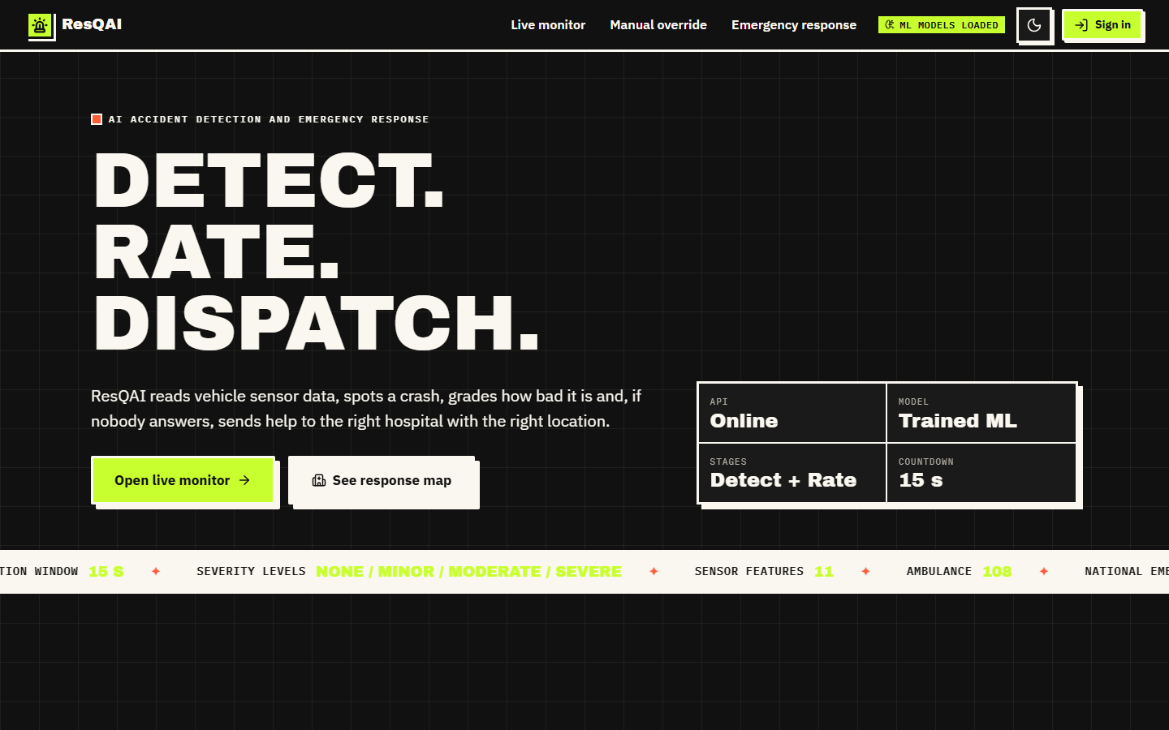  Figure 41: Landing page, dark theme (the theme switch at the top right is remembered in the browser). | 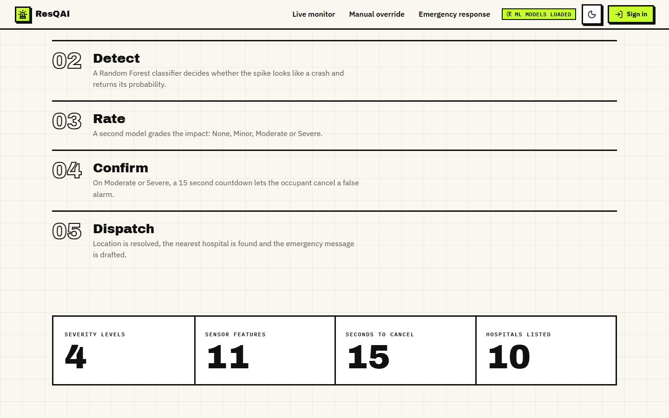  Figure 42: 'How it works' section of the landing page (Detect, Rate, Confirm, Dispatch). The tiles at the bottom (4 severity levels, 11 sensor features, 15 seconds to cancel, 10 hospitals listed) are captured after their count-up animation has finished.

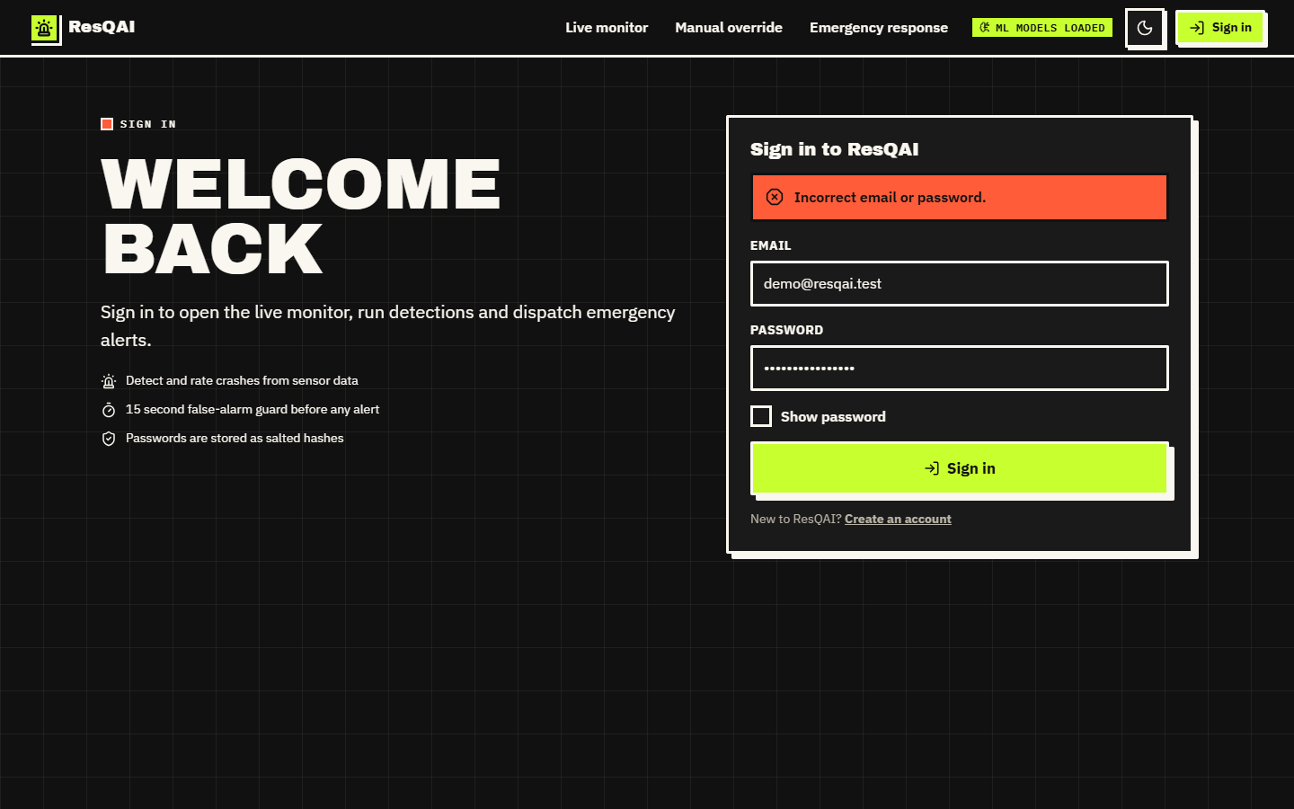  Figure 43: Sign-in with a wrong password (dark theme): the form reports 'Incorrect email or password.' without saying which of the two was wrong. | 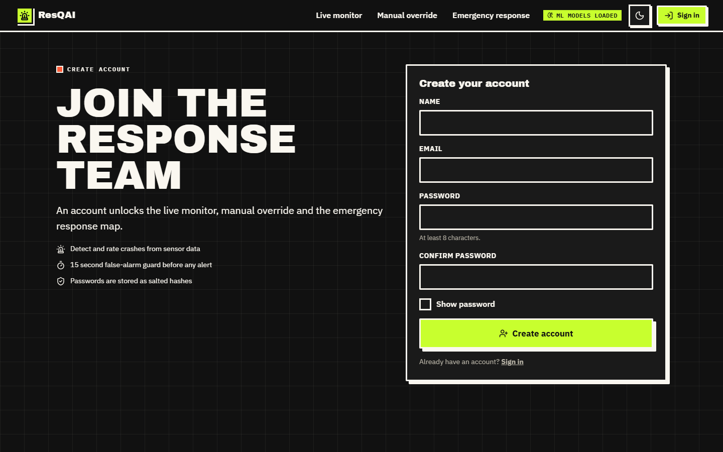  Figure 44: Create-account form (name, e-mail, password and confirmation).

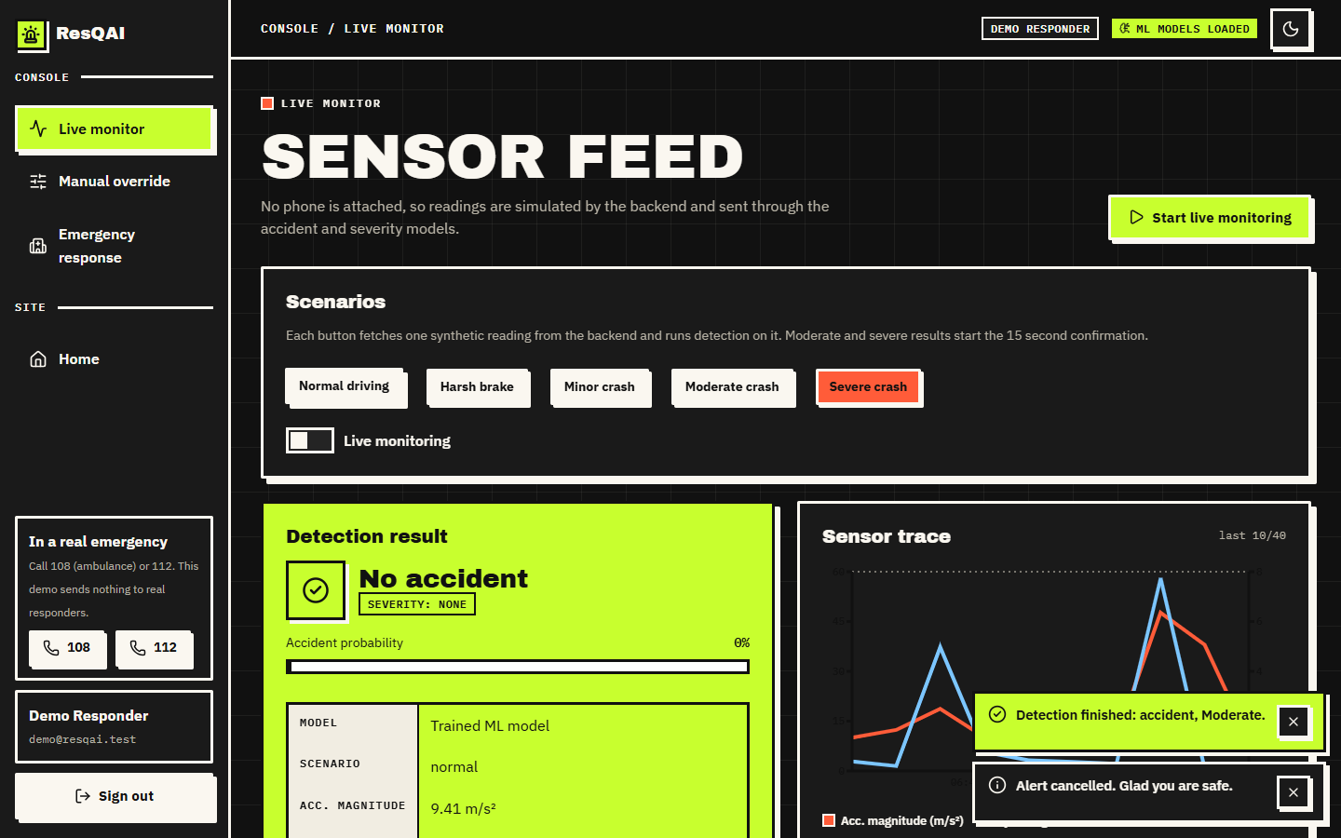  Figure 45: Live monitor in the dark theme after a normal reading. | 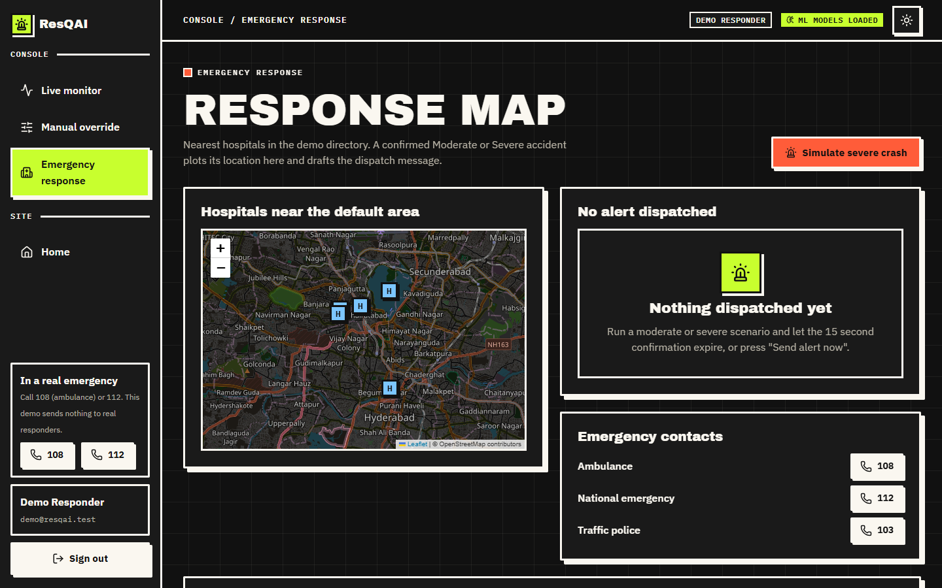  Figure 46: Response map before any alert (dark theme): the ten-hospital directory around the default location and the emergency numbers 108, 112 and 103.

Figure 47: Top of the manual override screen: the input fields for the accelerometer, gyroscope, speed and jerk, with the magnitude derived from them. | 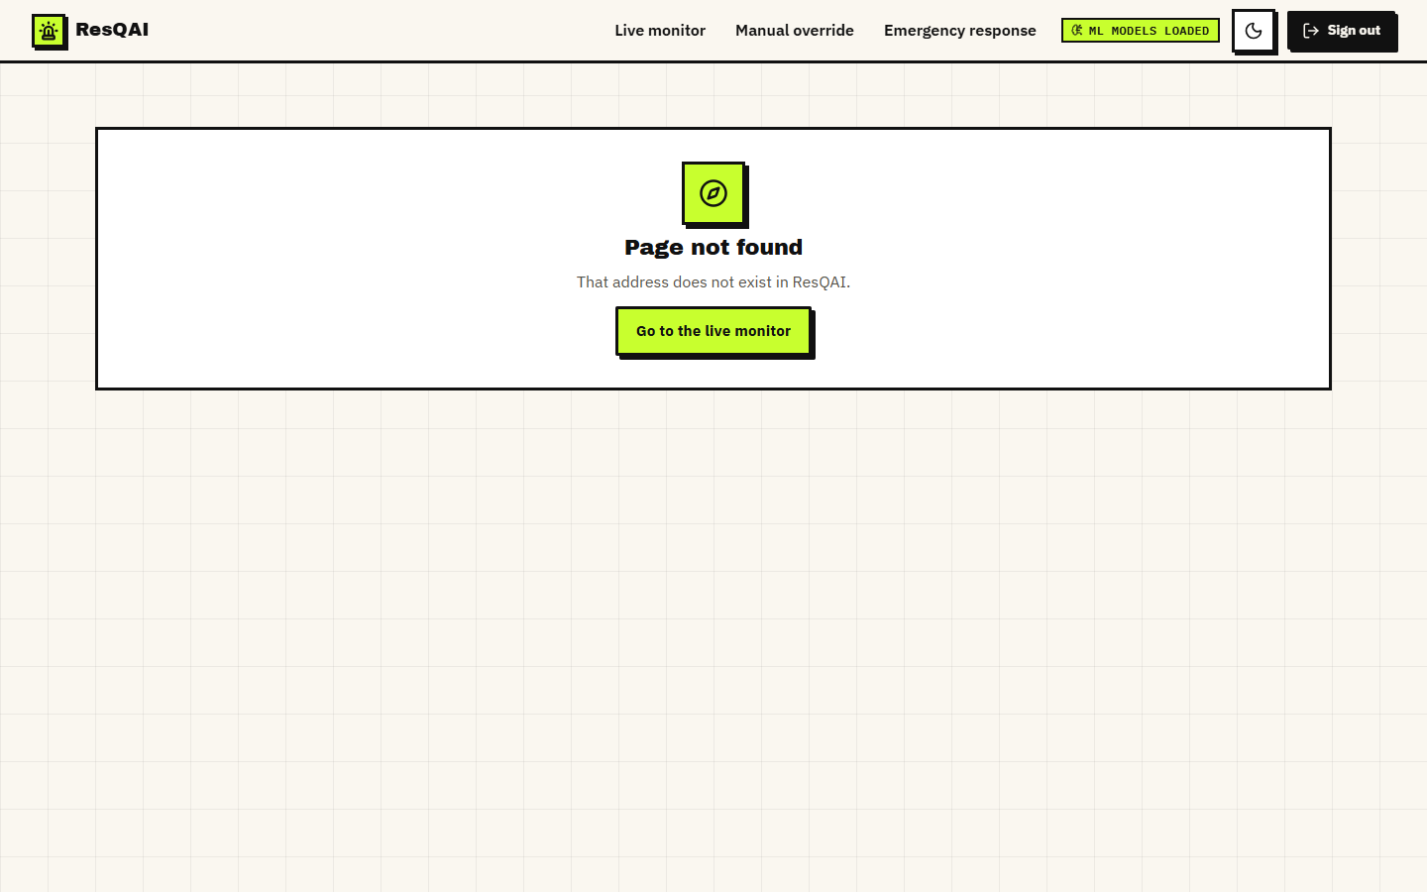  Figure 48: The 404 page shown for an unknown route.

